Recovering Option-Implied Risk-Neutral Densities from SPX Prices
Constrained estimation, synthetic validation and empirical comparisons
Joel Cerraga
Quantitative research project
September 2026
Final assembled paper · Version 1.0

Abstract
This project investigates how European option prices can be used to recover risk-neutral terminal distributions, and what numerical consistency and price agreement establish about the recovered density. A controlled lognormal experiment first verifies call-price differentiation and demonstrates its sensitivity to quote errors. A finite histogram estimator then prices bin probabilities exactly, imposes non-negativity, unit mass and a forward-consistent mean, and links maturities through normalised call inequalities. Analytical within-bin checks identify calendar violations that boundary-only checks miss.
Synthetic evaluation examines support, resolution, smoothing, strike coverage and supplied-forward sensitivity using single-lognormal and two-component mixture benchmarks. Repeated experiments separate noise effects from missing strike information and distinguish Monte Carlo precision from density uncertainty. The results show that similar price errors can accompany materially different density and tail errors, and that selecting smoothing for interior price prediction need not improve density recovery.
The empirical application uses documented exchange bid and offer observations at three snapshots across two dates, with three SPXW expiries per snapshot. Discount factors and forwards are inferred from matched call–put pairs. A minimum-curvature estimator satisfies all 5,518 retained option intervals across the primary fits at the stated numerical tolerance. One held-out validation fold remains numerically unresolved. Linear programmes quantify the range of event probabilities compatible with the same finite density family, while dated comparisons distinguish fixed expiries from an explicitly assumed common-sixty-day mixture.
The evidence supports a conditional conclusion: probability validity, calendar consistency and in-sample price compatibility are necessary checks, but do not identify a unique empirical density or validate extrapolated tail probabilities. The work provides a reproducible estimation process, retains failed numerical attempts and separates imposed restrictions from measured recovery accuracy. The empirical findings remain conditional on the small sample, inferred carry, finite support and stated interpolation assumptions.
Table of contents
Abstract i
List of figures iv
List of tables v
List of equations vi
List of abbreviations viii
List of mathematical symbols x
1 Introduction 1
1.1 Research background 1
1.2 Aim and objectives 1
1.3 Scope and contribution 2
1.4 Organisation of the paper 2
2 Valuation relationships and numerical recovery 3
2.1 From European calls to a risk-neutral density 3
2.2 Controlled benchmark and finite differences 3
2.3 Convergence, cancellation and noisy observations 5
3 Quote assessment and constrained estimation 7
3.1 Assessing observations before calibration 7
3.2 Representing a valid terminal distribution 11
3.3 Fitting noisy calls with a smoothness penalty 12
3.4 Single-maturity validation 12
4 Consistency across maturity 16
4.1 Valid marginal densities can form an inconsistent family 16
4.2 A joint programme in common coordinates 19
4.3 Checking between the constraint locations 20
4.4 Results of joint fitting 20
5 Robustness and repeated synthetic evaluation 26
5.1 Extending the benchmark and making smoothing comparable 26
5.2 Measuring density and tail errors 27
5.3 Separating noise from missing strike information 34
5.4 Results across repeated quote realisations 38
6 Smoothing selection and forward sensitivity 45
6.1 Evaluating a complete selection procedure 45
6.2 Price selection and density recovery are different targets 47
6.3 Perturbing the input without moving the risk event 50
7 Empirical inputs and the first market calibration 55
7.1 Establishing an auditable input route 55
7.2 Conditional forwards and training-only inference 56
7.3 Synthetic acceptance exercise 58
7.4 The supplied market files and contract scope 63
7.5 Inferring a quote-implied carry proxy 65
7.6 Market fit, selection and remaining spread misses 68
8 Original-spread compatibility and dated comparisons 76
8.1 Defining a common empirical comparison 76
8.2 Distinguishing grid feasibility from quote inconsistency 78
8.3 Selecting a smooth member of the feasible family 80
8.4 Held-out pairs and the unresolved fold 83
8.5 Conditional ranges rather than a single tail answer 85
8.6 Fixed expiries and a common elapsed horizon 85
9 Development challenges and lessons learned 95
9.1 Purpose of the development record 95
9.2 Notebook 1: a smaller numerical step was not always better 95
9.3 Notebook 2: retrieving prices did not establish usable observations 95
9.4 Notebook 3: smoothing required an interpretable constrained object 95
9.5 Notebooks 4–5: good slices did not guarantee a consistent surface 96
9.6 Notebook 6: fair sensitivity comparisons and a solver limitation 96
9.7 Notebook 7: repeated studies required more than additional runs 97
9.8 Notebook 8: the selection target and the evaluation target diverged 97
9.9 Notebook 9: empirical access, inferred inputs and misleading visual agreement 97
9.10 Notebook 10: feasibility, finite precision and unresolved evidence 98
9.11 Final assembly: retaining the evidence in a readable paper 99
10 Discussion and limitations 100
10.1 What the evidence establishes 100
10.2 Limits of identification and probability interpretation 100
10.3 Limits of empirical and numerical validation 101
11 Conclusions and future work 102
11.1 Conclusion 102
11.2 Priorities for further work 102
References 104
Appendix A Reproducibility and interactive companions 106
A.1 Structure of the project package 106
A.2 Interactive figures 106
A.3 Reproduction and software scope 106
Appendix B Attribution and reporting conventions 107
B.1 Established relationships and project definitions 107
B.2 Units and interpretation 107
List of figures
Figure 1. Synthetic European call prices 4
Figure 2. Known and recovered synthetic density 4
Figure 3. Strike-spacing convergence 5
Figure 4. Sensitivity to independent quote errors 6
Figure 5. Candidate quote coverage by expiry and root 9
Figure 6. Candidate coverage under spread thresholds 10
Figure 7. Constrained synthetic call-price fit and residuals 13
Figure 8. Constrained density versus raw differentiation 14
Figure 9. Smoothing-penalty sensitivity 15
Figure 10. Synthetic multi-maturity density surface; interactive companion 17
Figure 11. Known and fitted density slices across horizons 18
Figure 12. Calendar gap before and after joint fitting 22
Figure 13. Joint density comparison and remaining tail differences 24
Figure 14. Joint synthetic maturity surface; interactive comparison 25
Figure 15. Density sensitivity across support, resolution and smoothing choices 30
Figure 16. Price and full-density error across sensitivity settings 31
Figure 17. Tail-probability errors under alternative fitting choices 33
Figure 18. Nested strike patterns and tail-threshold coverage 36
Figure 19. Repeated recovery errors and Monte Carlo precision 40
Figure 20. Repeated upper-tail errors and clean-input controls 43
Figure 21. Noisy held-out price scores for smoothing selection 46
Figure 22. Selected and fixed smoothing on separate recovery measures 49
Figure 23. Density, price and fixed-event tail sensitivity to supplied forwards 53
Figure 24. Matched-pair forward intervals and an intentionally incompatible quote 57
Figure 25. Synthetic input-fixture density recovery and bid–ask residuals 62
Figure 26. Observed market prices and complete call–put spread residuals 70
Figure 27. Empirical density sensitivity on full support and central detail 73
Figure 28. First empirical maturity surface and offline explorer 75
Figure 29. Original call/put spread residuals before and after hard-bound fitting 82
Figure 30. Fixed-expiry comparisons across the three observed snapshots 86
Figure 31. Assumed common-60-day densities and common-contract control 88
Figure 32. Chosen tail estimates and conditional feasible probability ranges 92
Figure 33. Dated density surfaces on shared scales; offline date-aware companion 94
List of tables
Table 1. Measured baseline validation 5
Table 2. Data-source assessment and access status 7
Table 3. Candidate-snapshot audit results 8
Table 4. Required market-data fields 11
Table 5. Baseline constrained-fit diagnostics 13
Table 6. Smoothing sensitivity 15
Table 7. Synthetic validation by expiry horizon 17
Table 8. Cross-maturity calendar diagnostic 19
Table 9. Independent and joint consistency and recovery accuracy 21
Table 10. Joint-fit recovery accuracy by horizon 23
Table 11. Declared sensitivity settings and comparable smoothing coefficients 27
Table 12. Recovery accuracy across two benchmarks and seven settings 29
Table 13. Known and fitted tail probabilities and variance at 365 days 32
Table 14. Quote patterns, counts and threshold coverage 35
Table 15. Mean recovery errors and Monte Carlo standard errors 39
Table 16. Clean-input and repeated upper-tail errors 42
Table 17. Paired changes in density and absolute tail errors 44
Table 18. Smoothing-selection frequencies across repetitions 45
Table 19. Recovery under selected and fixed smoothing 48
Table 20. Paired selected-minus-fixed recovery errors 50
Table 21. Forward sensitivity and incompatible lower-bound quotes 52
Table 22. Updated source-access assessment for empirical calibration 55
Table 23. Synthetic input pairs and conditional forward inference 59
Table 24. Separate fixture recovery and in-sample spread diagnostics 61
Table 25. Deliberately invalid input cases and observed responses 63
Table 26. Supplied marking-price files, dates and assigned roles 64
Table 27. Quote-implied discount/forward inputs and feasible discount projections 67
Table 28. Primary empirical coverage and call/put spread residuals 69
Table 29. Primary and post-hoc smoothing grids and fit diagnostics 72
Table 30. Conditional empirical tail probabilities and variance sensitivity 74
Table 31. Dated quote coverage, common strikes and inferred carry 77
Table 32. Finite-grid price feasibility and equivalent numerical formulations 79
Table 33. Original call/put spread fit and midpoint residual comparisons 81
Table 34. Paired held-out price errors and successful-fold coverage 84
Table 35. Common-horizon conditional risk summaries and sample sensitivity 89
Table 36. Conditional feasible ranges for common-horizon tail events 91
List of equations
Equation 1. Discounted expected call payoff 3
Equation 2. First strike derivative of the call price 3
Equation 3. Breeden–Litzenberger density-extraction relationship 3
Equation 4. Centred finite-difference density estimate 4
Equation 5. Bid–ask midpoint 7
Equation 6. Relative bid–ask spread 7
Equation 7. Discounted put–call parity 10
Equation 8. Indicative forward interval from bid–ask quotes 10
Equation 9. Piecewise-constant probability density 11
Equation 10. Non-negativity, total-mass and forward constraints 11
Equation 11. Exact call valuation under interval probabilities 12
Equation 12. Regularised constrained fitting objective 12
Equation 13. Forward-normalised call value 16
Equation 14. Cross-maturity consistency at fixed forward moneyness 16
Equation 15. Integrated absolute density error on fitting support 16
Equation 16. Common forward-coordinate density and physical density 19
Equation 17. Joint quadratic programme with calendar constraints 20
Equation 18. Within-bin quadratic calendar gap 20
Equation 19. Interior calendar-gap minimum 20
Equation 20. Lognormal-mixture density and weighted option prices 26
Equation 21. Grid-scaled discrete density roughness 26
Equation 22. Equivalent smoothing coefficient across grids 26
Equation 23. Full-domain density error including omitted tails 27
Equation 24. Risk-neutral tail probabilities at stated forward thresholds 27
Equation 25. Normalised terminal-level variance for histograms and mixtures 28
Equation 26. Paired bounded synthetic quote perturbations 37
Equation 27. Simulation bias, empirical variance and finite-sample MSE decomposition 37
Equation 28. Monte Carlo standard error of a mean 37
Equation 29. Mean paired contrast and its Monte Carlo standard error 37
Equation 30. Pooled noisy-price validation score and penalty selection 45
Equation 31. Relative perturbation of the supplied forward curve 50
Equation 32. Density evaluation and fixed risk event in reference coordinates 51
Equation 33. Supplied-forward call lower bound and quote shortfall 51
Equation 34. Common bid–ask forward intersection and point convention 56
Equation 35. Minimum uniform widening of incompatible forward intervals 56
Equation 36. Smoothing selection with training-only inferred forwards 58
Equation 37. Fitted option-price distance outside its bid–ask range 60
Equation 38. Linear put–call parity and bid–ask difference bounds 65
Equation 39. Constrained quote-implied discount and forward estimation 65
Equation 40. Quote-implied continuously compounded rate equivalent 66
Equation 41. Intersection of original call and parity-transformed put intervals 78
Equation 42. Minimum diagnostic quote widening under the finite density basis 78
Equation 43. Minimum-curvature density inside original quote restrictions 80
Equation 44. Conditional feasible lower and upper event probabilities 85
Equation 45. Assumed interpolation of normalised distributions at a common horizon 87
Equation 46. Absolute distance between two fitted normalised densities 90
List of abbreviations
Abbreviation | Meaning
3D | Three-dimensional
ACT/365F | Actual elapsed time divided by a fixed 365-day year; UTC seconds are used here
AM / PM | Before / after noon; settlement conventions require contract-specific confirmation
API | Application programming interface
BBO | Best Bid and Offer on the stated exchange; not necessarily consolidated NBBO
BS | Black–Scholes, used as a component-pricing subscript
CSV | Comma-separated values
CT / ET | Chicago / New York civil time, with the date-specific UTC offset
CV | Cross-validation; here an interlaced interior-price selection rule
DOI | Digital object identifier
EOD | End of day; a provider product can also contain a separately specified intraday snapshot
EOM | End of month
HTML | HyperText Markup Language
ISO | International Organization for Standardization; ISO datetime notation is used in the input format
JSON | JavaScript Object Notation
LN | Lognormal, used as a component-density subscript
LP | Linear programme
MCSE | Monte Carlo standard error of an estimated simulation summary
MSE | Mean squared error
NBBO | National Best Bid and Offer
OSI | Options Symbology Initiative; encoded contract identifier
OSQP | Operator Splitting Quadratic Program; the solver used in Milestone 5
PCG64 | NumPy’s 64-bit permuted congruential random-number generator
PDF | Probability density function; a .pdf document separately denotes Portable Document Format
QDLDL | Named sparse LDL factorisation implementation used by the Clarabel backend
QP | Quadratic programme
RMSE | Root-mean-square error
RND | Risk-neutral density
SD | Standard deviation
SHA-256 | Secure Hash Algorithm with a 256-bit digest
SLSQP | Sequential least-squares programming
SPX | Cboe S&P 500 Index option identifier; a product symbol rather than an ordinary abbreviation
SPXW | SPX option trading-class identifier; kept separate from SPX in the quote audit
SVI | Stochastic volatility inspired; the parameterisation in reference [12], not the estimator used here
UTC | Coordinated Universal Time
WRDS | Wharton Research Data Services
List of mathematical symbols
Symbols are defined in the context of their equation. Reused letters with different subscripts or roles are distinguished below.
Symbol | Definition | Units
$S_{0}$ | Initial index level | Index points
$S_{T}$, $s$ | Terminal index level, or its possible value | Index points
$K$, $K_{i}$ | Option strike | Index points
$T$ | Time from observation to settlement | Years
$r$ | Continuously compounded risk-free rate | Per year
$q$ | Continuous dividend yield; dividend in the code | Per year
$σ$ | Annualised volatility | Per square-root year
$Q$ | Risk-neutral probability measure | Not applicable
$f_{Q}$, ${\hat{f}}_{Q}$ | Known/theoretical and estimated risk-neutral densities | Inverse index points
$C$, $P$ | European call and put prices | Index points
$F\left(T\right)$ | Forward index level for the horizon | Index points
$D\left(T\right)$ | Discount factor, $e^{−rT}$ | Dimensionless
$T_{i}$ | The $i$th increasing synthetic expiry horizon | Years
$κ$ | Forward moneyness, $K/F\left(T\right)$; not log-moneyness | Dimensionless
$\overline{C}$ | Call value divided by $D\left(T\right)F\left(T\right)$ | Dimensionless
$E^{Q}$ | Expectation under the risk-neutral measure | Same as the random quantity averaged
$L_{1}\left(T\right)$ | Integrated absolute density error on the fitting support | Dimensionless
$h$ | Strike spacing in finite differences | Index points
$B_{i}$, $A_{i}$ | Bid and ask of option observation $i$ | Index points
$M_{i}$ | Quote midpoint | Index points
$R_{i}$ | Spread divided by midpoint | Dimensionless
$a_{j}$, $b_{j}$ | Lower and upper terminal-level interval boundaries | Index points
$Δs_{j}$, $m_{j}$ | Interval width and centre | Index points
$w_{j}$, $w$ | Probability in interval $j$, and vector of these probabilities | Dimensionless
$J$ | Number of terminal-level intervals | Count
$N$ | Number of observed or synthetic option prices | Count
$A_{ij}$ | Discounted call payoff for strike $i$ under unit uniform mass in interval $j$ | Index points
$y_{i}$ | Noisy synthetic price supplied to the fitter | Index points
$g_{j}$ | Density height in coordinates normalised by the forward | Dimensionless
$m$, $M$ | Maturity index and number of jointly fitted maturities | Count
$T_{m}$, $F_{m}$ | Maturity and its forward in the joint problem | Years; index points
$x$ | Terminal level divided by the forward, $s/F_{m}$ | Dimensionless
$u_{j}$, ${\overset{‾}{u}}_{j}$, $Δu$ | Common normalised edge, bin centre and equal bin width | Dimensionless
$w_{mj}$, $w_{m}$ | Bin probability and probability vector at maturity $m$ | Dimensionless
${\hat{g}}_{m}\left(x\right)$ | Fitted density of the normalised terminal level | Dimensionless
$B_{j}\left(κ\right)$, $B\left(κ\right)$ | Uniform-bin normalised call payoff and its row vector | Dimensionless
$ℓ_{m}\left(w_{m}\right)$ | Per-maturity objective from Equation (12) | Dimensionless
$K_{m}$ | Calendar-constraint locations for adjacent pair $m,m+1$ | Set of dimensionless ratios
$δ_{mj}$ | Later minus earlier probability in bin $j$ | Dimensionless
$Δ_{m}\left(κ\right)$ | Later minus earlier normalised call value | Dimensionless
$z$, $z_{mj}^{*}$ | Offset from the left bin edge; eligible interior-minimum offset | Dimensionless
$X_{T}$ | Normalised terminal random level, $S_{T}/F\left(T\right)$ | Dimensionless
$L$, $ℓ$ | Number of mixture components and component index | Count
$π_{ℓ}$ | Probability weight of mixture component $ℓ$ | Dimensionless
$σ_{ℓ}$ | Annualised volatility of mixture component $ℓ$ | Per square-root year
$g_{mix}$, $g_{LN}$ | Mixture and component densities of the normalised terminal level | Dimensionless
$C_{mix}$, $C_{BS}$ | Mixture call price and component Black–Scholes call price | Index points
$R_{Δu}\left(g\right)$ | Discrete roughness of the normalised density-height sequence | Dimensionless
$α$, $α_{0}$ | Grid-comparable roughness coefficient and its baseline | Dimensionless
$L_{1}^{full}\left(T\right)$ | Density absolute error across the entire positive domain | Dimensionless
$p_{0.8}^{−}$, $p_{1.2}^{+}$, $p_{1.8}^{+}$ | Lower- and upper-tail probabilities relative to the forward | Dimensionless; optionally displayed as percentages
$\hat{μ}$ | Fitted mean of the normalised terminal level | Dimensionless
$\hat{V}$, $V_{known}$ | Fitted and known variance of the normalised terminal level | Dimensionless
$ν$, $n_{sim}$ | Simulation repetition index and number of repetitions | Count
$a$, $η_{mi}\left(a\right)$ | Declared error half-width limit and its price-dependent bound | Index points
$C_{mi}$, $y_{νmi}\left(a\right)$ | Clean and perturbed call value at horizon $m$ and master strike $i$ | Index points
$U_{νmi}$, $U\left[−1,1\right]$ | Shared random draw and its uniform distribution | Dimensionless
$θ$, ${\hat{θ}}_{ν}$, $\overline{θ}$ | Known target, repetition-level estimate and mean estimate | Units of the stated target; dimensionless for probability
$\hat{Bias}$, $s_{θ}$ | Estimated bias and empirical SD of repeated estimates | Same as $θ$
$z_{ν}$, $\overline{z}$, $s_{z}$ | Repetition-level performance scalar, its mean and sample SD | Units of the selected performance measure
$Δ_{ν}$, $\overline{Δ}$ | Paired difference and its mean across repetitions | Same as $z_{ν}$
$MCSE$ | Standard error due to a finite simulation repetition count | Units of the estimated summary
$λ$ | Smoothing penalty coefficient in the specified scaled objective | Dimensionless
$Λ$, $\hat{λ}$ | Declared candidate set and selected smoothing coefficient | Set of dimensionless values; dimensionless
$k$, $H_{k}$ | Validation-fold index and its held-out quote positions | Count; index set
${\hat{C}}_{m,λ}^{\left(−k\right)}$ | Call-price fit trained without fold $k$ at maturity $m$ | Index points
$CV\left(λ\right)$ | Pooled mean squared noisy-price residual after forward scaling | Dimensionless
$ε$ | Relative supplied-forward error in the stress experiment | Dimensionless; optionally displayed as a percentage
${\tilde{F}}_{m}^{\left(ε\right)}$ | Forward supplied to the stressed fit | Index points
${\hat{g}}_{m}^{\left(ε\right),ref}$ | Stressed fitted density expressed using the fixed reference forward | Dimensionless
${\hat{p}}_{1.8,m}^{\left(ε\right)}$ | Stressed fitted probability above the fixed physical level $1.8F_{m}$ | Dimensionless
$D_{m}$ | Discount factor at maturity $T_{m}$ | Dimensionless
$ℓ_{mi}^{F}$, $u_{mi}^{F}$ | Lower and upper conditional forward bounds from matched pair $i$ | Index points
${\underline{F}}_{m}$, ${\overline{F}}_{m}$ | Largest pair lower bound and smallest pair upper bound | Index points
${\hat{F}}_{m}$, ${\hat{F}}_{m}^{\left(−k\right)}$ | Declared forward point from all pairs or fold-$k$ training pairs only | Index points
$s_{m}^{*}$ | Minimum common widening of forward intervals needed for intersection; diagnostic only | Index points
$H_{km}$ | Pair positions held out in fold $k$ at maturity $m$ | Index set
$C_{mi}^{mid}$ | Observed or fixture call midpoint used for fitting/selection | Index points
${CV}_{F}\left(λ\right)$ | Pooled call-price selection loss using training-only inferred forwards | Dimensionless
$o$, ${\hat{V}}_{mi,o}$ | Option type (call/put) and corresponding fitted price | Type label; index points
$B_{mi,o}$, $A_{mi,o}$ | Matched option’s bid and ask | Index points
$d_{mi,o}^{spread}$ | Fitted-price distance outside the option’s bid–ask range | Index points
$L_{mi}^{\left(ε\right)}$, $v_{mi}^{\left(ε\right)}$ | Supplied-forward call lower bound and positive observed-price shortfall | Index points
$1_{[a,b)}$ | Indicator of the half-open interval | Dimensionless
${\left(x\right)}_{+}$ | Positive part, $max\left(x,0\right)$ | Same as $x$
f | Estimated quantity | Same as the quantity
$∂$ | Partial differentiation | Determined by the variables
$O\left(h^{2}\right)$ | Second-order truncation-error notation | Order statement
§ / §§ | Section / sections in a cited source; not a mathematical variable | Not applicable
$H_{m}$, ${\hat{H}}_{m}$ | Discounted forward, $D_{m}F_{m}$, and its quote-implied estimate | Index points
${\hat{D}}_{m}$, ${\hat{r}}_{m}$ | Quote-implied discount factor and equivalent continuously compounded rate | Dimensionless; per year
$b_{mi}^{−}$, $b_{mi}^{+}$ | Opposite-side bid–ask bounds on the call-minus-put difference | Index points
$y_{mi}$ | Observed call-midpoint minus put-midpoint difference | Index points
$K_{0m}$ | Median training strike, used to centre and scale the carry regression | Index points
$β_{0}$, $β_{1}$ | Scaled parity intercept $\left(H−DK_{0}\right)/K_{0}$ and discount factor $D$ | Dimensionless
$ε_{carry}$ | Positive lower bound for scaled carry inputs in Equation (39), ${10}^{−8}$ | Dimensionless
$N_{m}$ | Retained call–put pair count used in a full-sample or training-only carry fit | Count
$K_{mi}$ | Strike of matched pair $i$ at maturity $m$ | Index points
$ℓ_{mi}^{C}$, $u_{mi}^{C}$ | Intersection bounds from original call and parity-transformed put quotes | Index points
$W$ | Matrix of probability masses over all jointly fitted maturities | Dimensionless
$P_{J}$, $F_{J}$ | Finite-bin probability/calendar family, and its original-spread-feasible subset | Sets of mass matrices
$δ_{J}^{*}$ | Minimum common quote widening on the stated density grid; diagnostic only | Index points
$R_{J}\left(W\right)$ | Discrete density-curvature criterion used without a price-error tradeoff | Dimensionless
$a$ | Exact bin-event fractions, including time weights where applicable | Dimensionless
$vec\left(W\right)$ | Mass matrix flattened in maturity-major order | Dimensionless
${\underline{p}}_{J}$, ${\overline{p}}_{J}$ | Conditional minimum/maximum event probability in the finite feasible family | Dimensionless; optionally percentages
$T_{a}$, $T_{b}$, $T_{*}$ | Adjacent interpolation horizons and target horizon; all in the same unit | Elapsed days in Notebook 10
$ω_{*}$ | Linear common-horizon time-mixture weight | Dimensionless
$w_{*}$ | Assumed common-horizon mixture of normalised bin masses | Dimensionless
$d_{1}\left({\hat{g}}^{\left(a\right)},{\hat{g}}^{\left(b\right)}\right)$ | Integrated absolute difference between two fitted normalised densities | Dimensionless

Introduction

Research background
Option prices contain information about the distribution of future outcomes, but extracting that information requires more than drawing a smooth curve through observed prices. As Bahra explains in Implied risk-neutral probability density functions from option prices: theory and application, a European option price is a discounted expected payoff under a risk-neutral probability measure [1]. The relationship allows prices to be used to recover a distribution. It also determines how that distribution should be interpreted: the probabilities are valuation probabilities, rather than direct estimates of how frequently an event will occur in the real world.
Breeden and Litzenberger established the relationship between the curvature of a call-price curve and its implied state-contingent claims [6]. Following the derivation presented by Bahra [1], this project begins with numerical differentiation of a known price curve and develops a constrained estimator for discrete observations. As Aït-Sahalia and Duarte explain in Nonparametric option pricing under shape restrictions, the direction and curvature of an estimated price function should respect the restrictions implied by option valuation [9]. These restrictions provide the foundation for the estimation work, although their particular locally polynomial estimator is not implemented here.
The practical difficulty is that market observations are finite, spreads are nonzero and information is unevenly distributed across strikes. In his study of option-based distributions, Malz discusses the importance of interpolation and extrapolation when calculating tail probabilities [14]. This motivates the central question of the present work: how far can a numerically consistent option-implied density be trusted when the available price information is incomplete?

Aim and objectives
The aim is to develop and critically evaluate a reproducible method for recovering risk-neutral terminal distributions from European SPX option prices. The work has five linked objectives: establish the price–density relationship on a known benchmark; replace unstable differentiation with a probability-constrained estimator; enforce consistency across observed maturities; measure sensitivity and recovery error in controlled simulations; and apply the method to traceable market observations while retaining its empirical and numerical limitations.
These objectives distinguish four questions that recur throughout the paper. Does the fitted object satisfy the probability and pricing restrictions? Does the numerical solution meet its stated tolerances? Does it reproduce the observations used to fit it? Finally, how accurately is the underlying distribution identified? A favourable answer to one question does not answer the others. In synthetic experiments, the last question can be measured against a known distribution. In the market application, that truth is unavailable, so the analysis instead reports sensitivity and conditional feasible probability ranges.

Scope and contribution
The project comprises ten analytical notebooks, progressing from a single synthetic expiry to dated empirical comparisons. Its contribution is the integrated implementation and evaluation of a finite histogram estimator, exact bin-payoff valuation, analytical checks between calendar-constraint locations, controlled recovery experiments and bid–ask-compatible empirical estimation. The individual valuation identities, optimisation principles and simulation summaries are established relationships; the discretisation, experiment designs and reported numerical findings are this project’s work.
The empirical sample contains two dates, 31 August and 18 September 2026, with a second intraday observation on the latter date. It uses three SPXW settlement horizons per snapshot and documented exchange best bid and offer prices. It is a small conditional case study, not a historical backtest or an event study. Discount factors and forwards are estimated jointly from matched call–put observations; an independently observed discount curve and executable market depth are unavailable in this profile.

Organisation of the paper
Chapter 2 establishes the valuation relationships and the limitations of numerical differentiation. Chapter 3 addresses data assessment and the constrained single-maturity method. Chapter 4 links the maturity slices and develops the interval-level calendar check. Chapters 5 and 6 evaluate robustness, repeated perturbations, smoothing selection and forward sensitivity. Chapter 7 develops the empirical input process and the first market fit, before Chapter 8 addresses original bid–ask compatibility and dated comparisons. Chapter 9 consolidates the development setbacks and lessons. Chapters 10 and 11 discuss the evidence, answer the research question and identify further work. The appendices describe the reproducibility package and the four interactive companions.

Valuation relationships and numerical recovery

From European calls to a risk-neutral density
Let $S_{T}$ denote the terminal index level, $K$ the strike and $T$ the time to settlement in years. A density gives probabilities through integration over ranges of outcomes; its value at one exact outcome is not itself a probability. As Bahra explains in his Bank of England paper [1], deterministic discounting and a continuous terminal density give the expected-payoff representation in Equation (1).
$$C\left(K,T\right)=e^{−rT}\int_{K}^{∞}{\left(s−K\right)}f_{Q}\left(s;T\right) ds.$$
Equation 1. Discounted expected call payoff.
Here $r$ is the continuously compounded rate and $f_{Q}$ is the density under the risk-neutral measure $Q$. Differentiating across strikes at one observation instant and one maturity gives Equation (2). The moving-boundary term is zero because the call payoff vanishes at $s=K$.
$$\frac{∂C}{∂K}=−e^{−rT}\int_{K}^{∞}{f_{Q}}\left(s;T\right) ds.$$
Equation 2. First strike derivative of the call price.
Differentiating once more gives the Breeden–Litzenberger extraction relationship [6], following its derivation in Bahra [1]. The argument requires the stated smoothness and valuation assumptions; it is not differentiation across maturities or observation dates.
$$f_{Q}\left(K;T\right)=e^{rT}\frac{∂^{2}C}{∂K^{2}}.$$
Equation 3. Breeden–Litzenberger density-extraction relationship.

Controlled benchmark and finite differences
Black and Scholes derive option valuation through a no-arbitrage argument [8]. As Bahra describes [1], the constant-volatility benchmark provides a lognormal terminal distribution. It is used here as a known answer against which the implementation can be assessed. The synthetic initial index level is 6,000, the annual rate is 4%, the continuous dividend yield is 1.5%, the annual volatility is 20% and the maturity is half a year. The dividend adjustment follows the spot–forward relationship discussed by Aït-Sahalia and Lo [10, Equation (16)]. These are illustrative inputs and do not assert a lognormal empirical SPX distribution.
As Driscoll and Braun explain in Fundamentals of Numerical Computation, §5.4, a three-point centred difference approximates the second derivative [7]. Substituting their stencil into Equation (3) gives Equation (4), where $h$ is the strike spacing.
$${\hat{f}}_{Q}\left(K_{i}\right)=e^{rT}\frac{C\left(K_{i}+h\right)−2C\left(K_{i}\right)+C\left(K_{i}−h\right)}{h^{2}}.$$
Equation 4. Centred finite-difference density estimate.
The validated call grid spans 2,500–14,000 index points with spacing 5; density values use the interior points, 2,505–13,995. Grid endpoints are excluded because a centred stencil is unavailable there. No negative estimates are clipped and no density is renormalised. Figure 1 shows the input price curve and Figure 2 compares the recovered density with its analytical counterpart.
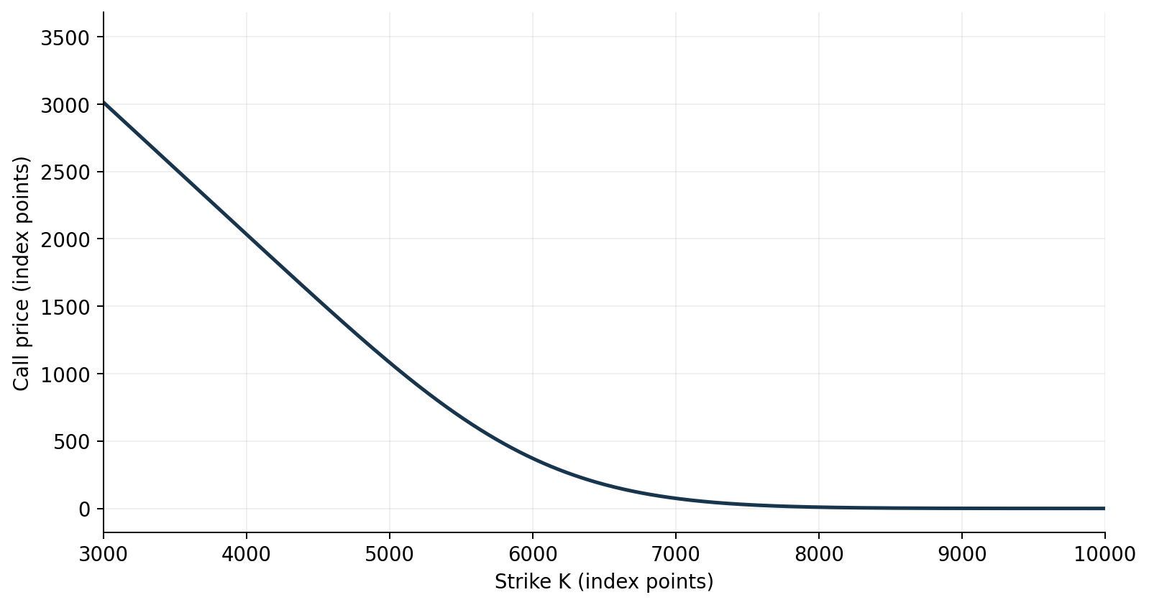
Figure 1. Synthetic European call prices across strikes for a six-month expiry, using an illustrative initial index level of 6,000 and constant annual volatility of 20%.
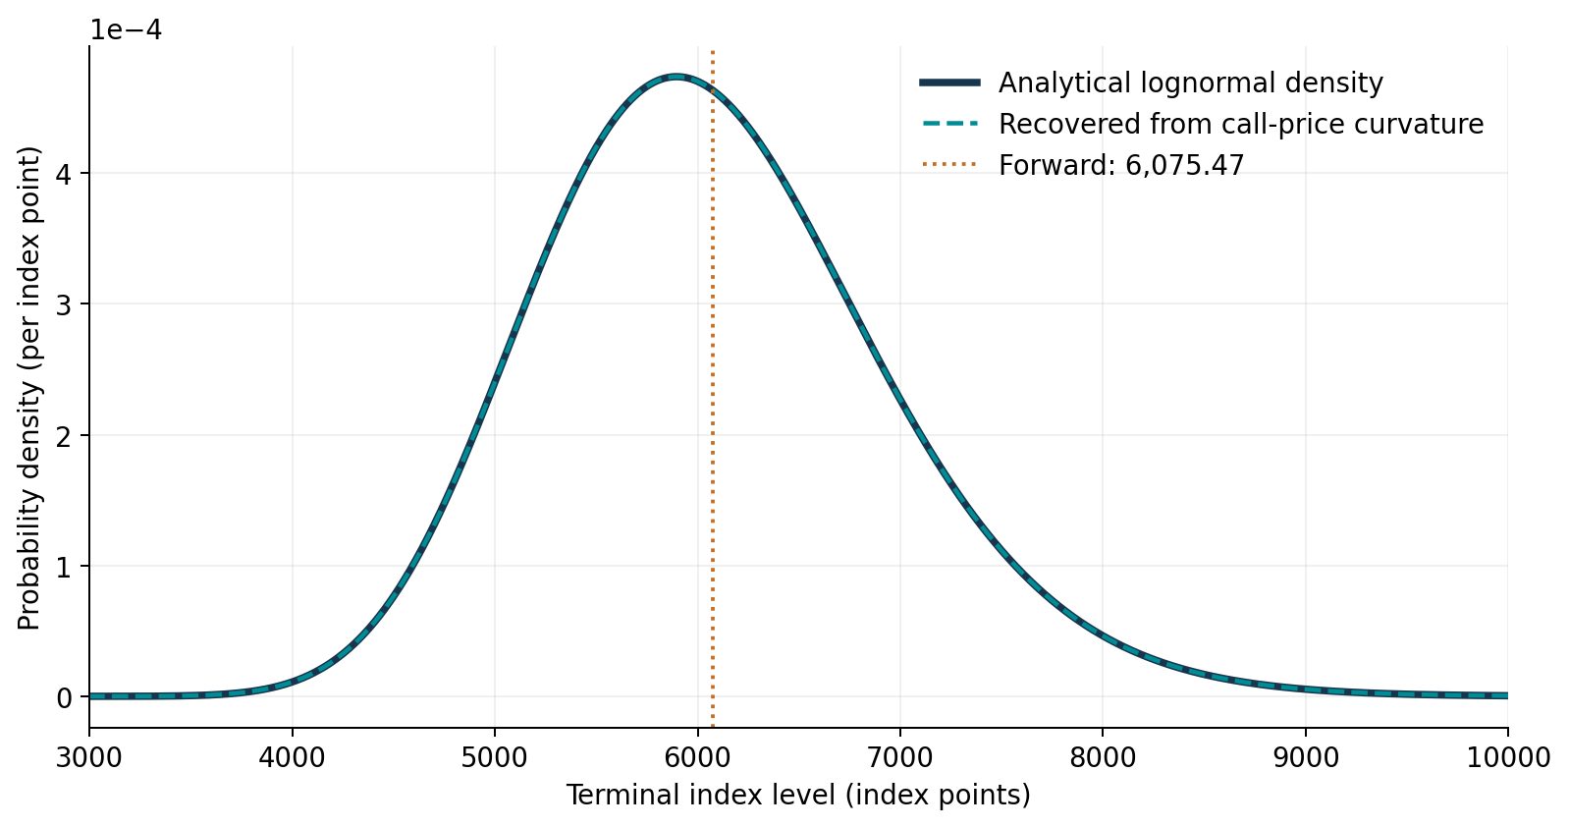
Figure 2. Analytical lognormal density and density recovered from synthetic call-price curvature. The dashed vertical line identifies the theoretical forward of 6,075.47. The recovered and analytical curves nearly coincide.
The curves nearly coincide in this controlled example. The forward is 6,075.470709 index points and is the risk-neutral mean under the assumptions described by Bahra [1, Mathematical appendix]. It is distinct from the density’s mode. Table 1 records the numerical checks rather than relying on visual agreement alone.
Metric | Result
Integrated probability mass | 0.9999999985
Minimum density (per index point) | 3.649747692e-12
Negative density estimates | 0
Integrated absolute density error | 2.914825705e-06
Recovered mean (index points) | 6075.470692
Theoretical forward (index points) | 6075.470709
Relative error in the forward mean | 2.895368748e-09
Maximum repricing error (index points) | 1.099256224e-05
Table 1. Measured baseline validation

Convergence, cancellation and noisy observations
As Driscoll and Braun discuss in §5.5 [7], the centred second-difference truncation error is of order $h^{2}$ when the price function is sufficiently smooth. Refining the grid from 80 to 5 points produces approximately second-order convergence, as Figure 3 demonstrates. However, smaller steps also increase exposure to roundoff through subtraction of nearly equal values.
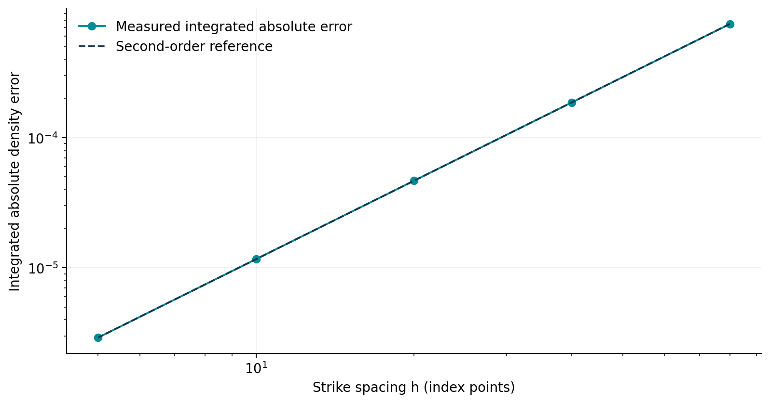
Figure 3. Integrated absolute density error against strike spacing. The measured error follows approximately second-order convergence over the tested grid spacings.
An initial lower boundary of 1,000 produced tiny negative second differences in the far left tail, where call prices were nearly linear. Raising the boundary to 2,500 reduced cancellation while retaining essentially all the known benchmark mass. This was a benchmark-specific numerical decision, not a rule transferred automatically to the empirical sample.
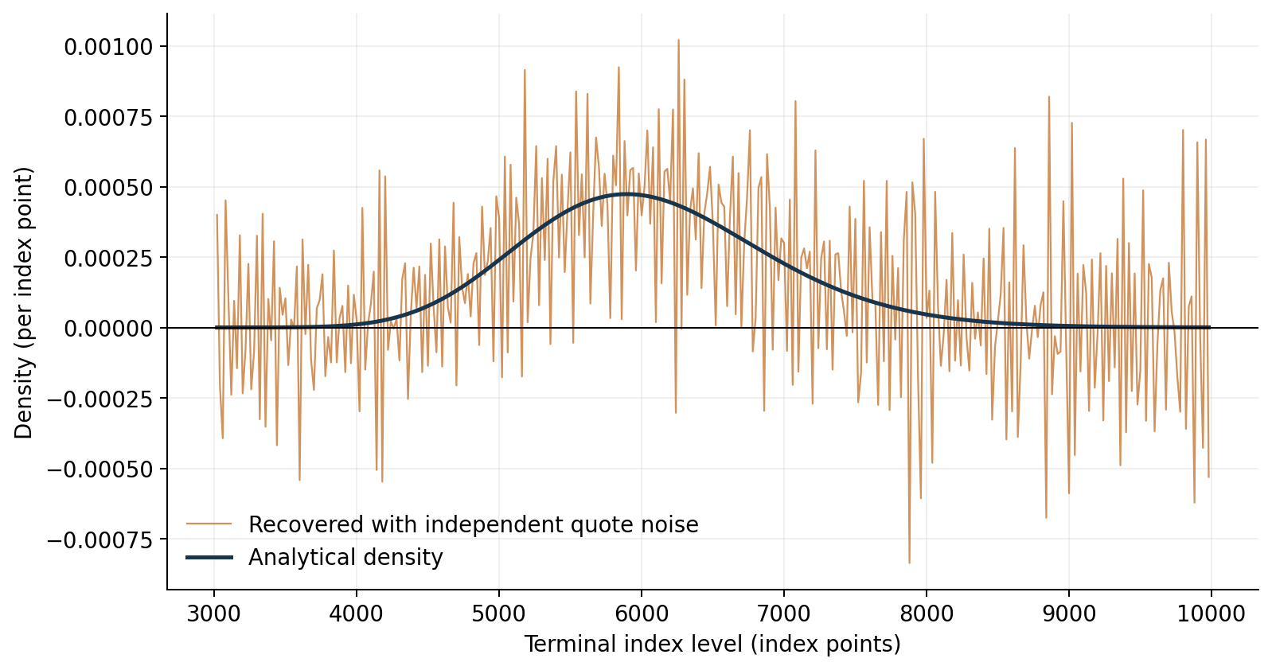
Figure 4. Density recovered after adding independent, zero-mean quote noise with a standard deviation of 0.05 index points (seed 42). Negative estimates demonstrate the sensitivity of raw second differences to quote errors.
Figure 4 introduces independent zero-mean quote perturbations with a standard deviation of 0.05 index points and seed 42. These errors need not preserve arbitrage constraints. Applying Equation (4) amplifies their effect through division by the squared strike spacing. This is an algebraic consequence of the stencil in Driscoll and Braun [7], rather than a calibrated model of market noise. The stress test deliberately shows the consequence of applying raw differences to inconsistent quotes; it is not a fitted market-noise model.
The clean-data result therefore validates the implementation within the tested conditions. It does not validate direct numerical differentiation of market quotes. The subsequent estimator addresses this failure by fitting probabilities subject to explicit restrictions, rather than interpreting clipped negative derivatives as recovered probabilities.

Quote assessment and constrained estimation

Assessing observations before calibration
Cboe’s source and contract documentation distinguishes product conventions, observation fields and settlement classes [2–5]. These operational facts must be established before a statistical or numerical method can supply an interpretable market result. The first candidate payload contained 27,782 option records across 61 root/expiry groups. Its time-only field, 17:43:22, did not establish a complete quote observation instant. The underlying’s last-trade timestamp described a different event, and every bid/ask size field was zero. Those fields were treated as unavailable information, not evidence that all contracts lacked liquidity.
Table 2 records the initial access assessment. It is a historical assessment of that stage: the separately supplied marking-price files used in Chapters 7–8 subsequently enabled the empirical application. They did not resolve the original payload’s missing interpretation.
Source | Evidence obtained | Decision
Cboe public SPX delayed-quotes page [2] | Embedded option records retrieved; time-only timestamp; zero sizes throughout | Audit candidate only
Cboe DataShop Option Quotes [3] | Documented bid/ask snapshots, contract identifiers and quote datetime | Structured fallback; no purchase made
DataShop downloadable sample [3] | Download attempt returned HTTP 403 | Sample contents not inspected
Table 2. Source assessment and access status.
For finite, ordered bid and ask prices, the audit uses the arithmetic midpoint and relative spread in Equations (5)–(6). These are project definitions rather than new pricing relationships.
$$M_{i}=\frac{B_{i}+A_{i}}{2}.$$
Equation 5. Bid–ask midpoint.
$$R_{i}=\frac{A_{i}−B_{i}}{M_{i}}.$$
Equation 6. Relative bid–ask spread.
At a 25% maximum relative spread, 25,866 records passed the provisional price screen; 1,916 were wider and 697 had a zero bid, with overlapping exclusion reasons retained. Tightening the threshold to 10% retained 24,721 records, while 50% retained 26,475. Counts describe the candidate data and do not establish usable observation timing or executable depth.
Measure | Result
Retrieved option records | 27,782
Root-and-expiry groups | 61
Records passing the 25% local price screen | 25,866
Records excluded for wide relative spread | 1,916
Zero-bid records, overlapping the spread exclusions | 697
Records reporting zero bid size | 27,782
Records reporting zero ask size | 27,782
Table 3. Candidate-snapshot audit results.

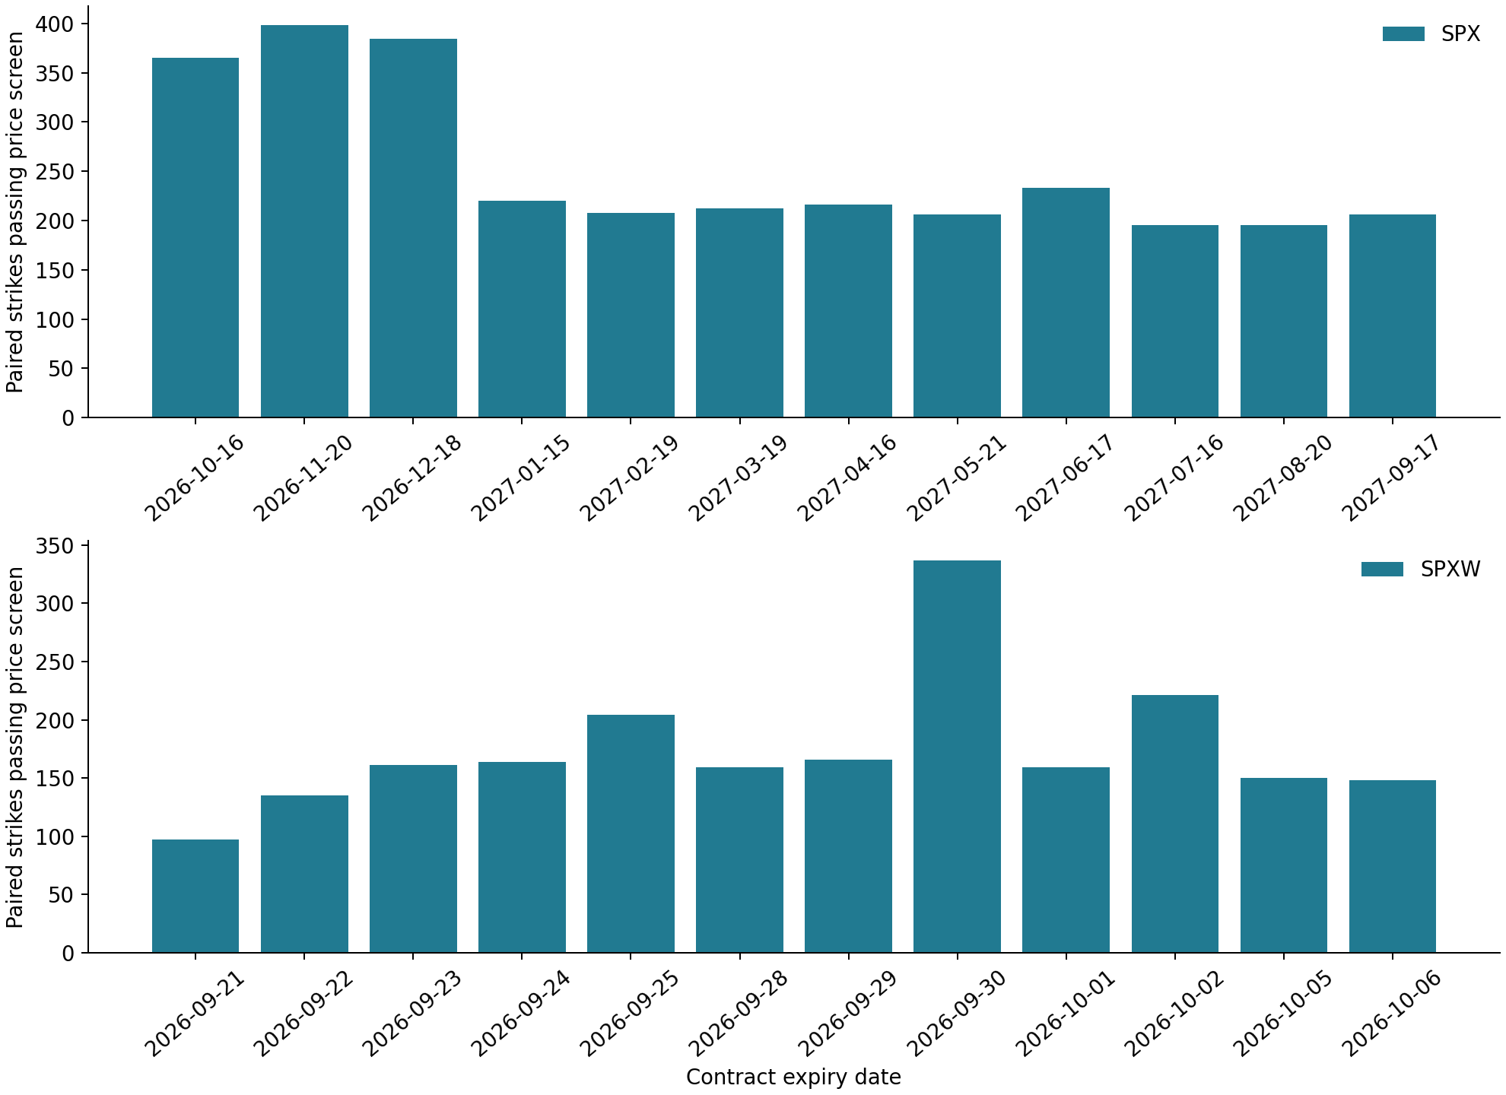
Figure 5. Number of strikes with both a call and a put passing the provisional 25% price screen, for the first twelve listed expiry dates within each root. The panels retain SPX and SPXW separately. Dates are contract expiry labels, not verified settlement horizons. Counts do not establish continuous strike coverage or quote usability.

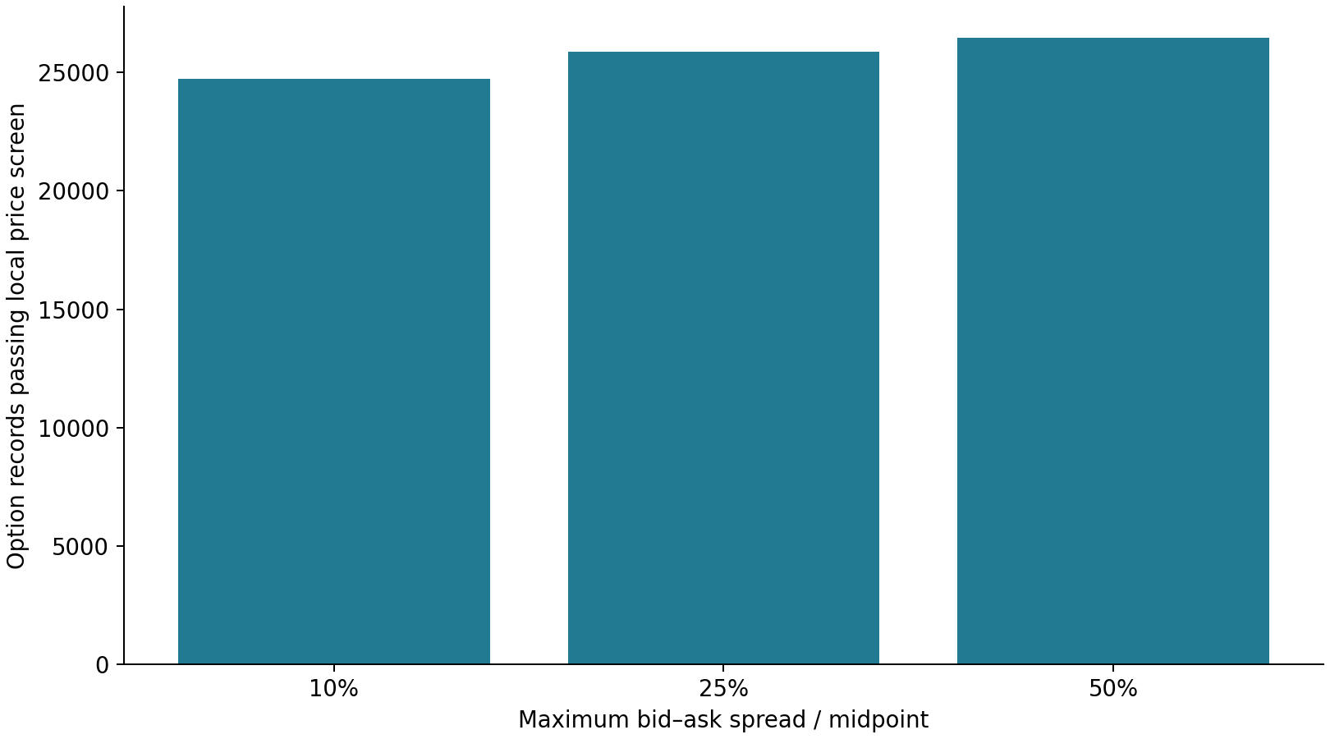
Figure 6. Records passing the local price screen when the maximum spread-to-midpoint ratio is set to 10%, 25% and 50%. Counts are 24,721, 25,866 and 26,475, respectively. These are candidate-data diagnostics; the observation-time and size limitations apply at every threshold.
As Aït-Sahalia and Lo explain in their state-price-density paper [10, §III.A], European put–call parity links prices at the same strike and maturity. Equation (7) states the relationship, and Equation (8) rearranges the opposite sides of the quoted spreads into an indicative forward interval conditional on the discount factor.
$$C\left(K,T\right)−P\left(K,T\right)=D\left(T\right) \left[F\left(T\right)−K\right], D\left(T\right)=e^{−rT}.$$
Equation 7. Discounted put–call parity.
$$K+\frac{C_{bid}−P_{ask}}{D\left(T\right)}≤F\left(T\right)≤K+\frac{C_{ask}−P_{bid}}{D\left(T\right)}.$$
Equation 8. Indicative forward interval from bid–ask quotes.
The interval requires matched contracts and compatible observation information. A provider specification cannot fill missing metadata in another payload. Table 4 identifies the required fields and the treatment at the initial audit stage. The later empirical adapter supplies a separate, explicit profile based on the information actually available.
Field | Meaning and treatment
Raw contract symbol | Preserved identifier; decoded root, expiry date, type and strike
Bid and ask | Index-point premiums; finite and ordered
Bid and ask sizes | Preserved in raw JSON; missing or nonpositive values flagged
Full quote observation datetime | Required before estimation; currently unresolved
Quote timezone | Required and explicit; currently unresolved
Settlement convention and datetime | Confirm for selected contracts before calculating maturity
Retrieval time and source | Provenance only; not substitutes for observation time
Discount factor and forward | Establish and document separately for each horizon
Table 4. Required fields and current treatment.

Representing a valid terminal distribution
As Aït-Sahalia and Duarte explain [9], imposing the shape restrictions of option valuation helps prevent inconsistent estimated price curves. The present implementation takes a direct probability approach. Interval $j$ has boundaries $a_{j},b_{j}$, width $Δs_{j}$ and centre $m_{j}$. A mass $w_{j}$ is uniformly distributed inside it, giving the histogram in Equation (9).
$${\hat{f}}_{Q}\left(s\right)=\sum_{j=1}^{J}{\frac{w_{j}}{Δs_{j}}} 1_{[a_{j},b_{j})}\left(s\right).$$
Equation 9. Piecewise-constant probability density.
The stepwise density is intentional and is zero outside its finite support. Following the mean–forward identity discussed by Bahra [1], the masses satisfy non-negativity, unit total mass and the supplied forward mean.
$$w_{j}≥0, \sum_{j=1}^{J}{w_{j}}=1, \sum_{j=1}^{J}{m_{j}}w_{j}=F\left(T\right).$$
Equation 10. Non-negativity, total-mass and forward constraints.
These are imposed conditions. Recovering a total mass of one or the supplied forward does not independently establish recovery accuracy. Integrating the positive-part payoff over each interval gives the exact bin-pricing map in Equation (11), a project discretisation of Equation (1).
CKi=j​Aijwj,Aij=DT2Δsjbj−Ki+2−aj−Ki+2.
Equation 11. Exact call valuation under interval probabilities.
Here ${\left(x\right)}_{+}=max\left(x,0\right)$ and $A_{ij}$ is a discounted payoff coefficient, not an ask quote. The map is linear in the unknown probabilities. It produces a decreasing, convex, continuously differentiable call curve that is quadratic within each bin; its strike slope lies between $−D$ and zero. Its second derivative recovers the histogram away from bin boundaries.

Fitting noisy calls with a smoothness penalty
Boyd and Vandenberghe explain in Convex Optimization that regularisation balances agreement with observations against a chosen complexity criterion [11, §6.3]. Equation (12) applies that principle to second differences of the forward-normalised density heights $g_{j}=w_{j}/\left(Δs_{j}/F\right)$.
minw 1Ni=1Nj​Aijwj−yiF2+λJ−2j=1J−2gj+2−2gj+1+gj2,subject to Equation (10).
Equation 12. Regularised constrained fitting objective.
The observations $y_{i}$ and price residuals are in index points before division by $F$. The parameter $λ$ controls the penalty. The precise normalisation is a project choice; in particular, equal numerical coefficients do not produce equal effective smoothing when the bin width changes. This issue is examined explicitly in Chapter 5.
As Boyd and Vandenberghe describe [11, §4.4], a convex quadratic objective with affine restrictions has a quadratic-programme formulation. The initial implementation uses sequential least-squares programming with an analytical gradient and independent residual checks. No negative masses are clipped and no fitted density is renormalised.

Single-maturity validation
The experiment uses 81 calls between $0.65F$ and $1.45F$, independent Gaussian errors with standard deviation 0.5 points and seed 2026, and 120 bins on $\left[0.3F,2.2F\right]$. This is a separate noise experiment from Figure 4. The baseline is $λ={10}^{−6}$, with ${10}^{−8}$ and ${10}^{−4}$ as sensitivity cases. Known prices at 80 interleaved strikes are excluded from fitting and used only for subsequent evaluation.
Check | Result | Interpretation
Total fitted probability mass | 1.0000000000 | Imposed by Equation (10)
Fitted mean | 6,075.470709 | Imposed forward consistency
Negative fitted interval masses | 0 | Enforced non-negativity
Negative raw finite-difference estimates | 18 of 79 | Failure of direct differentiation on these noisy prices
Fitted-price RMSE against noisy inputs | 0.437732 index points | Training-data discrepancy
Price RMSE at withheld clean strikes | 0.246113 index points | Synthetic interpolation accuracy
Integrated absolute density error on support | 0.030998 | Density discrepancy; not a pointwise percentage error
Sampled decreasing-price or convexity violations | 0 | Numerical check of theoretical shape properties
Table 5. Baseline constrained-fit diagnostics, using $λ={10}^{−6}$.
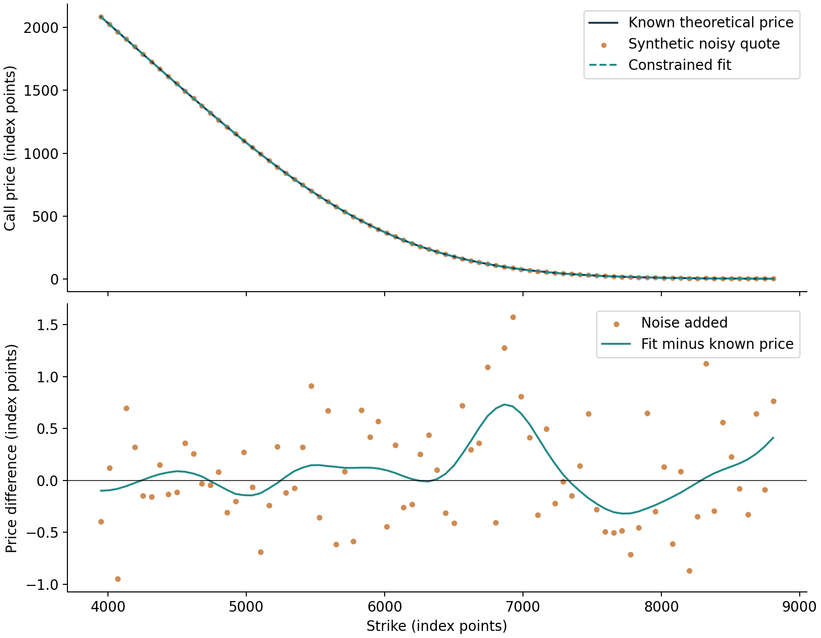
Figure 7. Synthetic call prices and the constrained fit for the baseline penalty. The upper panel shows prices; the lower panel compares the added price errors with the fitted price’s deviation from the known value. Prices are in index points, not currency per contract.
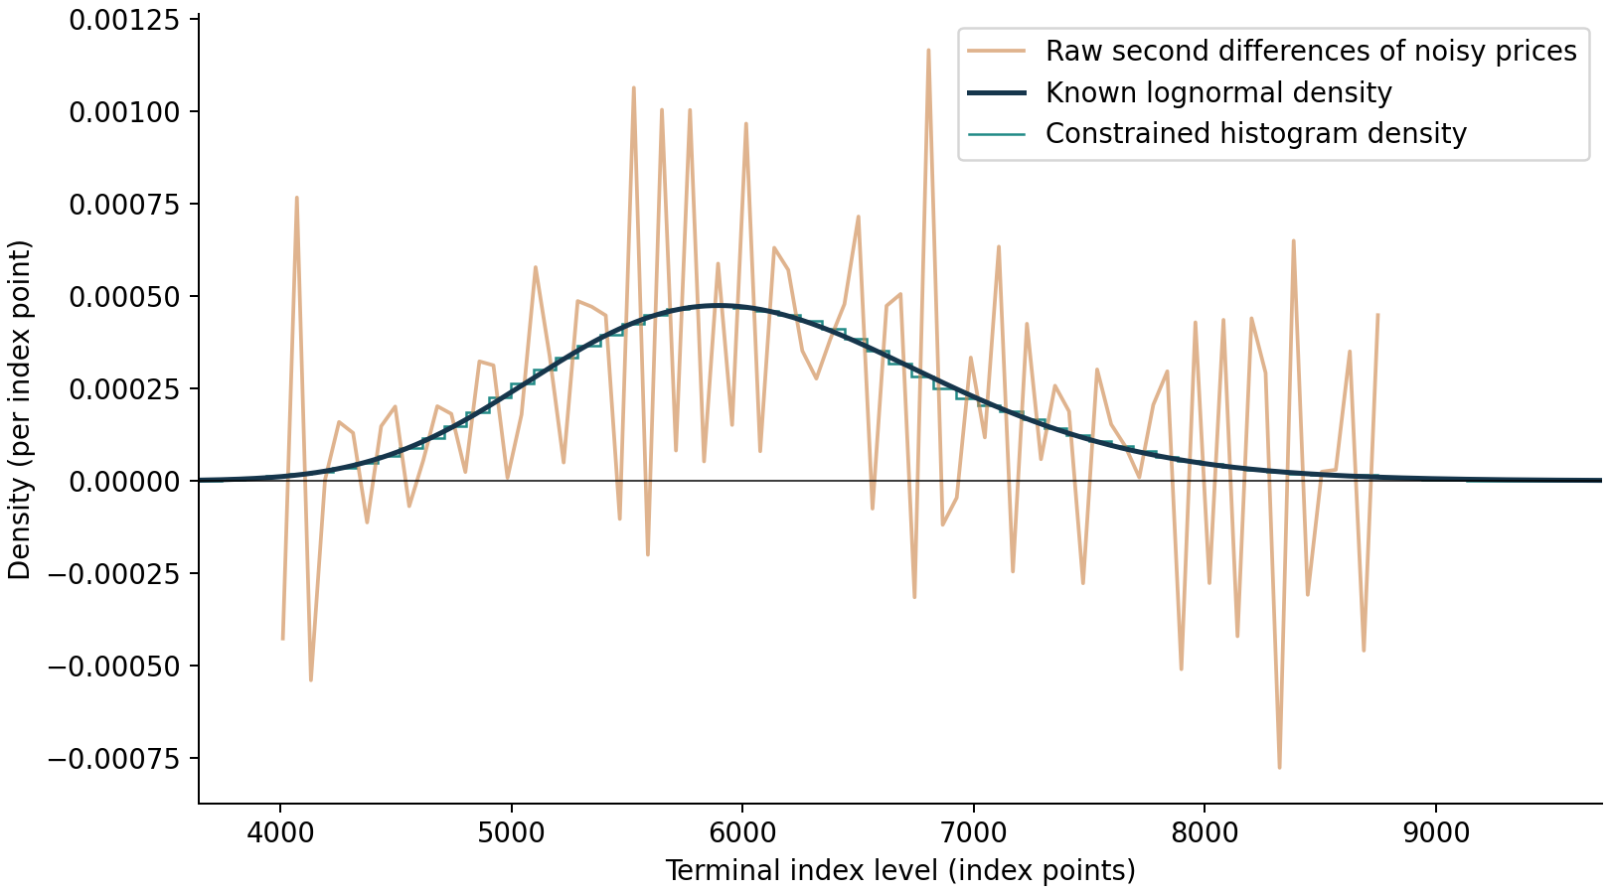
Figure 8. Known lognormal density, raw second differences of noisy call prices and the fitted histogram density. The display is cropped to $\left[0.6F,1.6F\right]$ for readability; fitting uses the wider support stated above. All inputs are synthetic.
The baseline achieves a withheld clean-price RMSE of 0.246113 points and integrated absolute density error of 0.030998 on the fitting support. Raw differentiation gives 18 negative estimates among 79 interior strikes, whereas the constrained masses remain nonnegative. This demonstrates the intended structural improvement within the chosen experiment. It does not establish an optimal penalty or resolve tail extrapolation.
Penalty | Noisy-input price RMSE | Withheld clean-price RMSE | Integrated absolute density error
${10}^{−8}$ | 0.392897 | 0.287372 | 0.108563
${10}^{−6}$ | 0.437732 | 0.246113 | 0.030998
${10}^{−4}$ | 0.458675 | 0.211071 | 0.025788
Table 6. Smoothing sensitivity in the synthetic experiment.
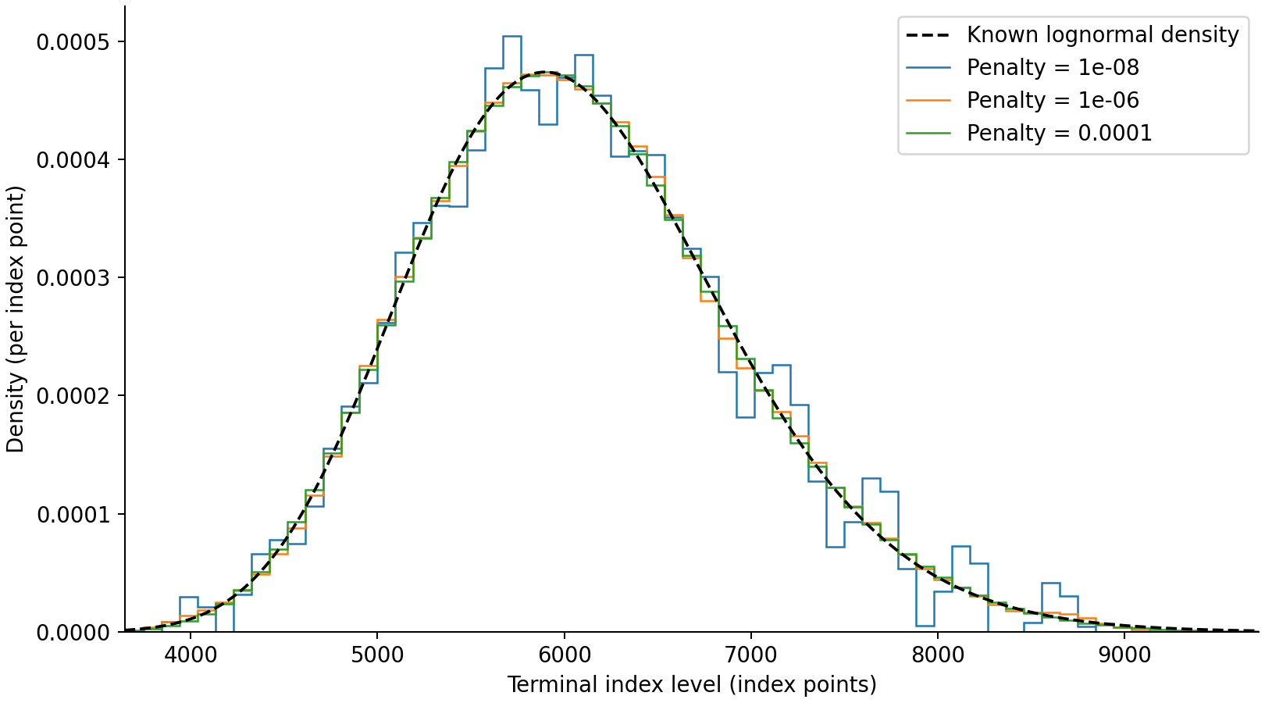
Figure 9. Histogram densities obtained with penalties ${10}^{−8}$, ${10}^{−6}$ and ${10}^{−4}$, with the same prices, interval grid and forward. The dashed curve is the known density. This comparison isolates the penalty setting within one noise realisation.
Changing the penalty alters both the price residuals and recovered shape. The analytical benchmark probability outside the chosen support is approximately $8.21×{10}^{−9}$, so truncation is negligible in this particular case. Broader distributions need an explicit outside-support accounting, developed in Chapter 5.

Consistency across maturity

Valid marginal densities can form an inconsistent family
The next experiment fits eight horizons: 30, 60, 90, 120, 180, 240, 300 and 365 days, each divided by 365 for valuation. Each horizon contains 81 strikes spanning $Fexp\left(±2.5σ\sqrt{T}\right)$, with linear spacing between the endpoints. The known volatility determines this synthetic design, not empirical strike selection. Bounded independent price errors are uniform on $\left[−0.5,0.5\right]$ points, with standard deviation approximately 0.288675 points. The seed at each horizon is 20260920 plus its day count.
As Gatheral and Jacquier explain in their calendar-arbitrage discussion [12, §2.1], normalised call values should be ordered across increasing maturities under the relevant martingale and carry assumptions. Retaining discounting explicitly gives Equation (13), with $κ=K/F\left(T\right)$.
$$\overline{C}\left(κ,T\right)=\frac{C\left(κF\left(T\right),T\right)}{D\left(T\right)F\left(T\right)}=E^{Q}​\left[{\left(\frac{S_{T}}{F\left(T\right)}−κ\right)}_{+}\right].$$
Equation 13. Forward-normalised call value.
Under the project’s deterministic-carry and proportional-dividend assumptions, the implemented ordering is Equation (14). It is checked within an observation snapshot, not between separate observation dates.
$$\overline{C}\left(κ,T_{i+1}\right)≥\overline{C}\left(κ,T_{i}\right), T_{i+1}>T_{i}.$$
Equation 14. Cross-maturity consistency at fixed forward moneyness.
The initial independent fits retain 120 normalised bins on $\left[0.3,2.2\right]$ and $λ={10}^{−6}$. Equation (15) defines their integrated absolute error on the fitting support. It is a project evaluation measure, not a claim that the estimator minimises density error.
$$L_{1}\left(T\right)=\int_{a_{1}\left(T\right)}^{b_{J}\left(T\right)}{\left|{\hat{f}}_{Q}\left(s;T\right)−f_{Q}\left(s;T\right)\right|} ds.$$
Equation 15. Integrated absolute density error on fitting support.
Horizon (days) | Withheld clean-price RMSE | Density $L_{1}$ on support | Known probability outside support
30 | 0.127809 | 0.058293 | $1.6893×{10}^{−43}$
60 | 0.109230 | 0.042719 | $8.0373×{10}^{−23}$
90 | 0.131872 | 0.036594 | $6.8132×{10}^{−16}$
120 | 0.096013 | 0.030898 | $2.0625×{10}^{−12}$
180 | 0.083350 | 0.027398 | $6.5773×{10}^{−9}$
240 | 0.149516 | 0.026950 | $3.8505×{10}^{−7}$
300 | 0.105392 | 0.025826 | $4.5167×{10}^{−6}$
365 | 0.137777 | 0.032580 | $2.6468×{10}^{−5}$
Table 7. Synthetic validation by expiry horizon. RMSE is measured in index points; $L_{1}$ and probability mass are dimensionless.
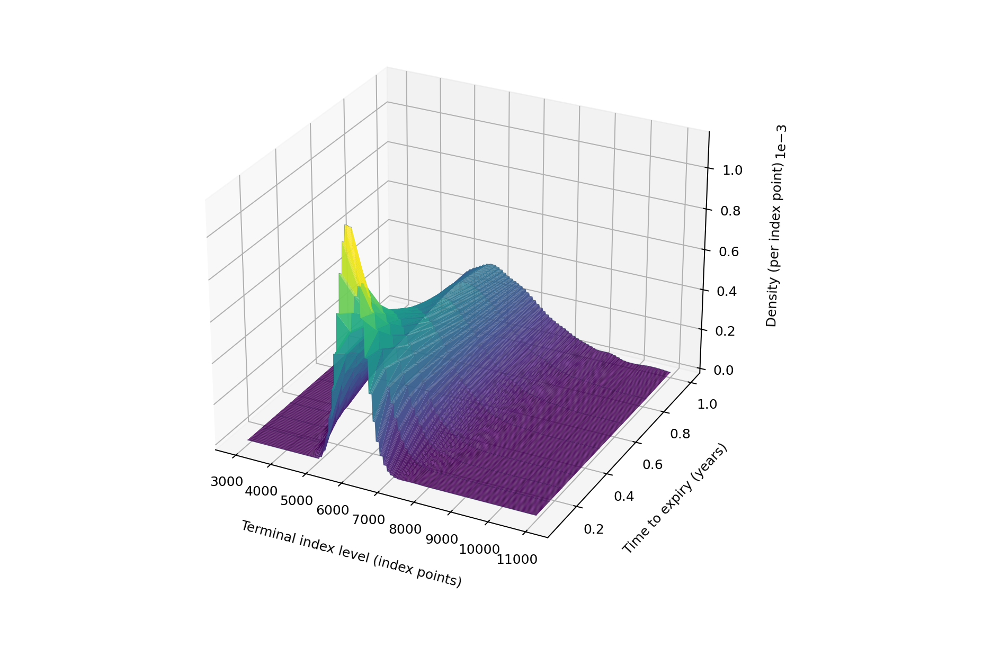
Figure 10. Constrained synthetic densities at eight horizons from 30 to 365 days, displayed over terminal levels 3,000–11,000. The sheet joins sampled values for visual orientation; it is not a fitted interpolation model between maturities. Density is measured per index point. The interactive companion adds rotation, zoom, hover values and maturity selection.

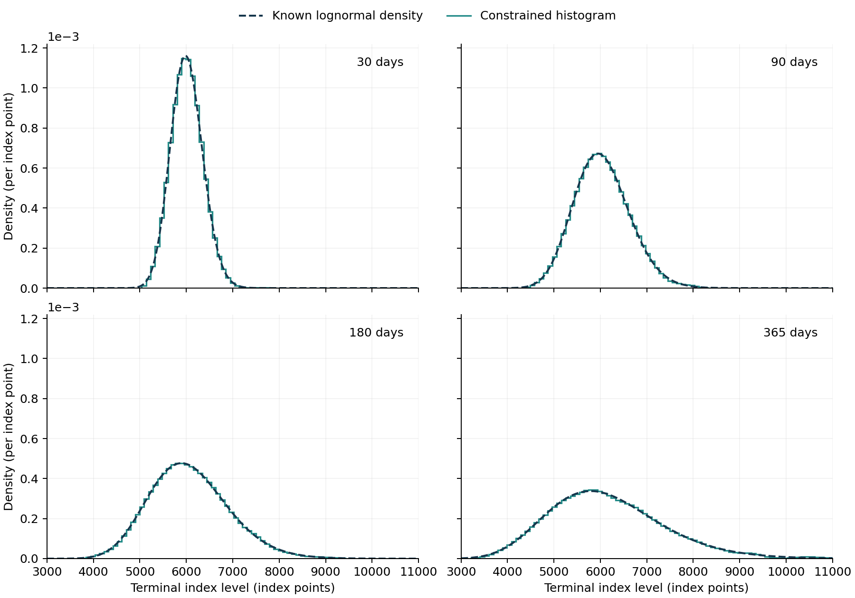
Figure 11. Known lognormal densities and fitted histogram slices at 30, 90, 180 and 365 days. All panels use the same axes. The stepwise density is the actual interval representation, without display smoothing. The interactive companion permits selection of all eight fitted horizons.

The visual surface connects the fitted maturity slices for viewing. It is not an estimated continuous-time model. All individual distributions satisfy their probability restrictions, yet 2,762 of 13,307 sampled calendar comparisons fail at the stated tolerance. The worst normalised gap is approximately $−1.90808×{10}^{−4}$. None of the 4,267 comparisons inside both adjacent quote ranges fail; the difficulty is concentrated where prices are extrapolated.
Horizons (days) | Violations across full grid | Minimum normalised change | Violations within shared quote range
30 → 60 | 0 | $−4.44×{10}^{−16}$ | 0
60 → 90 | 723 | $−5.42381×{10}^{−5}$ | 0
90 → 120 | 393 | $−3.59782×{10}^{−5}$ | 0
120 → 180 | 823 | $−8.97400×{10}^{−5}$ | 0
180 → 240 | 0 | 0 | 0
240 → 300 | 309 | $−6.68342×{10}^{−5}$ | 0
300 → 365 | 514 | $−1.90808×{10}^{−4}$ | 0
Table 8. Adjacent-maturity calendar diagnostic on the finite grid in Equation (14). The minimum change is in normalised, dimensionless call value.

A joint programme in common coordinates
To link the maturities, define $x=s/F_{m}$ and common bin edges $u_{j}$, width $Δu$ and centres ${\overset{‾}{u}}_{j}$. Equation (16) relates the normalised and physical densities. A common coordinate system allows adjacent maturities to be compared at the same forward moneyness.
$$\begin{matrix}{\hat{g}}_{m}\left(x\right)=\sum_{j=1}^{J}{\frac{w_{mj}}{Δu}}1_{[u_{j−1},u_{j})}\left(x\right), \\ {\hat{f}}_{Q}\left(s;T_{m}\right)=\frac{1}{F_{m}}{\hat{g}}_{m}\left(\frac{s}{F_{m}}\right).\end{matrix}$$
Equation 16. Common forward-coordinate density and physical density.
Equation (17) minimises the sum of the per-maturity objectives while imposing the mass, mean and calendar restrictions jointly. The payoff row $B\left(κ\right)$ is the exact uniform-bin normalised call map, and $K_{m}$ initially contains the internal bin boundaries. The quadratic-programme framework follows Boyd and Vandenberghe [11]; the calendar motivation follows Gatheral and Jacquier [12].
$$\begin{matrix}\min_{w_{1},…,w_{M}} \sum_{m=1}^{M}{ℓ_{m}}\left(w_{m}\right) \\ \text{subject to} w_{mj}≥0, 1^{⊤}w_{m}=1, {\overset{‾}{u}}^{⊤}w_{m}=1, \\ B\left(κ\right)\left(w_{m+1}−w_{m}\right)≥0, \\ κ∈K_{m}, m=1,…,M−1.\end{matrix}$$
Equation 17. Joint quadratic programme with calendar constraints.
An independent fit with the same OSQP solver provides a control for the change of optimisation software. As Stellato and colleagues explain in their OSQP paper [13], the method uses residual-based stopping criteria. The project additionally checks the returned probabilities and full interval calendar gaps. Numerical status alone is insufficient.

Checking between the constraint locations
A coarse grid can miss a negative gap between checked locations. For adjacent maturities, let $δ_{mj}=w_{m+1,j}−w_{mj}$. Exact bin integration makes the later-minus-earlier normalised call gap quadratic within each bin, as Equation (18) shows.
$$\begin{matrix}Δ_{m}\left(u_{j−1}+z\right)=Δ_{m}\left(u_{j−1}\right)−z\sum_{ℓ=j}^{J}{δ_{mℓ}}+\frac{δ_{mj}}{2Δu}z^{2}, \\ 0≤z≤Δu.\end{matrix}$$
Equation 18. Within-bin quadratic calendar gap.
Endpoints are always checked. Where the quadratic is convex and its stationary point lies inside the bin, Equation (19) supplies the additional eligible minimum.
$$z_{mj}^{*}=Δu \frac{\sum_{ℓ=j}^{J}{δ_{mℓ}}}{δ_{mj}}, δ_{mj}>0, 0<z_{mj}^{*}<Δu.$$
Equation 19. Interior calendar-gap minimum.
These are project derivations from the uniform-bin payoff, rather than formulae taken from the SVI parameterisation in [12]. Violating interior minima are added as constraint locations and the programme is solved again. A deliberately constructed mean-one counterexample passed boundary checks but reached a gap of $−0.009375$ at $κ=0.875$, independently demonstrating why the interval check is needed.

Results of joint fitting
The baseline joint problem has 960 masses. Its initial 833 calendar rows grow to 858 after five refinement rounds. The boundary-only solution reaches an interval minimum of approximately $−3.14×{10}^{−7}$; refinement improves it to $−8.56×{10}^{−10}$, inside the ${10}^{−8}$ reporting tolerance and the ${10}^{−9}$ refinement target.

Fit | Grid violations | Minimum calendar gap | Pooled withheld-price RMSE | Mean density $L_{1}$
Saved independent SLSQP | 2,762 | $−1.90808×{10}^{−4}$ | 0.119513 | 0.035157
Independent OSQP control | 2,763 | $−1.90836×{10}^{−4}$ | 0.119513 | 0.035158
Joint OSQP | 0 | $−8.56105×{10}^{−10}$ | 0.119153 | 0.035162
Table 9. Calendar consistency and recovery accuracy across the three fitting cases. Grid counts use 13,307 adjacent-pair comparisons and tolerance ${10}^{−8}$. The minimum gap comes from the interval-level check. Price RMSE is in index points; gap and density $L_{1}$ are dimensionless.

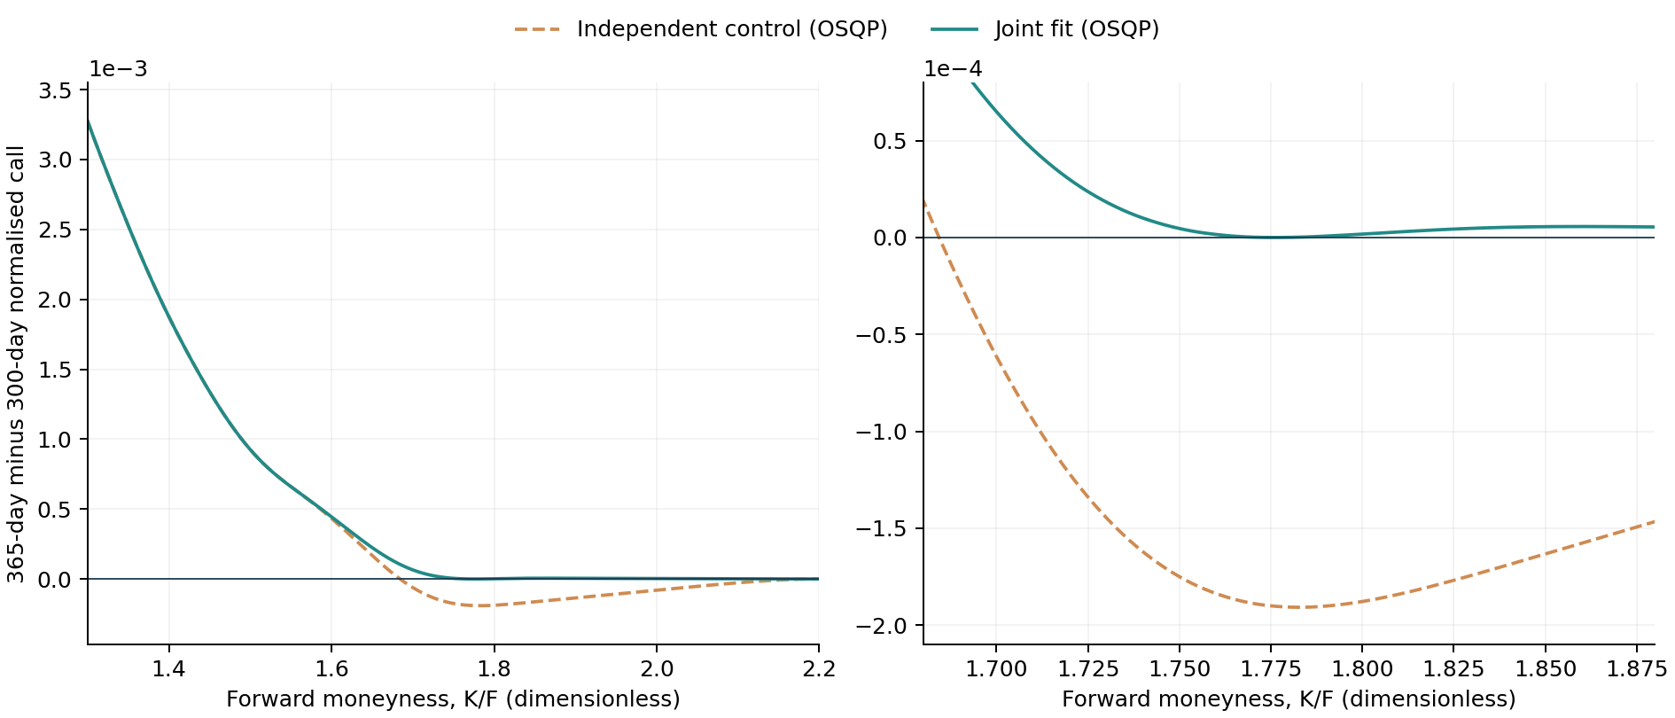
Figure 12. Difference between 365-day and 300-day forward-normalised call values under the independent control and joint fit. The left panel shows the upper-strike wing; the right panel enlarges the interval containing the control’s deepest decrease. A negative value violates the required maturity ordering when its magnitude exceeds the stated tolerance. Values are dimensionless.

The same-solver independent control has 2,763 sampled violations and the joint fit has zero. Withheld clean-price RMSE changes only from 0.119513 to 0.119153 points. Mean density error changes from 0.035158 to 0.035162, a slight deterioration. The regularised objective increases by approximately 0.03994%, as expected when adding restrictions. The extra independent-control violation relative to the earlier count reflects a numerical threshold difference, not new observations.
Horizon (days) | Control RMSE | Joint RMSE | Control density $L_{1}$ | Joint density $L_{1}$
30 | 0.127807 | 0.127248 | 0.058292 | 0.058580
60 | 0.109230 | 0.108049 | 0.042718 | 0.043281
90 | 0.131872 | 0.131690 | 0.036594 | 0.037064
120 | 0.096014 | 0.095934 | 0.030899 | 0.031052
180 | 0.083350 | 0.083266 | 0.027399 | 0.027311
240 | 0.149516 | 0.148945 | 0.026954 | 0.026008
300 | 0.105392 | 0.105271 | 0.025824 | 0.025642
365 | 0.137777 | 0.137723 | 0.032580 | 0.032363
Table 10. Recovery accuracy by synthetic horizon. RMSE compares against withheld clean prices; the density error is Equation (15) on the finite support.

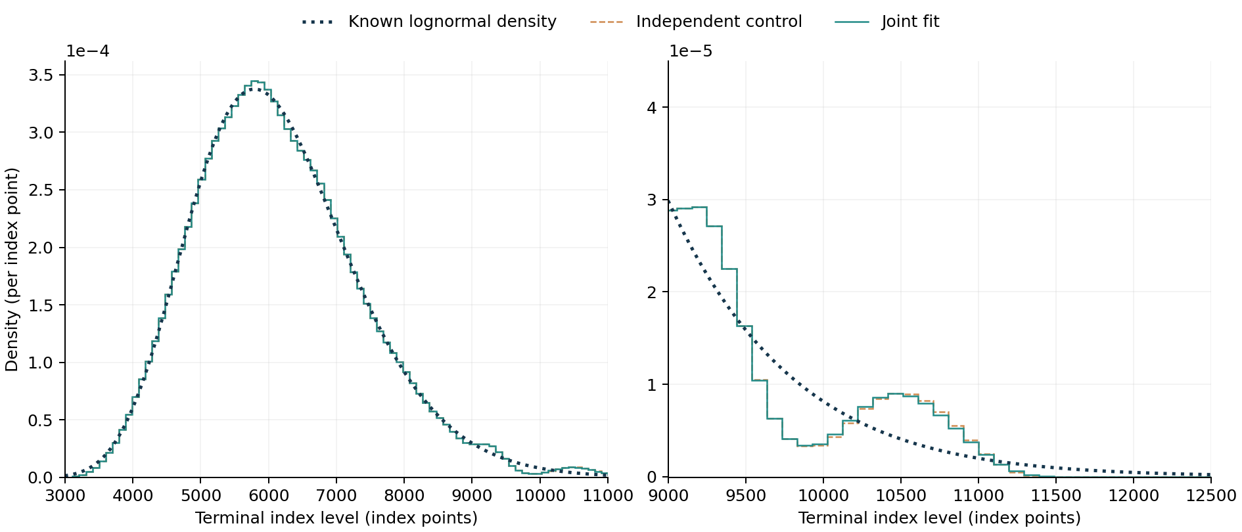
Figure 13. Known density, independent control and joint fit at 365 days. The main panel covers terminal levels 3,000–11,000; the second panel enlarges the right tail over 9,000–12,500. Fitted curves show the actual histogram steps. Density is measured per index point.

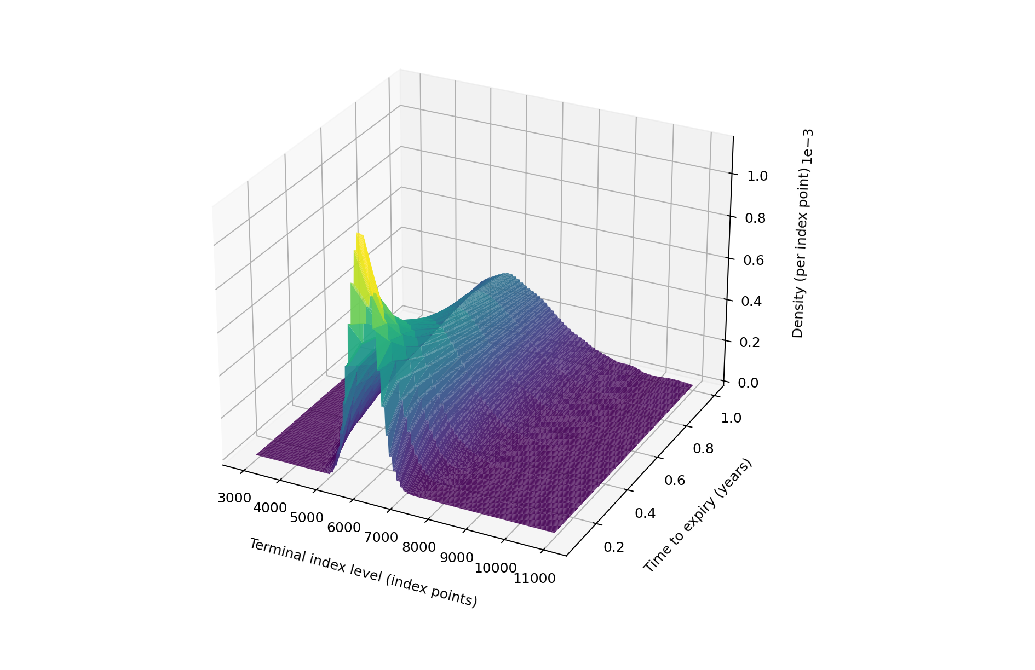
Figure 14. Jointly fitted synthetic risk-neutral densities at eight horizons. The axes are terminal index level, expiry horizon in years and density per index point. Connecting facets are graphical joins only; they do not establish an estimated or calendar-consistent distribution at an intermediate maturity.
The joint fit resolves the stated calendar inconsistency but retains a tail bump beyond the largest one-year quoted strike, approximately 10,143 points. This is the motivation for the subsequent sensitivity analysis. The maximum mass and normalised-mean residuals are $8.44×{10}^{−15}$ and $5.11×{10}^{−15}$; a minimum signed mass of approximately $−1.57×{10}^{−12}$ is retained as a numerical residual. The accepted OSQP result is not described as polished, because polishing was not accepted.

Robustness and repeated synthetic evaluation

Extending the benchmark and making smoothing comparable
As Bahra discusses in his treatment of mixture distributions [1, §§3.5–3.6], a weighted mixture provides a more flexible terminal distribution than a single lognormal component. The second benchmark uses component weights 0.75 and 0.25, volatilities 14% and 40%, and a common component mean equal to the forward. Equation (20) states the corresponding mixture density and weighted call values. These parameters are declared synthetic choices.
$$\begin{matrix}g_{mix}\left(x,T\right)=\sum_{ℓ=1}^{L}{π_{ℓ}}g_{LN}\left(x,T;σ_{ℓ}\right), \\ C_{mix}\left(K,T\right)=\sum_{ℓ=1}^{L}{π_{ℓ}}C_{BS}\left(K,T;σ_{ℓ}\right), \\ \sum_{ℓ=1}^{L}{π_{ℓ}}=1.\end{matrix}$$
Equation 20. Lognormal-mixture density and weighted option prices.
The sensitivity study varies support, bin count and smoothing across seven settings for each benchmark. Changing bin width also changes the action of an unscaled second-difference penalty. Applying the stencil discussed by Driscoll and Braun [7] motivates the grid-scaled roughness in Equation (21).
$$\begin{matrix}R_{Δu}\left(g\right)=Δu\sum_{j=1}^{J−2}{{\left(\frac{g_{j+2}−2g_{j+1}+g_{j}}{{\left(Δu\right)}^{2}}\right)}^{2}} \\ =\frac{1}{{\left(Δu\right)}^{3}}\sum_{j=1}^{J−2}{{\left(g_{j+2}−2g_{j+1}+g_{j}\right)}^{2}}.\end{matrix}$$
Equation 21. Grid-scaled discrete density roughness.
Equating this penalty with the convention in Equation (12) gives Equation (22). The baseline $α_{0}$ reproduces $λ={10}^{−6}$ on the original 120-bin grid. Thus changing resolution is not inadvertently treated as a simultaneous arbitrary change in smoothing strength.
$$λ\left(J,Δu;α\right)=α\frac{J−2}{{\left(Δu\right)}^{3}}, α_{0}={10}^{−6}\frac{{\left(1.9/120\right)}^{3}}{118}.$$
Equation 22. Equivalent smoothing coefficient across grids.
Setting | Support | Bins | Roughness multiple | Lambda
Baseline | [0.300000, 2.200000] | 120 | 1 | 1e-06
80 bins | [0.300000, 2.200000] | 80 | 1 | 1.958569e-07
160 bins | [0.300000, 2.200000] | 160 | 1 | 3.173886e-06
Smoothing / 10 | [0.300000, 2.200000] | 120 | 0.1 | 1e-07
Smoothing x 10 | [0.300000, 2.200000] | 120 | 10 | 1e-05
Narrow support | [0.458333, 1.883333] | 90 | 1 | 7.457627e-07
Wide support | [0.110000, 2.580000] | 156 | 1 | 1.305085e-06
Table 11. Declared sensitivity settings. Support is in forward-normalised terminal levels; lambda is the coefficient passed to Equation (12).
The narrower and wider supports use nested edges with the same bin width as the baseline. The settings are a declared sensitivity study, not parameters optimised against the known density. The finite fitted support remains a substantive restriction even when its edge selection is numerically convenient.

Measuring density and tail errors
Because the fitted density is zero outside its support, evaluating only the central integral would omit a known source of error. Equation (23) extends the density measure to the full positive domain by adding the benchmark probability outside the fitted range.
$$\begin{matrix}L_{1}^{full}\left(T\right)=\int_{u_{0}}^{u_{J}}{\left|\hat{g}\left(x,T\right)−g\left(x,T\right)\right|} dx \\ +Q\left(X_{T}<u_{0}\right)+Q\left(X_{T}>u_{J}\right), \\ X_{T}=S_{T}/F\left(T\right).\end{matrix}$$
Equation 23. Full-domain density error including omitted tails.
Following Malz’s discussion of threshold-based summaries and extrapolation [14], Equation (24) defines three risk-neutral events. The thresholds are project choices in forward coordinates, not calibrated statements about economically exceptional moves.
$$\begin{matrix}p_{0.8}^{−}\left(T\right)=Q\left(S_{T}<0.8F\left(T\right)\right), \\ p_{1.2}^{+}\left(T\right)=Q\left(S_{T}>1.2F\left(T\right)\right), \\ p_{1.8}^{+}\left(T\right)=Q\left(S_{T}>1.8F\left(T\right)\right).\end{matrix}$$
Equation 24. Risk-neutral tail probabilities at stated forward thresholds.
Equation (25) gives exact histogram variance and the corresponding known mixture variance. These are variances of the normalised terminal level, not annualised implied volatilities. In the fitted case $\hat{μ}$ is its normalised mean.
$$\begin{matrix}\hat{V}\left(T\right)=\sum_{j=1}^{J}{w_{j}}\frac{u_{j−1}^{2}+u_{j−1}u_{j}+u_{j}^{2}}{3}−{\hat{μ}}^{2}, \\ V_{known}\left(T\right)=\sum_{ℓ=1}^{L}{π_{ℓ}}\left(e^{σ_{ℓ}^{2}T}−1\right).\end{matrix}$$
Equation 25. Normalised terminal-level variance for histograms and mixtures.

Benchmark | Setting | Withheld-price RMSE (points) | Mean full-domain density $L_{1}$ | Calendar check
Single lognormal | Baseline | 0.119153 | 0.035165 | Pass
Single lognormal | 80 bins | 0.119451 | 0.048880 | Pass
Single lognormal | 160 bins | 0.119123 | 0.028548 | Pass
Single lognormal | Smoothing / 10 | 0.123455 | 0.042368 | Pass
Single lognormal | Smoothing x 10 | 0.204097 | 0.034196 | Pass
Single lognormal | Narrow support | 0.119134 | 0.035164 | Pass
Single lognormal | Wide support | 0.119154 | 0.035111 | Pass
Two-lognormal mixture | Baseline | 0.162515 | 0.053741 | Pass
Two-lognormal mixture | 80 bins | 0.159930 | 0.069154 | Pass
Two-lognormal mixture | 160 bins | 0.163632 | 0.046317 | Pass
Two-lognormal mixture | Smoothing / 10 | 0.124574 | 0.064150 | Pass
Two-lognormal mixture | Smoothing x 10 | 0.527565 | 0.061080 | Pass
Two-lognormal mixture | Narrow support | 0.218804 | 0.068692 | Pass
Two-lognormal mixture | Wide support | 0.162515 | 0.052483 | Pass
Table 12. Recovery accuracy across all eight fitted horizons. Each calendar entry refers to the interval-level check at tolerance ${10}^{−8}$. Density error includes benchmark probability outside the chosen support.

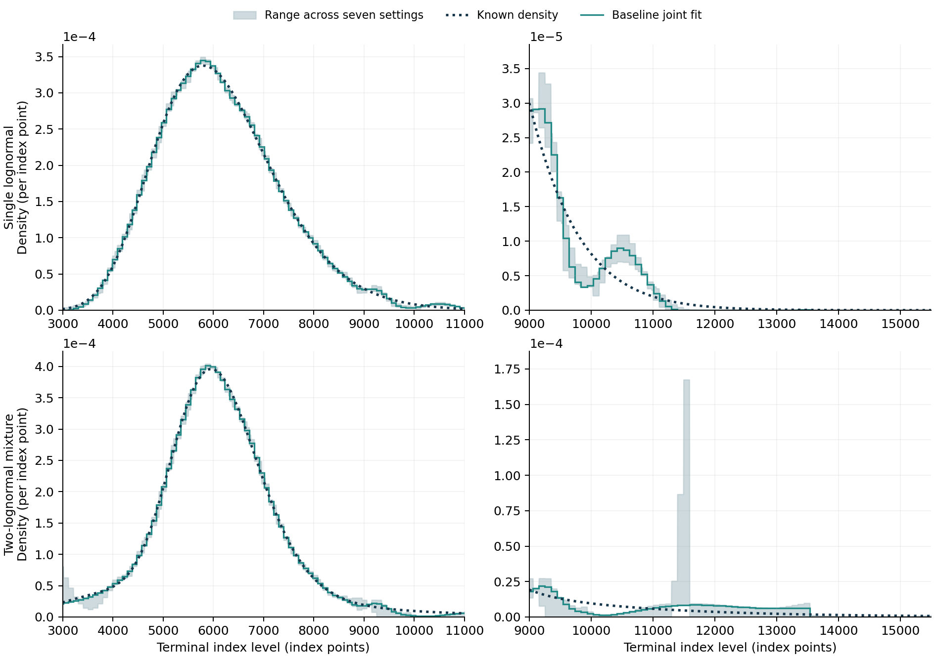
Figure 15. Known and baseline fitted densities at 365 days, with the pointwise range across all seven settings shaded. The upper row is the single-lognormal benchmark and the lower row is the two-lognormal mixture. Left panels show the central distribution; right panels enlarge the upper tail. Density is per index point. The shaded envelope is sampled for display and is not a probability density or a confidence band.

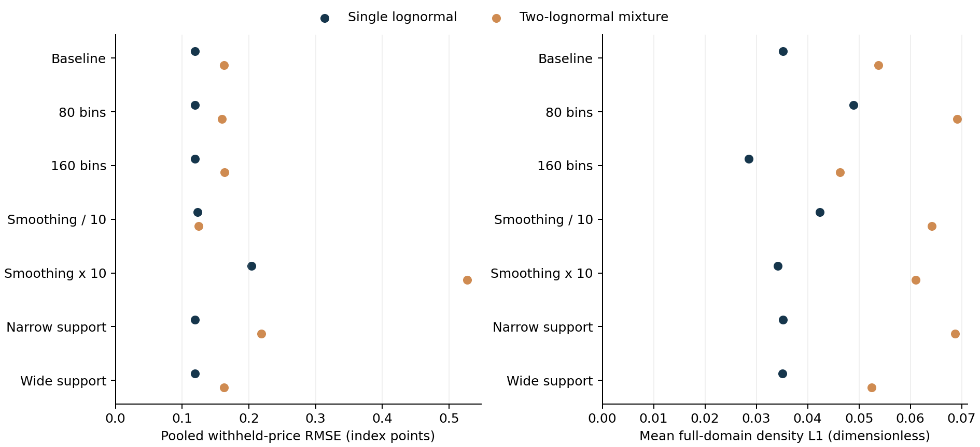
Figure 16. Pooled withheld clean-price RMSE and mean full-domain density error across the seven settings. Each point summarises all eight horizons for one benchmark. RMSE is in index points; integrated density error is dimensionless. The two horizontal axes represent different measures and should not be compared numerically to one another.

For the single lognormal, moving from 80 to 160 bins changes withheld price RMSE only from 0.119451 to 0.119123 points, while density error changes from 0.048880 to 0.028548. Similar price agreement therefore conceals a noticeable difference in the recovered density. At one year, the known mixture probability omitted by the narrow support is 1.9339%, compared with 0.1273% for the wider support.
Benchmark | Quantity | Known value | Minimum fitted | Maximum fitted
Single lognormal | P(S < 0.8F), % | 15.488190 | 15.479921 | 15.542850
Single lognormal | P(S > 1.2F), % | 15.586281 | 15.541113 | 15.550680
Single lognormal | P(S > 1.8F), % | 0.118709 | 0.010066 | 0.058278
Single lognormal | Var(S/F) | 0.040811 | 0.040748 | 0.040811
Two-lognormal mixture | P(S < 0.8F), % | 13.788289 | 13.782732 | 13.848692
Two-lognormal mixture | P(S > 1.2F), % | 12.773293 | 12.725272 | 12.737735
Two-lognormal mixture | P(S > 1.8F), % | 1.188550 | 1.745535 | 2.720848
Two-lognormal mixture | Var(S/F) | 0.058223 | 0.054783 | 0.056258
Table 13. Known values and fitted ranges at 365 days across the seven declared settings. Probabilities are percentages; normalised variance is dimensionless. Ranges are sensitivity summaries, not confidence intervals.

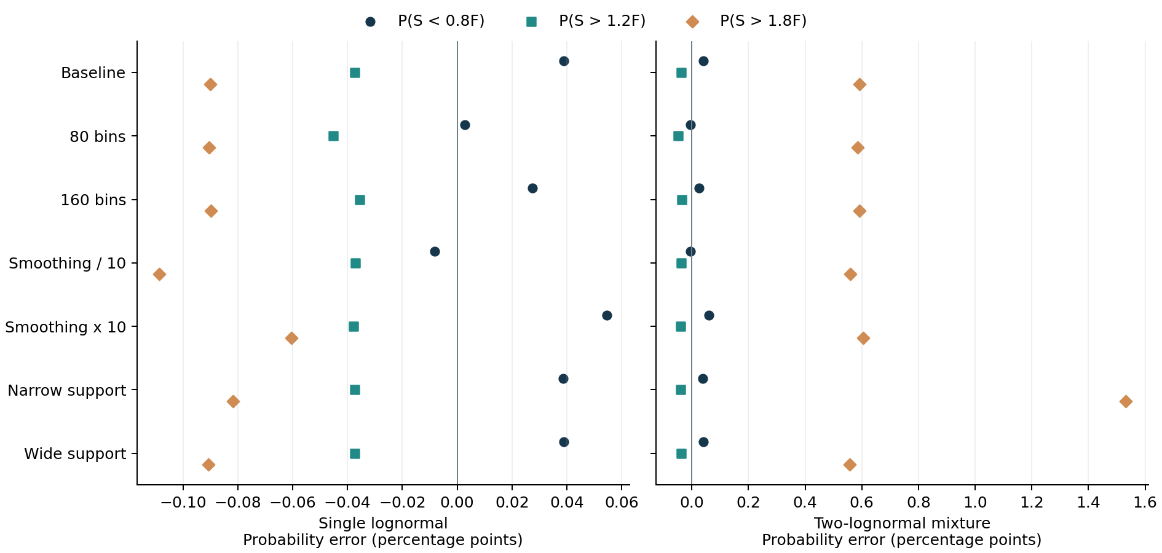
Figure 17. Fitted minus known probabilities at 365 days for the three events in Equation (24). Errors are measured in percentage points; the vertical zero line indicates agreement with the benchmark. Each panel contains the same seven modelling choices. A one-percentage-point error is an absolute probability difference of 0.01, not a 1% relative error.

The known probability above $1.8F$ is 0.118709% for the single lognormal, while the seven fitted values range from 0.010066% to 0.058278%. For the mixture, the corresponding truth is 1.188550% and fitted values range from 1.745535% to 2.720848%. All fourteen joint fits pass their structural checks. The ranges are sensitivity summaries, not confidence intervals, and their common bias shows why apparent stability alone is insufficient.
The broader benchmark also exposed a solver limitation. OSQP reached its strict iteration limit; increasing the allowance from 100,000 to 300,000 and trying objective scaling did not establish an acceptable solution. An algebraically equivalent formulation retained explicit price and roughness residual variables and used Clarabel. As Goulart and Chen describe [15], that solver supports conic programmes with quadratic objectives. Controlled cross-solver checks preceded its use in the sensitivity batch. The accepted fourteen fits retain their original tolerances and independently checked constraints.

Separating noise from missing strike information
As Morris, White and Crowther explain in Using simulation studies to evaluate statistical methods, the experiment design and uncertainty of its reported summaries require explicit treatment [16]. A repeated study therefore compares four nested quote patterns: Original 81, Sparse 41 across the original span, Central 41 within a narrower span, and Extended 121 with twenty additional strikes at each side. Comparing the two 41-strike patterns isolates a coverage difference while holding the count fixed.

Pattern | Quotes per horizon | Minimum K/F | Maximum K/F | 0.8F inside? | 1.2F inside? | 1.8F inside?
Original 81 | 81 | 0.6065 | 1.6487 | Yes | Yes | No
Sparse 41 | 41 | 0.6065 | 1.6487 | Yes | Yes | No
Central 41 | 41 | 0.8671 | 1.3882 | No | Yes | No
Extended 121 | 121 | 0.3460 | 1.9093 | Yes | Yes | Yes
Table 14. Quote patterns at 365 days. The same nested construction is used at every horizon. The fitting support remains [0.3, 2.2] in forward coordinates. Threshold entries indicate whether that strike is inside the quoted span.

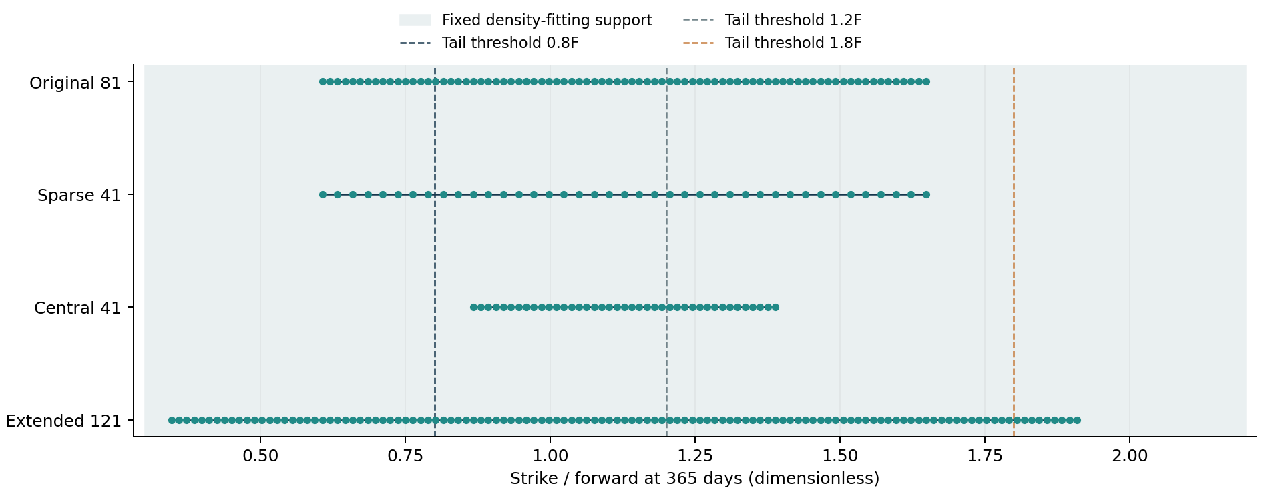
Figure 18. The four quote patterns at 365 days, expressed as strike divided by forward. Points identify actual supplied strikes. The shaded interval is the common density-fitting support, and dashed lines identify the three probability thresholds. The corresponding strike ranges change with horizon; the plotting example does not imply that 1.8F is quoted at every maturity.

Each benchmark, pattern and error amplitude uses fifty repetitions. Equation (26) supplies bounded independent quote perturbations with amplitude limits of 0.1 and 0.5 points. The minimum with half the clean call price keeps supplied prices positive on the extended grid. Its amplitude is a half-width, not a standard deviation.
$$\begin{matrix}y_{νmi}\left(a\right)=C_{mi}+η_{mi}\left(a\right)U_{νmi}, \\ η_{mi}\left(a\right)=min\{a,C_{mi}/2\}, U_{νmi}∼U\left[−1,1\right].\end{matrix}$$
Equation 26. Paired bounded synthetic quote perturbations.
The errors have conditional mean zero and variance $η_{mi}^{2}/3$, but do not preserve every arbitrage inequality. This is a deliberately idealised synthetic mechanism, not an empirical bid–ask noise model. Shared PCG64 child streams pair the master-strike errors across comparable designs; their states are retained for replay. Eight clean-input controls distinguish limitations that exist without price perturbations.
The common validation grid has 120 arithmetic master-strike midpoints per maturity, giving 960 known prices never supplied to a fit. Results distinguish points inside and outside the observed range. Empty outside-range subsets are reported as unavailable, rather than assigned zero error. Equations (27)–(29) define the simulation summaries, Monte Carlo standard error of a mean and precision of a paired contrast, following the framework discussed by Morris and colleagues [16].
$$\begin{matrix}\overline{θ}=\frac{1}{n_{sim}}\sum_{ν=1}^{n_{sim}}{{\hat{θ}}_{ν}}, \hat{Bias}=\overline{θ}−θ, \\ s_{θ}^{2}=\frac{1}{n_{sim}−1}\sum_{ν=1}^{n_{sim}}{{\left({\hat{θ}}_{ν}−\overline{θ}\right)}^{2}}, \\ {RMSE}_{θ}^{2}=\frac{1}{n_{sim}}\sum_{ν=1}^{n_{sim}}{{\left({\hat{θ}}_{ν}−θ\right)}^{2}} \\ ={\hat{Bias}}^{2}+\frac{n_{sim}−1}{n_{sim}}s_{θ}^{2}.\end{matrix}$$
Equation 27. Simulation bias, empirical variance and finite-sample MSE decomposition.
$$MCSE\left(\overline{z}\right)=\frac{s_{z}}{\sqrt{n_{sim}}}.$$
Equation 28. Monte Carlo standard error of a mean.
$$\begin{matrix}\overline{Δ}=\frac{1}{n_{sim}}\sum_{ν=1}^{n_{sim}}{Δ_{ν}}, \\ MCSE\left(\overline{Δ}\right)=\sqrt{\frac{\sum_{ν=1}^{n_{sim}}{{\left(Δ_{ν}−\overline{Δ}\right)}^{2}}}{n_{sim}\left(n_{sim}−1\right)}}.\end{matrix}$$
Equation 29. Mean paired contrast and its Monte Carlo standard error.
The $n_{sim}−1$ variance denominator explains the finite-sample factor in Equation (27). The spread of individual estimates is different from the MCSE of their mean. Neither is an empirical confidence interval for an SPX density. Paired differences use within-repetition contrasts before estimating their standard error.

Results across repeated quote realisations
Table 15 reports the complete repeated comparison, with one MCSE alongside each mean. Figure 19 separates price and density performance so that a favourable value of one does not conceal a poor value of the other.

Benchmark | Error limit a (points) | Quote pattern | Mean density L1 (MCSE) | Mean price RMSE (MCSE)
Single lognormal | 0.1 | Original 81 | 0.0307 (4.2e-05) | 0.1146 (0.0036)
Single lognormal | 0.1 | Sparse 41 | 0.0311 (4.6e-05) | 0.1238 (0.0041)
Single lognormal | 0.1 | Central 41 | 0.0364 (0.0001) | 1.0844 (0.0150)
Single lognormal | 0.1 | Extended 121 | 0.0298 (1e-05) | 0.0374 (0.0002)
Single lognormal | 0.5 | Original 81 | 0.0357 (0.0001) | 0.2251 (0.0072)
Single lognormal | 0.5 | Sparse 41 | 0.0386 (0.0002) | 0.2535 (0.0070)
Single lognormal | 0.5 | Central 41 | 0.0448 (0.0003) | 1.7134 (0.0626)
Single lognormal | 0.5 | Extended 121 | 0.0335 (0.0001) | 0.0931 (0.0008)
Two-lognormal mixture | 0.1 | Original 81 | 0.0470 (0.0001) | 0.4459 (0.0114)
Two-lognormal mixture | 0.1 | Sparse 41 | 0.0479 (0.0001) | 0.4962 (0.0144)
Two-lognormal mixture | 0.1 | Central 41 | 0.1134 (0.0001) | 7.8641 (0.0208)
Two-lognormal mixture | 0.1 | Extended 121 | 0.0443 (0.0001) | 0.1254 (0.0002)
Two-lognormal mixture | 0.5 | Original 81 | 0.0575 (0.0003) | 0.9229 (0.0211)
Two-lognormal mixture | 0.5 | Sparse 41 | 0.0623 (0.0003) | 1.0044 (0.0206)
Two-lognormal mixture | 0.5 | Central 41 | 0.1223 (0.0005) | 8.3539 (0.0789)
Two-lognormal mixture | 0.5 | Extended 121 | 0.0521 (0.0001) | 0.1596 (0.0010)
Table 15. Average recovery errors across 50 repetitions per scenario. Parentheses contain one Monte Carlo standard error of the mean. Each repetition aggregates eight horizons; the common validation grid contains 960 withheld clean prices. Density L1 is dimensionless and price RMSE is in index points.

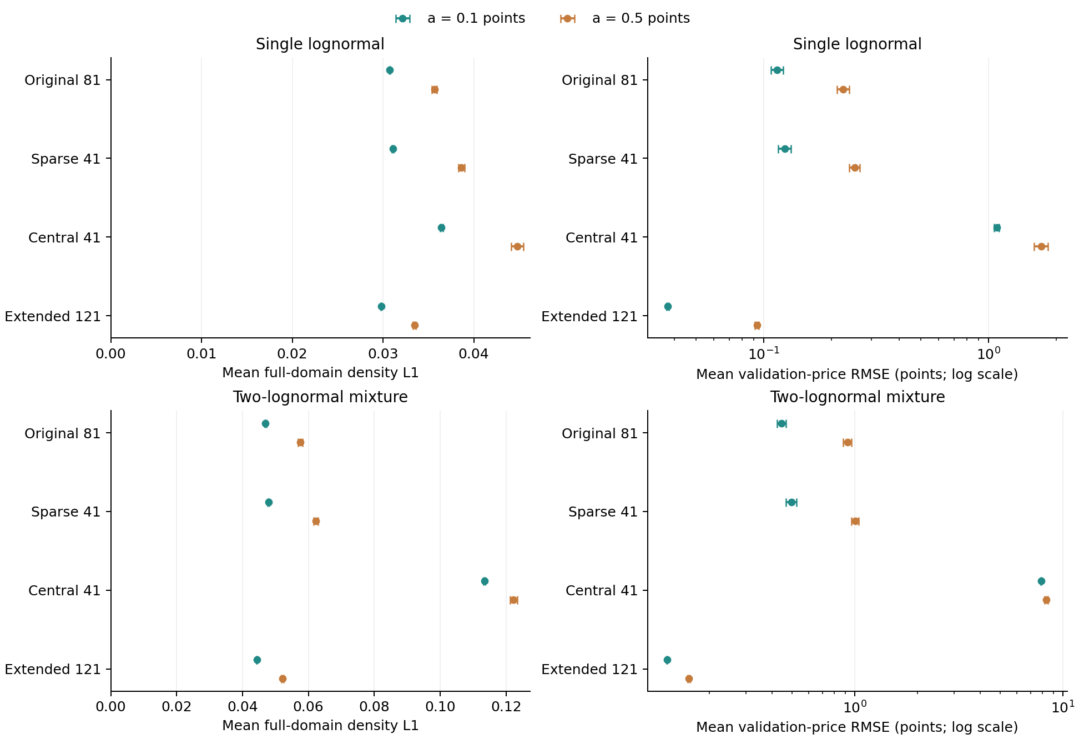
Figure 19. Mean full-domain density error and mean validation-price RMSE across 50 repetitions per scenario. Bars show the mean plus or minus two Monte Carlo standard errors, describing the precision of the simulation mean. They are not the spread of individual estimates or confidence intervals for a density. Price panels use logarithmic horizontal scales; density panels use linear scales.

At amplitude 0.5 points, Central 41 minus Sparse 41 increases mean density error by 0.00614 for the single lognormal, with MCSE 0.00038, and by 0.06001 for the mixture, with MCSE 0.00064. The narrower span is materially worse despite having the same number of observations. Even with clean mixture prices, Central 41 gives a within-range price RMSE of 0.1186 points but 7.7981 points on the common validation grid. This exposes extrapolation error without attributing it to random noise.

Benchmark | Pattern | Clean-input error | Mean error (MCSE) | Empirical SD | Root MSE
Single lognormal | Original 81 | +0.0044 | -0.0443 (0.0047) | 0.0332 | 0.0552
Single lognormal | Sparse 41 | +0.0044 | -0.0438 (0.0058) | 0.0408 | 0.0595
Single lognormal | Central 41 | -0.0130 | +0.0688 (0.0175) | 0.1238 | 0.1405
Single lognormal | Extended 121 | +4.69e-05 | -0.0026 (0.0041) | 0.0289 | 0.0287
Two-lognormal mixture | Original 81 | +0.2265 | +0.3108 (0.0330) | 0.2333 | 0.3873
Two-lognormal mixture | Sparse 41 | +0.2241 | +0.3159 (0.0306) | 0.2164 | 0.3817
Two-lognormal mixture | Central 41 | +0.4398 | +0.1061 (0.0537) | 0.3794 | 0.3903
Two-lognormal mixture | Extended 121 | -0.0503 | -0.0436 (0.0043) | 0.0304 | 0.0530
Table 16. Error in the 365-day probability above 1.8F with a = 0.5 points. The known probabilities are 0.1187% (single lognormal) and 1.1885% (mixture). All errors and SDs are percentage points. The clean column uses exact input prices once, without a Monte Carlo error bar.

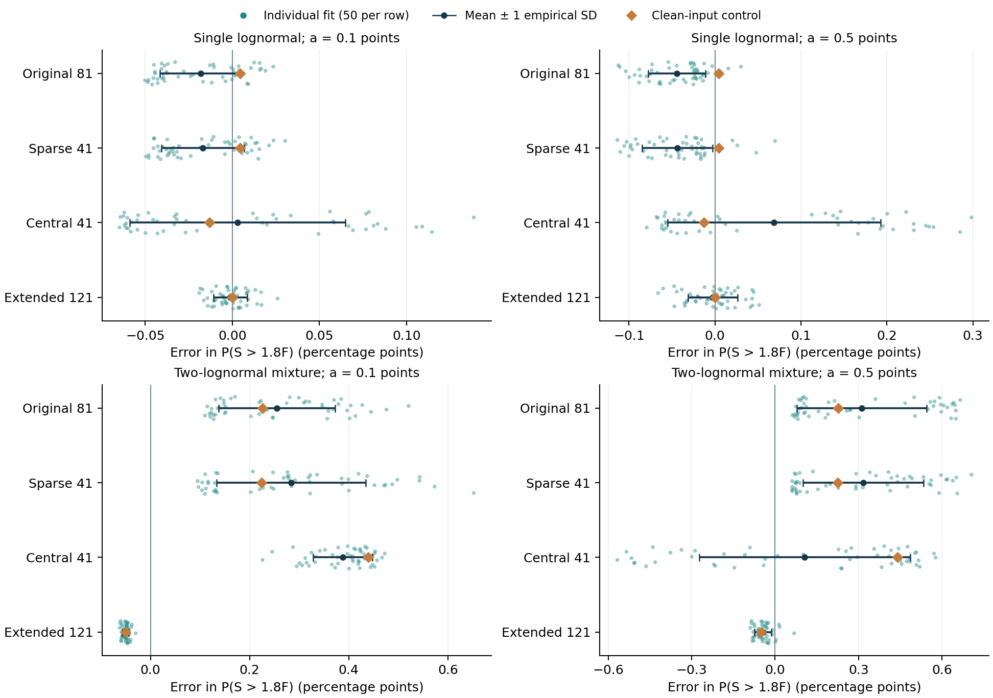
Figure 20. Errors in the 365-day risk-neutral probability above 1.8F, in percentage points. Each row displays all 50 noisy fits, their mean plus or minus one empirical SD, and the corresponding clean-input control. Vertical offsets separate points for visibility and carry no numerical meaning. The spread shown here differs from the Monte Carlo mean-error bars in Figure 19. Horizontal scales may differ between panels.

Benchmark | First pattern − second pattern | Change in density L1 | Change in mean absolute tail error (pp)
Single lognormal | Sparse 41 − Original 81 | +0.0030 (0.0001) | +0.0042 (0.0030)
Single lognormal | Central 41 − Original 81 | +0.0091 (0.0004) | +0.0661 (0.0129)
Single lognormal | Extended 121 − Original 81 | -0.0022 (0.0001) | -0.0231 (0.0050)
Single lognormal | Central 41 − Sparse 41 | +0.0061 (0.0004) | +0.0618 (0.0132)
Two-lognormal mixture | Sparse 41 − Original 81 | +0.0048 (0.0003) | +0.0050 (0.0196)
Two-lognormal mixture | Central 41 − Original 81 | +0.0648 (0.0007) | +0.0475 (0.0425)
Two-lognormal mixture | Extended 121 − Original 81 | -0.0053 (0.0004) | -0.2632 (0.0338)
Two-lognormal mixture | Central 41 − Sparse 41 | +0.0600 (0.0006) | +0.0425 (0.0394)
Table 17. Paired changes at a = 0.5 points, with one MCSE in parentheses. Each difference uses matched repetitions. Negative values mean a smaller error for the first pattern. The tail measure is mean absolute probability error at 365 days, in percentage points.
For the single lognormal, the mean estimated probability above $1.8F$ moves from 0.0744% under Original 81 to 0.1161% under Extended 121, against truth 0.1187%. The paired reduction in absolute probability error is 0.0231 percentage points, with MCSE 0.0050. For the mixture, the estimates move from 1.4994% to 1.1450%, against truth 1.1885%; the paired reduction in absolute error is 0.2632 percentage points, with MCSE 0.0338.
The full batch contains 800 noisy and eight clean fits, or 6,464 marginal densities. All 808 joint fits meet the acceptance rule; the worst calendar gap is $−9.995×{10}^{−10}$. These successes describe numerical completion. They do not remove the model, support or missing-information errors measured above.

Smoothing selection and forward sensitivity

Evaluating a complete selection procedure
As Cawley and Talbot explain in On Over-fitting in Model Selection and Subsequent Selection Bias in Performance Evaluation, tuning a method and assessing its performance are distinct operations [17]. This study therefore selects smoothing from noisy prices alone and reserves clean prices, densities and event probabilities for evaluation. It uses Original 81 and Extended 121, both benchmarks and twenty new paired realisations at amplitude 0.5 points.
The declared candidates are $Λ=\{{10}^{−7},{10}^{−6},{10}^{−5}\}$. Interior strikes are assigned in order to three interlaced folds, while both endpoints remain in training. All eight maturities are fitted jointly in every fold. Equation (30) pools the individual held-out errors after forward scaling and resolves exact ties in favour of the larger coefficient.
CVλ=k=13m=1Mi∈Hk​Cm,λ−kKmi−ymiFm2Mk=13Hkλ=max​arg minλ∈ΛCVλ.
Equation 30. Pooled noisy-price validation score and penalty selection.
Pooling matters because the folds have different numbers of observations. Equal weighting of fold means would overweight smaller folds. The score targets interpolation at interior strikes; it does not directly target density recovery or unobserved tails. Every repetition reruns selection, then refits all observations at the selected coefficient. The fixed ${10}^{−6}$ refit is a paired control using exactly the same quotes.
Benchmark | Strike pattern | Selected 10⁻⁷ | Selected 10⁻⁶ | Selected 10⁻⁵
Single lognormal | Original 81 | 0 | 20 | 0
Single lognormal | Extended 121 | 0 | 20 | 0
Two-lognormal mixture | Original 81 | 20 | 0 | 0
Two-lognormal mixture | Extended 121 | 20 | 0 | 0
Table 18. Smoothing selections in 20 repetitions per benchmark and strike pattern. All columns refer to the declared candidate set; selecting an endpoint does not establish that it is optimal beyond this set.

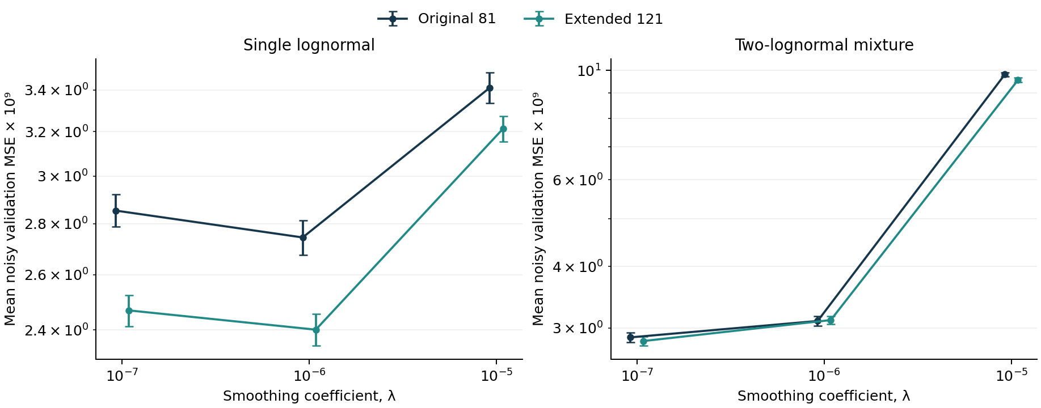
Figure 21. Mean pooled noisy-price validation MSE for each smoothing coefficient, with ±2 Monte Carlo standard errors across the 20 repetitions. The dimensionless score is multiplied by ${10}^{9}$ for display and the vertical scale is logarithmic. Lines connect the three evaluated candidates. These scores select the coefficient; they are not the final recovery-performance estimates.

Across eighty selection experiments, the three coefficients are selected forty, forty and zero times. A boundary choice establishes only a preference within the declared grid. The grid is not extended after inspecting the synthetic evaluation results.

Price selection and density recovery are different targets
The selected rule is assessed against the fixed baseline on the same quote realisations. Tables 19–20 and Figure 22 retain price, density and tail measures separately, with paired differences used to assess the change.

Benchmark | Pattern | Rule | Clean-price RMSE (points) | Full-density L1 | 365-day upper-tail bias (pp)
Single lognormal | Original 81 | Fixed 10⁻⁶ | 0.2178 (0.0107) | 0.0358 (0.0001) | -0.0374 (0.0099)
Single lognormal | Original 81 | Selected | 0.2178 (0.0107) | 0.0358 (0.0001) | -0.0374 (0.0099)
Single lognormal | Extended 121 | Fixed 10⁻⁶ | 0.0948 (0.0012) | 0.0336 (0.0001) | +0.0080 (0.0066)
Single lognormal | Extended 121 | Selected | 0.0948 (0.0012) | 0.0336 (0.0001) | +0.0080 (0.0066)
Two-lognormal mixture | Original 81 | Fixed 10⁻⁶ | 0.8887 (0.0434) | 0.0574 (0.0004) | +0.3225 (0.0530)
Two-lognormal mixture | Original 81 | Selected | 1.0928 (0.0290) | 0.0704 (0.0009) | +0.2533 (0.0511)
Two-lognormal mixture | Extended 121 | Fixed 10⁻⁶ | 0.1587 (0.0015) | 0.0524 (0.0003) | -0.0358 (0.0073)
Two-lognormal mixture | Extended 121 | Selected | 0.1174 (0.0011) | 0.0630 (0.0003) | -0.0366 (0.0110)
Table 19. Recovery after full-data refitting. The clean-price RMSE pools 960 withheld prices in each repetition. Full-density $L_{1}$ is averaged across eight maturities and includes the known omitted tails as in Equation (23). Upper-tail bias is the mean error in $Q\left(S_{T}>1.8F\right)$ at 365 days, expressed in percentage points. Entries are mean (MCSE).

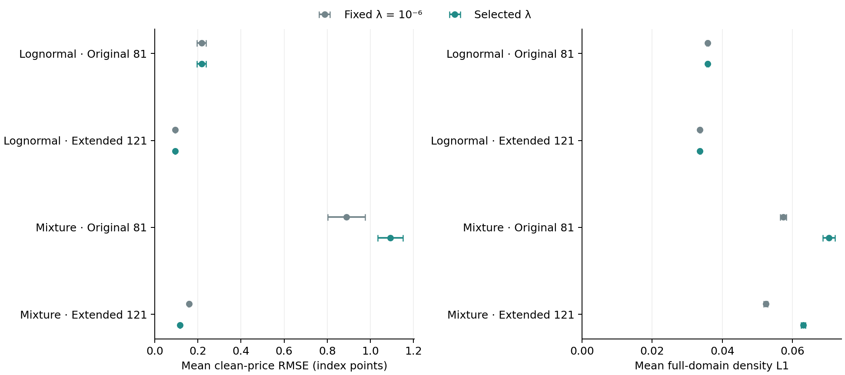
Figure 22. Mean clean-price RMSE and full-domain density error after refitting with selected or fixed smoothing, using the same quote realisations in each comparison. Bars show ±2 MCSE. A small price error does not, by itself, establish a small density error, since prices integrate the density through the payoff relationship in Equation (1).

Benchmark | Pattern | Δ clean-price RMSE (points) | Δ full-density L1 | Δ absolute upper-tail error (pp)
Single lognormal | Original 81 | +0.0000 (0.0000) | +0.0000 (0.0000) | +0.0000 (0.0000)
Single lognormal | Extended 121 | +0.0000 (0.0000) | +0.0000 (0.0000) | +0.0000 (0.0000)
Two-lognormal mixture | Original 81 | +0.2042 (0.0374) | +0.0130 (0.0007) | -0.0692 (0.0316)
Two-lognormal mixture | Extended 121 | -0.0413 (0.0011) | +0.0107 (0.0004) | +0.0073 (0.0048)
Table 20. Paired selected-minus-fixed differences, reported as mean (MCSE). Negative values indicate lower error under the selection rule. The last column compares absolute errors for the fixed 365-day upper-tail event; it is not a difference between signed biases.
For the mixture under Original 81, selection changes mean common-grid clean-price RMSE from 0.8887 to 1.0928 points and density error from 0.0574 to 0.0704. Under Extended 121, price RMSE improves from 0.1587 to 0.1174 points while density error worsens from 0.0524 to 0.0630. The latter paired density increase is 0.0107, with MCSE 0.0004. These findings concern the specified selector and benchmarks; they do not establish that cross-validation is generally ineffective.
A post-hoc range diagnostic explains the Original 81 discrepancy without changing the selector. At the 640 evaluation strikes inside the quoted span, price RMSE improves from 0.1571 to 0.1235 points; at the 320 outside it, RMSE worsens from 1.5224 to 1.8847. Better interior interpolation accompanies worse extrapolation. The diagnostic is labelled as subsequent analysis, rather than presented as a predeclared performance result.

Perturbing the input without moving the risk event
As Bahra explains [1], the terminal mean is linked to the forward under the valuation assumptions. Enforcing that mean cannot prove that an externally supplied forward is correct. The Extended 121 experiment therefore perturbs the supplied forward as in Equation (31), retaining strikes, prices, discounts and the coefficient selected at the correct forward.
$${\tilde{F}}_{m}^{\left(ε\right)}=\left(1+ε\right)F_{m}, ε∈\{−0.005,−0.001,0,0.001,0.005\}.$$
Equation 31. Relative perturbation of the supplied forward curve.
The support remains $\left[0.3,2.2\right]$ relative to the supplied forward, so its physical endpoints move. Mean restrictions, residual scaling, smoothing and calendar normalisation also depend on the supplied input. The exercise measures their combined conditional response, not separately identified causal effects.
Equation (32) evaluates every fitted distribution against the same known reference forward. In particular, the event remains $S_{T}>1.8F_{m}$ even when the fitting input changes. The conversion changes the interpretation coordinate of a saved fit; it does not move or refit its physical probabilities.
$$\begin{matrix}{\hat{g}}_{m}^{\left(ε\right),ref}\left(x\right)=F_{m}{\hat{f}}_{m}^{\left(ε\right)}\left(F_{m}x\right), \\ {\hat{p}}_{1.8,m}^{\left(ε\right)}=\int_{1.8}^{∞}{{\hat{g}}_{m}^{\left(ε\right),ref}}\left(x\right) dx.\end{matrix}$$
Equation 32. Density evaluation and fixed risk event in reference coordinates.
Applying convexity of the positive-part payoff to Equation (1) gives the call lower bound and quote-shortfall diagnostic in Equation (33). This is a direct project derivation from the valuation relationship described by Bahra [1].
$$\begin{matrix}C_{m}\left(K_{mi}\right)≥L_{mi}^{\left(ε\right)}=D_{m}{\left({\tilde{F}}_{m}^{\left(ε\right)}−K_{mi}\right)}_{+}, \\ v_{mi}^{\left(ε\right)}={\left(L_{mi}^{\left(ε\right)}−y_{mi}\right)}_{+}.\end{matrix}$$
Equation 33. Supplied-forward call lower bound and quote shortfall.
The RMS shortfall is a lower bound on training-price RMSE under exact probability restrictions, not on the separate clean-price evaluation error. No supplied observations are clipped to satisfy it.

Benchmark | Forward error (%) | Clean-price RMSE (points) | Full-density L1 | Upper-tail bias (pp) | Quotes below lower bound / 968
Single lognormal | -0.5 | 2.9202 (0.0001) | 0.0829 (0.0001) | +0.0082 (0.0066) | 0.00 (0.00)
Single lognormal | -0.1 | 0.4770 (0.0002) | 0.0421 (0.0001) | +0.0080 (0.0067) | 0.00 (0.00)
Single lognormal | +0.0 | 0.0948 (0.0012) | 0.0336 (0.0001) | +0.0080 (0.0066) | 56.90 (1.05)
Single lognormal | +0.1 | 2.4965 (0.0001) | 0.0559 (0.0001) | +0.0080 (0.0066) | 216.90 (0.26)
Single lognormal | +0.5 | 14.3147 (4e-05) | 0.1637 (0.0002) | +0.0081 (0.0066) | 285.00 (0.00)
Two-lognormal mixture | -0.5 | 1.7653 (0.0001) | 0.1079 (0.0003) | -0.0413 (0.0085) | 0.00 (0.00)
Two-lognormal mixture | -0.1 | 0.2109 (0.0006) | 0.0726 (0.0003) | -0.0393 (0.0108) | 0.00 (0.00)
Two-lognormal mixture | +0.0 | 0.1174 (0.0011) | 0.0630 (0.0003) | -0.0366 (0.0110) | 0.05 (0.05)
Two-lognormal mixture | +0.1 | 1.0523 (0.0001) | 0.0823 (0.0004) | -0.0340 (0.0113) | 99.35 (0.28)
Two-lognormal mixture | +0.5 | 10.2713 (1.5e-05) | 0.1468 (0.0004) | -0.0239 (0.0131) | 227.30 (0.29)
Table 21. Forward stress with the selected zero-shift coefficient held fixed. Entries are mean (MCSE); all errors use the same benchmark and physical risk events. The last column counts supplied-forward lower-bound violations among the 968 observed calls in each repetition. It diagnoses incompatible inputs, rather than failed solver convergence.

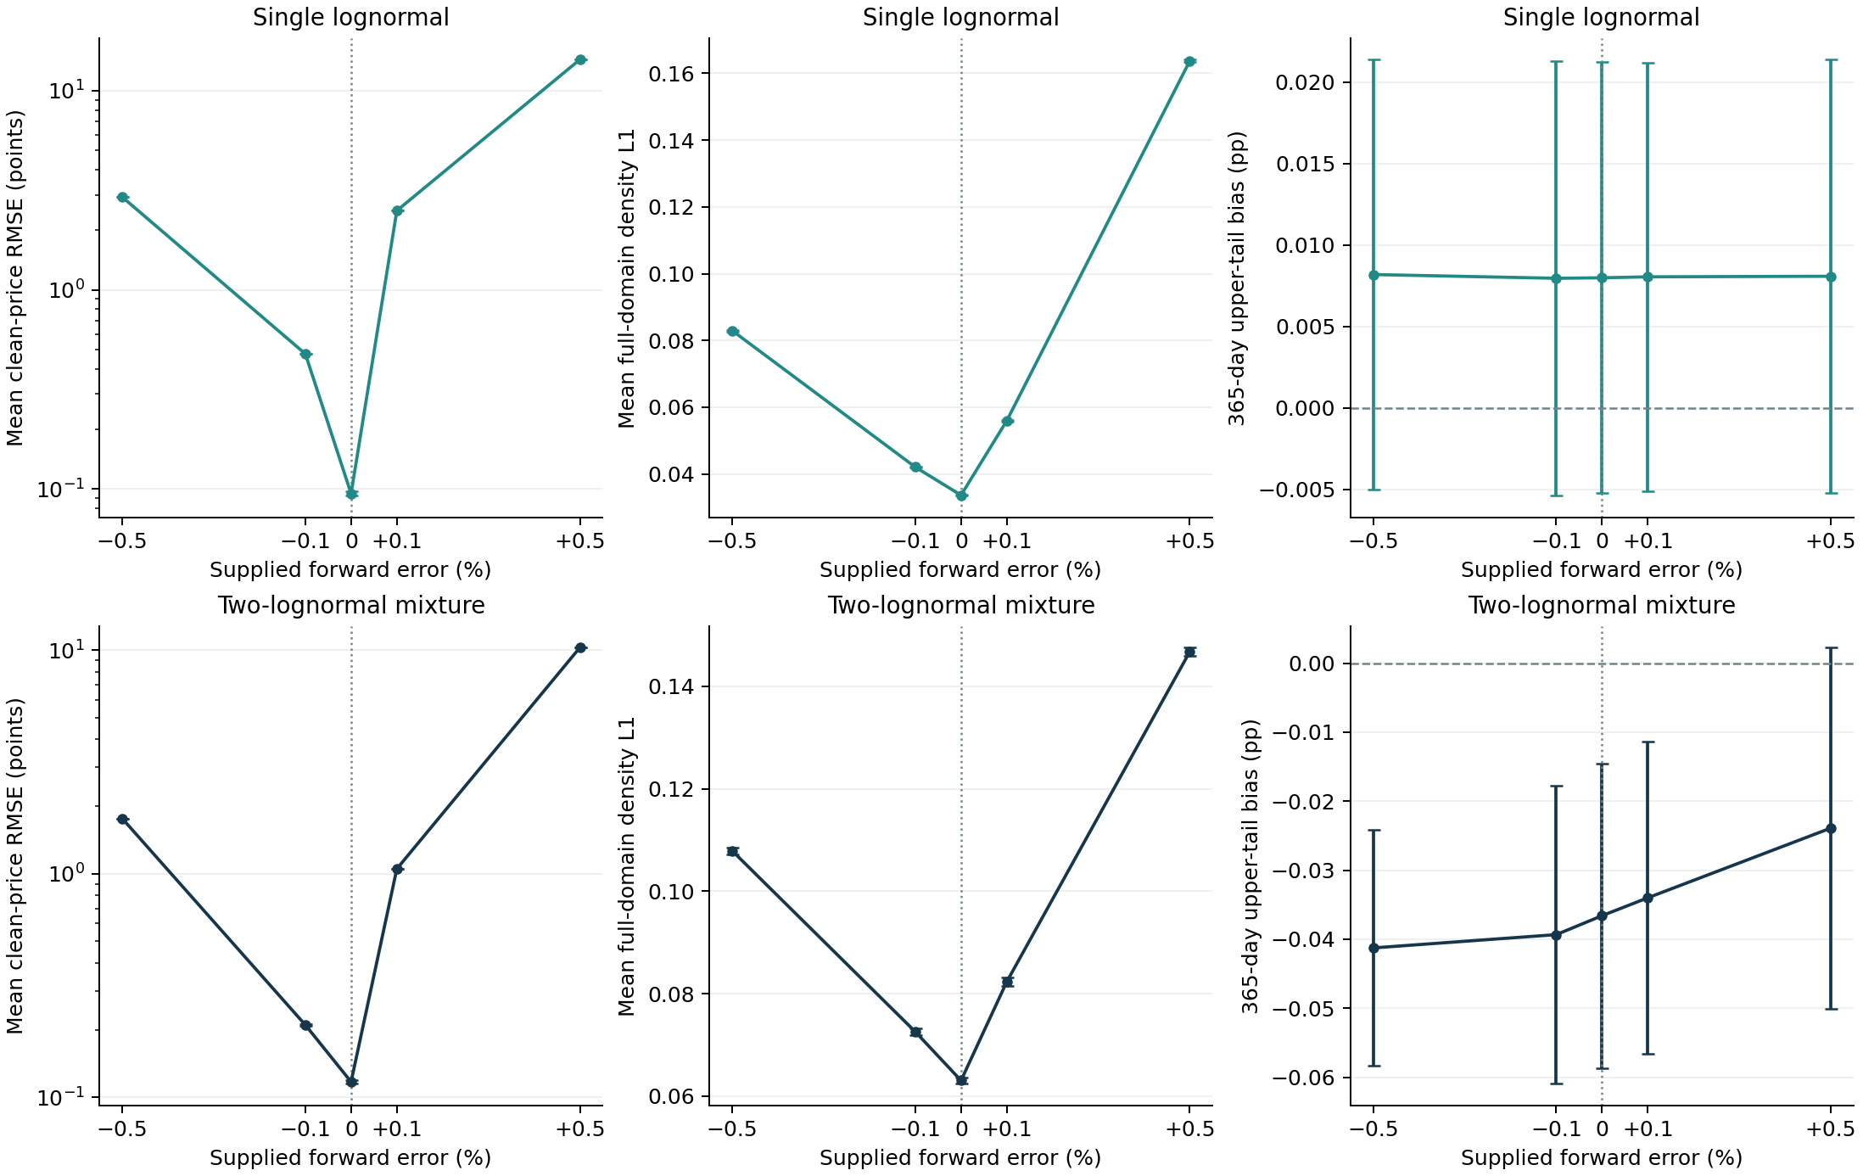
Figure 23. Sensitivity of the selected fit to the supplied forward, under Extended 121 coverage. Points are repetition means with ±2 MCSE; connecting lines are visual guides between the five stated stress levels. The price-error axis is logarithmic. The tail event remains $S_{T}>1.8F_{true}$ at 365 days throughout. Calendar feasibility is checked separately in supplied-forward coordinates.

For the mixture, mean clean-price RMSE is 0.1174 points at the correct forward, 1.7653 points at a −0.5% shift and 10.2713 at +0.5%. The positive shift places an average of 227.3 of 968 supplied calls below the implied lower bound. This helps explain the asymmetry without claiming to isolate every consequence of the input change.
The study contains 1,000 unique accepted joint fits, or 8,000 marginal densities, including training fits. No planned experiment is silently omitted. The worst calendar gap is $−9.996×{10}^{−10}$. The experiment still assumes idealised independent bounded quote errors, two benchmark families and fixed support. Its success does not validate a market forward curve or convert risk-neutral events into physical forecasts.

Empirical inputs and the first market calibration

Establishing an auditable input route
A working estimator did not initially provide usable observations. The advertised Cboe end-of-day sample request returned HTTP 403 [18]; another provider’s advertised 2022 sample did not support the required contemporaneous timestamp interpretation [19]; WRDS described an institutional route but did not establish access to an unseen export [20]. Table 22 preserves that source assessment. No purchase or account access was undertaken.
Source | Evidence available in this project | Decision for this stage
Original Cboe page candidate [2] | Archived payload and audit; quote observation datetime/timezone and zero-size meaning remain unresolved | Retain for the data audit; no density fit
Cboe Option EOD Summary [18] | Primary layout documentation; advertised sample request returned HTTP 403 | No sample contents inspected; access attempt recorded
HistoricalData.net public 2022 sample [19] | Vendor documentation describes asynchronous last-standing quotes; quote timestamps start in August 2026 | Not downloaded: the advertised sample does not meet this study’s synchronised-input requirement
Institutional OptionMetrics route [20] | WRDS describes option quotes and curve data; no export or institutional access has been supplied | Possible route requiring an actual authorised export and its documentation
Table 22. Initial source assessment before the supplied marking-price files. Product descriptions establish possible routes, not actual access or approval of unseen files.
The original candidate remained unaccepted. A subsequent API retrieval with a fuller timestamp returned the same option array but did not establish the timezone or meaning needed to treat it as a verified quote instant. The implementation therefore separated the file format and validation rules from market access, using an explicitly synthetic input bundle to exercise the process.
The preparation profile requires a quote CSV, a discount CSV and a manifest recording conventions and source evidence. Full UTC-offset timestamps distinguish observation from settlement; ACT/365F uses elapsed UTC seconds. External discounts must have been available at the observation instant. A positive discount above one is permitted. Hashes support traceability but do not prove provenance, permission or economic suitability.

Conditional forwards and training-only inference
Using the parity foundation in Aït-Sahalia and Lo [10], Equation (34) intersects the pairwise intervals from Equation (8). Its midpoint is a declared point-input convention conditional on the supplied discount, not a statistically identified true forward.
$$\begin{matrix}{\underline{F}}_{m}=\max_{i}ℓ_{mi}^{F}, {\overline{F}}_{m}=\min_{i}u_{mi}^{F}, \\ {\hat{F}}_{m}=\frac{{\underline{F}}_{m}+{\overline{F}}_{m}}{2} \text{when }0<{\underline{F}}_{m}≤{\overline{F}}_{m}.\end{matrix}$$
Equation 34. Common bid–ask forward intersection and point convention.
An empty intersection blocks density fitting. Equation (35) records the minimum uniform widening needed to intersect the conditional forward intervals. It is measured in forward index points and is diagnostic only; no quote repair is applied.
$$\begin{matrix}s_{m}^{*}=min\{s≥0:\max_{i}\left(ℓ_{mi}^{F}−s\right)≤\min_{i}\left(u_{mi}^{F}+s\right)\} \\ =\frac{{\left({\underline{F}}_{m}−{\overline{F}}_{m}\right)}_{+}}{2}.\end{matrix}$$
Equation 35. Minimum uniform widening of incompatible forward intervals.

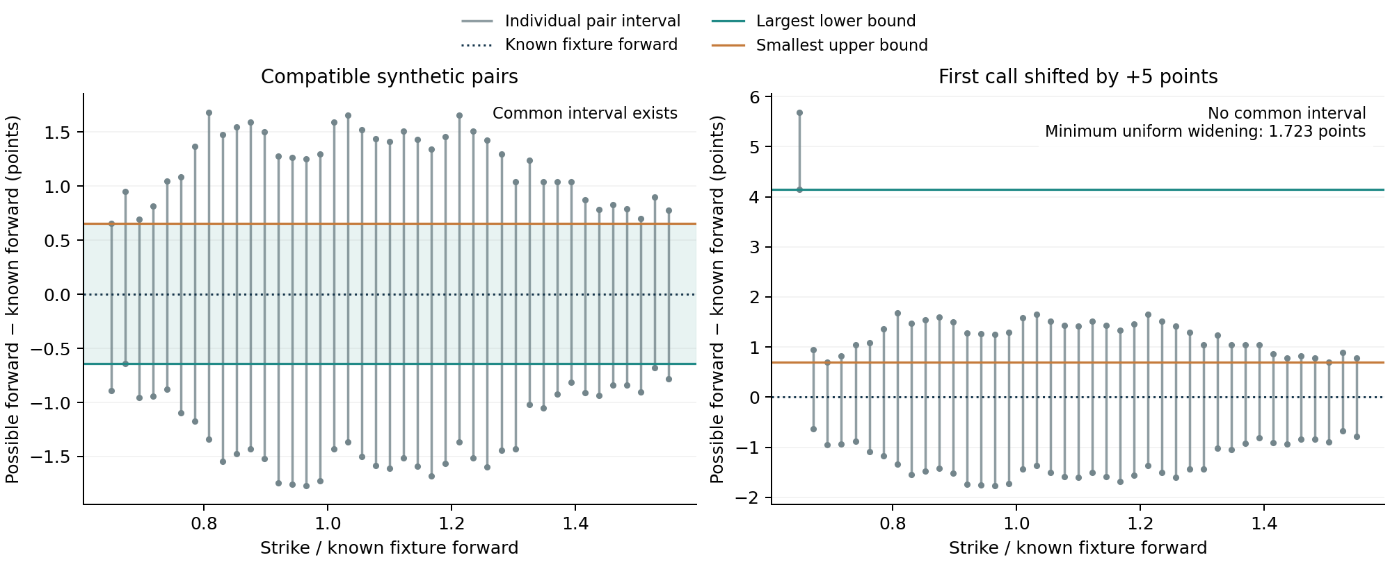
Figure 24. Conditional forward bounds for the first synthetic horizon. Each vertical segment is one call–put pair’s interval from Equation (8). The left panel has a common intersection. The right panel adds five points to the first call’s bid and ask while leaving the put unchanged; the largest lower bound then exceeds the smallest upper bound. The dotted line is the known fixture forward, available only because this example is synthetic. The shaded compatible band is not a confidence interval.

In the synthetic example, shifting one call’s bid and ask by five points leaves its row positive and ordered but destroys the common intersection. The required widening is 1.7234 forward points. Row screening therefore cannot replace cross-strike compatibility checks.
As Cawley and Talbot’s discussion of selection makes clear [17], inferred inputs are part of the procedure being evaluated. Whole call–put pairs are held out, and the forward is recomputed from each training subset. Equation (36) extends the selection score accordingly. Endpoints stay in training and exact score ties choose the larger coefficient.
CVFλ=k,m​i∈Hkm​Cm,λ−kKmi;Fm−k−CmimidFm−k2k,m​Hkmλ=argminλ∈ΛCVFλ.
Equation 36. Smoothing selection with training-only inferred forwards.

Synthetic acceptance exercise
The fixture contains 282 invented quote rows: 41, 47 and 53 pairs across three nominal horizons. Prices come from the two-lognormal mixture. Each analytical price receives a half-spread equal to the smaller of 0.75 points and 8% of that price; a midpoint perturbation of at most one fifth of the half-spread leaves the known price inside the range. Seed entropy is (20260921, 9). Dates, sizes and identifiers test the input process and do not claim actual exchange observations.

Nominal horizon | Elapsed years | Pairs | Conditional forward interval | Chosen forward | Error from known forward
60 days | 0.16429795 | 41 | [6024.0571, 6025.3527] | 6024.7049 | +0.0095
120 days | 0.32868151 | 47 | [6048.6398, 6050.5771] | 6049.6084 | +0.1031
240 days | 0.65744863 | 53 | [6098.1441, 6100.6864] | 6099.4153 | -0.0169
Table 23. Verified synthetic input pairs and full-data forward inference. Interval endpoints, forward estimates and forward errors are in index points. Known forwards are available only for the fixture.

The three candidate scores select ${10}^{−7}$, the lower grid boundary. Nine training fits and one refit produce ten accepted joint fits. Separate analytical prices at 138 strike midpoints and the known density are used only after fitting. Equation (37) defines a point-distance diagnostic for both option types, including puts inferred from parity.
$$d_{mi,o}^{spread}=max\{B_{mi,o}−{\hat{V}}_{mi,o}, {\hat{V}}_{mi,o}−A_{mi,o}, 0\}.$$
Equation 37. Fitted option-price distance outside its bid–ask range.

Nominal horizon | Separate clean-price RMSE (points) | Full-domain density L1 | Quotes outside spread | Largest spread distance (points)
60 days | 0.05257 | 0.04960 | 1 / 82 | 0.01993
120 days | 0.05195 | 0.04411 | 0 / 94 | 0.00000
240 days | 0.03808 | 0.06150 | 0 / 106 | 0.00000
Table 24. Independent fixture recovery and in-sample spread diagnostics. The clean-price column uses separate strike midpoints. The spread columns assess the supplied input quotes; the two roles should not be conflated.

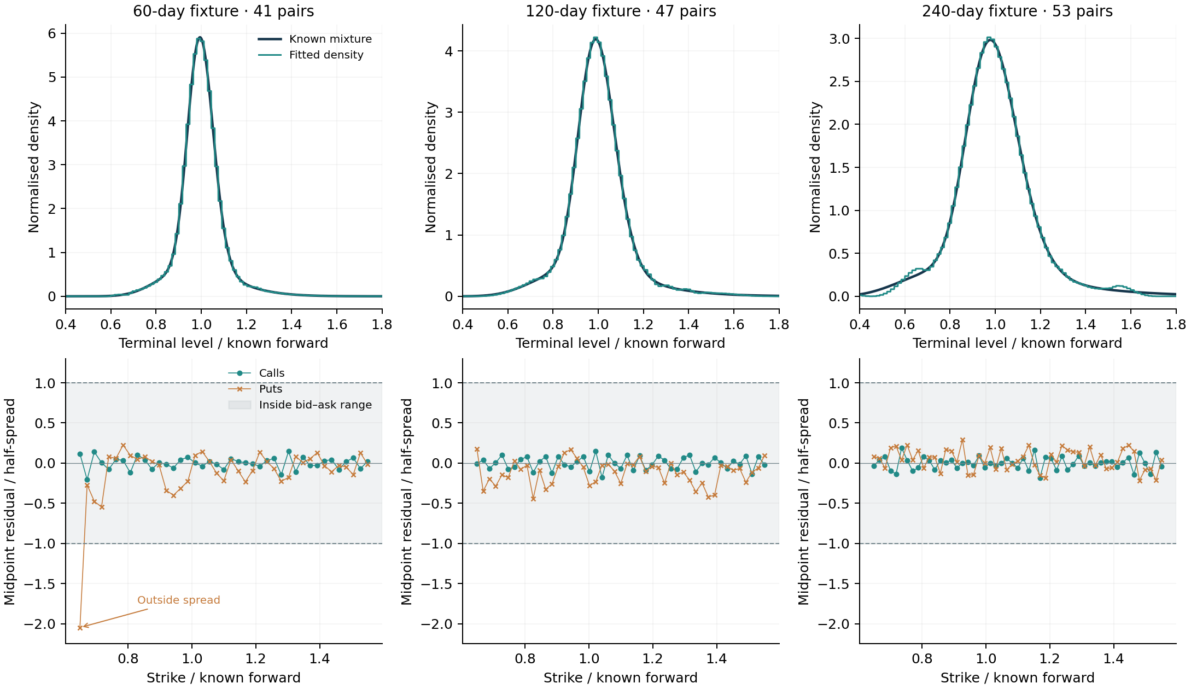
Figure 25. Density recovery and quote-range checks in the synthetic fixture. The upper panels compare the fitted histogram with the known mixture in fixed reference-forward coordinates. Only $0.4$–$1.8$ is displayed; Table 24’s density error covers the full positive domain. The lower panels divide midpoint residuals by each quote’s half-spread: values between $−1$ and $1$ lie inside the bid/ask interval. Both option types are shown. Half-spreads are positive in this fixture; the stored point-distance diagnostic also works for a valid zero-width quote.

One fitted price lies approximately 0.01993 points outside its quoted range. The result is retained. Parity compatibility does not imply that a regularised midpoint objective will satisfy every spread, and this residual does not prove that a spread-feasible fit is impossible. The distinction becomes central in Chapter 8.
Deliberate input change | Observed response
Missing quote timezone | Blocked
Unsynchronised quote | Blocked
Conflicting settlement time | Blocked
Discount published after the snapshot | Blocked
Discount older than the declared limit | Blocked
Call bid and ask at the first strike increased by 5 points | Blocked by parity
Zero size and a duplicated call quote | 5 rows excluded
Table 25. Input-failure exercises applied to the saved fixture. These are designed checks, not failures discovered in market observations. Mutations and returned reasons are retained in results/empirical_preparation.json.
The deliberately invalid fixtures test missing or conflicting metadata, unsuitable discounts and incompatible forwards. Additional checks change held-out observations and verify that their training-only inputs remain unchanged. The fixture demonstrates a complete file-to-fit process; it is kept distinct from the empirical evidence that follows.

The supplied market files and contract scope
Cboe’s marking-price documentation distinguishes indicative prices from exchange BBO fields [21]. The application uses the last-disseminated market bid and ask columns for calls and puts, not the final indicative marks. The supplied files were matched byte-for-byte to the advertised downloads, with hashes and retrieval records retained. Table 26 describes their initial roles; all three are analysed in Chapter 8.

File | Date | CT | All rows | SPX/SPXW pairs | Use here
eom_marking_prices_list.csv | 2026-08-31 | 15:00 | 39,945 | 13,813 | reserved date comparison
eod_marking_prices_list.csv | 2026-09-18 | 15:00 | 39,346 | 13,891 | primary calibration
eod_marking_prices_late_list.csv | 2026-09-18 | 15:15 | 38,995 | 13,891 | reserved intraday comparison
Table 26. Supplied file coverage and assigned role. Each target row contains a call and put at one strike. Counts include all SPX/SPXW expiries before screening. CT means Chicago civil time; all three observation dates are on UTC−05:00.

The files supply two observation dates and three snapshots. Concatenating the two September snapshots would mix observation instants. Indicative size entries of one are not demonstrated market depth. A separate exchange-BBO adapter records actual size as unavailable and makes no consolidated NBBO or execution-depth claim; the original external-curve profile remains separate.
The first market case uses 18 September 2026 at 15:00 Chicago time, with SPXW expiries on 16 October, 20 November and 18 December. Cboe’s specifications and 2026 schedule support the PM settlement convention used here [5,22]. Settlement is represented at 16:00 New York civil time, including the November offset change. The elapsed horizons are 28, 63 plus 1/24, and 91 plus 1/24 days. The extra hour comes from daylight saving, not an additional trading session.
The adapter checks the encoded root, expiry, type and strike, requires finite positive ordered prices on both sides, limits each relative spread to 25%, and excludes duplicates without averaging. Both last-update messages must be no later than the snapshot and no more than sixty seconds old. These are declared activity criteria, not proof of execution availability. The three selected expiries retain 364, 344 and 261 pairs: 969 pairs and 1,938 option intervals.

Inferring a quote-implied carry proxy
The files do not contain a discount curve. Rearranging the parity relationship discussed by Aït-Sahalia and Lo [10] gives Equation (38), where $H_{m}=D_{m}F_{m}$ and opposite bid–ask sides define the admissible difference range.
$$\begin{matrix}C_{mi}−P_{mi}=H_{m}−D_{m}K_{mi}, \\ b_{mi}^{−}=C_{mi}^{bid}−P_{mi}^{ask}, \\ b_{mi}^{+}=C_{mi}^{ask}−P_{mi}^{bid}.\end{matrix}$$
Equation 38. Linear put–call parity and bid–ask difference bounds.
Equation (39) jointly estimates discount and forward through equal-weight constrained least squares. The strike normalisation $K_{0m}$ is the median retained strike, and the small positive carry floor is a numerical convention. This estimator is a project choice supported by the convex-QP framework in Boyd and Vandenberghe [11].
$$\begin{matrix}\left({\hat{H}}_{m},{\hat{D}}_{m}\right)=\underset{H,D}{argmin} \frac{1}{N_{m}}\sum_{i=1}^{N_{m}}{{\left(\frac{H−DK_{mi}−y_{mi}}{K_{0m}}\right)}^{2}}, \\ \text{subject to} b_{mi}^{−}≤H−DK_{mi}≤b_{mi}^{+} \text{for every }i, \\ D≥ε_{carry}, H≥ε_{carry}K_{0m}, \\ ε_{carry}={10}^{−8}, {\hat{F}}_{m}={\hat{H}}_{m}/{\hat{D}}_{m}.\end{matrix}$$
Equation 39. Constrained quote-implied discount and forward estimation.
The implementation centres strikes and independently verifies every parity bound. Separate LPs project the feasible discount interval. That projection is a compatibility set, not a confidence interval. An empty or unbounded projection blocks calibration. The forward is the regression-implied ratio $\hat{H}/\hat{D}$, rather than the midpoint of Equation (34)’s conditional interval.
$${\hat{r}}_{m}=−\frac{log{\hat{D}}_{m}}{T_{m}}.$$
Equation 40. Quote-implied continuously compounded rate equivalent.
Equation (40) merely converts the fitted discount into an equivalent continuously compounded rate. It is not an independently observed risk-free curve or a finding about a particular funding mechanism. Bid–ask effects and the assumed parity inputs can influence it.

Expiry | Pairs | Elapsed days | Inferred D | Feasible D range | Inferred F (points) | Implied rate (%/yr)
2026-10-16 | 364 | 28.00000 | 0.99692766 | [0.99355705, 1.00051635] | 7666.5433 | 4.0112
2026-11-20 | 344 | 63.04167 | 0.99259513 | [0.99038168, 0.99531840] | 7691.7365 | 4.3032
2026-12-18 | 261 | 91.04167 | 0.98895253 | [0.98664835, 0.99123243] | 7712.2104 | 4.4537
Table 27. Full-sample quote-implied carry inputs. The discount intervals project all retained pair inequalities. Forward values are in index points; the last column is the equivalent annual rate, expressed as a percentage. Reporting digits aid reconstruction and do not imply this degree of economic precision.

Market fit, selection and remaining spread misses
Both discount and forward are re-estimated from training pairs in each of the three interior-strike folds. The primary grid remains $\{{10}^{−7},{10}^{−6},{10}^{−5}\}$ on 120 bins. Its weakest coefficient wins. The criterion predicts call midpoints; puts provide parity information and separate fit diagnostics.

Expiry | Retained K/F range | Call RMSE (points) | Put RMSE (points) | Calls / puts outside | Largest spread miss (points)
2026-10-16 | 0.6261–1.0905 | 0.8895 | 1.0036 | 100 / 236 | 1.8661
2026-11-20 | 0.4680–1.1571 | 0.4477 | 0.8228 | 36 / 145 | 1.3688
2026-12-18 | 0.4149–1.2188 | 0.3323 | 0.7146 | 6 / 127 | 0.6305
Table 28. Primary selected fit and quote coverage. RMSE uses retained midpoints. The outside counts separate calls and puts; each has the pair count in Table 27. A low price RMSE does not certify a recovered density.

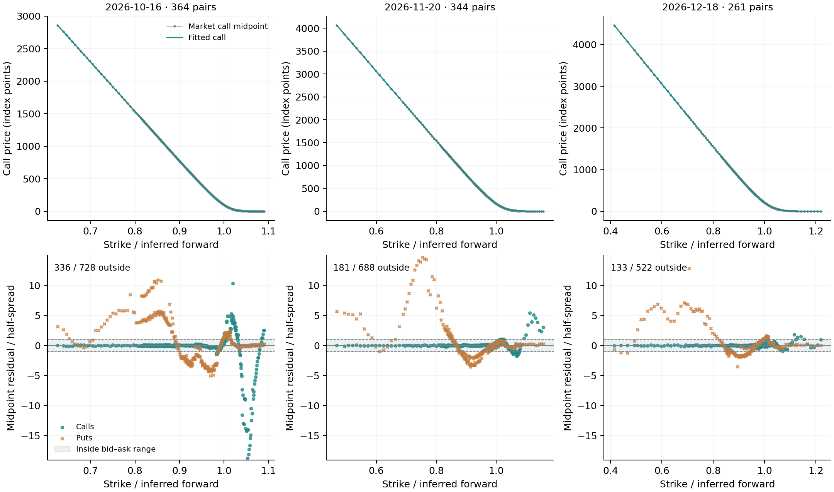
Figure 26. Primary market fit and bid–ask residuals on 18 September 2026. Upper panels show market call midpoints and the selected fitted call curve. Lower panels show both option types in units of their own half-spread. The shaded band is the bid–ask interval. The common vertical range covers every residual; misses are retained rather than clipped. Prices are index points, not dollars per contract. All retained spreads in this case have positive width.

The curves are close on the plotted price scale, yet 650 of 1,938 fitted call/put values miss their original spreads at a ${10}^{−7}$-point counting tolerance. The largest miss is 1.8661 points. Narrow put spreads can amplify modest point discrepancies in half-spread units. This is an in-sample failure of quote reproduction, not a failure of the probability constraints.
A separately recorded post-hoc grid, $\{{10}^{−10},{10}^{−9},{10}^{−8}\}$, tests whether weaker smoothing explains the result. It selects ${10}^{−10}$, again at the boundary, with a call-price score approximately 60% lower. Nevertheless, 501 prices still miss their spreads: three calls and 498 puts. The ${10}^{−9}$ refit has fewer misses, 496, despite a slightly worse score. Optimising call interpolation and satisfying both quote intervals are different targets.

Role | λ | Pooled held-out score | Outside spreads | Largest miss (points)
Primary | 1e-07 | 7.077784e-09 | 650 / 1938 | 1.8661
Primary | 1e-06 | 3.906252e-08 | 896 / 1938 | 5.7016
Primary | 1e-05 | 2.482028e-07 | 1083 / 1938 | 13.8752
Post-hoc | 1e-10 | 2.849965e-09 | 501 / 1938 | 1.3915
Post-hoc | 1e-09 | 2.927029e-09 | 496 / 1938 | 1.3963
Post-hoc | 1e-08 | 3.479806e-09 | 556 / 1938 | 1.3791
Table 29. Declared primary grid and subsequent lower-penalty diagnostic. Scores pool held-out call errors divided by training forwards. The outside-spread and maximum-miss columns instead describe full-data refits, so they need not rank coefficients in the same order.

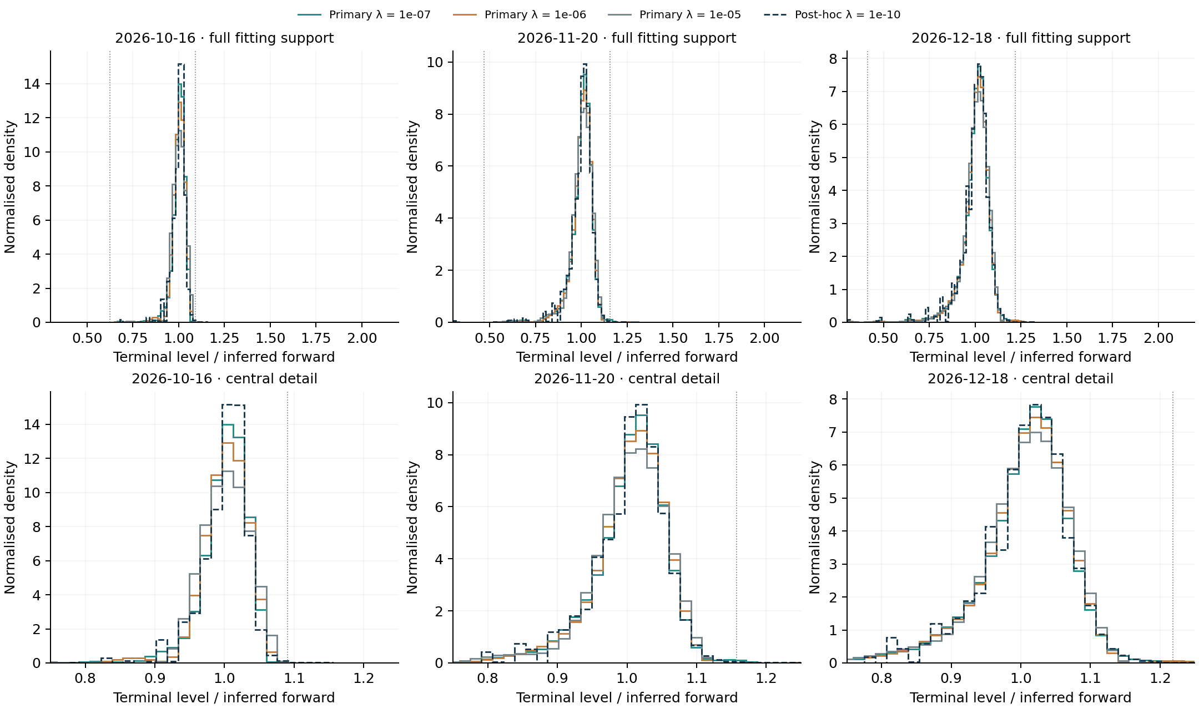
Figure 27. Market-density sensitivity to smoothing. The three solid curves use the declared primary coefficients; the dashed curve uses the post-hoc selected ${10}^{−10}$. Top panels show the entire fitting support and lower panels enlarge $0.75≤S/F≤1.25$. Dotted vertical lines delimit the retained strike range. Curves are estimated histograms, not analytical benchmark densities. Tiny far-tail masses are easier to compare numerically in Table 30 than on this peak-dominated linear scale.

Fit | Expiry | Q(S < 0.8F), % | Q(S > 1.2F), % | Q(S > 1.8F), % | Var(S/F)
Primary 1e−7 | 2026-10-16 | 0.37970 | 0.0096739 | 0.009673851 | 0.0016523
Primary 1e−7 | 2026-11-20 | 1.24439 | 0.0096739 | 0.009673851 | 0.0044610
Primary 1e−7 | 2026-12-18 | 2.34564 | 0.1486140 | 0.009673850 | 0.0068258
Post-hoc 1e−10 | 2026-10-16 | 0.37272 | 0.0000078 | 0.000001186 | 0.0015441
Post-hoc 1e−10 | 2026-11-20 | 1.35610 | 0.0997905 | 0.000049443 | 0.0043609
Post-hoc 1e−10 | 2026-12-18 | 2.06036 | 0.1797615 | 0.000218654 | 0.0067438
Table 30. Conditional risk-neutral summaries for the primary and post-hoc selected fits. Probabilities are percentages; variance is dimensionless. These are sensitivity outputs, not confidence intervals, physical forecasts or recommendations. Values near numerical resolution should not be read as precise market probabilities.

As Malz discusses [14], tail interpretation requires attention to extrapolation. Retained upper strikes reach only about $1.0905F$, $1.1571F$ and $1.2188F$ across the three horizons. The $1.8F$ event is outside all these spans. The first-horizon point estimate for this event changes from approximately 0.009674% under the primary coefficient to 0.000001186% under the weaker diagnostic fit. Neither is validated against an observable market density.
All twenty-four empirical joint fits, including the diagnostic grid, have strict solved status and pass the interval calendar check. The smallest final gap is $−5.749×{10}^{−10}$, and signed numerical masses are retained. The within-snapshot ordering is conditional on inferred deterministic carry and proportional dividends, following the assumptions underlying Gatheral and Jacquier’s argument [12]. The index’s actual cash-dividend process is not reconstructed.
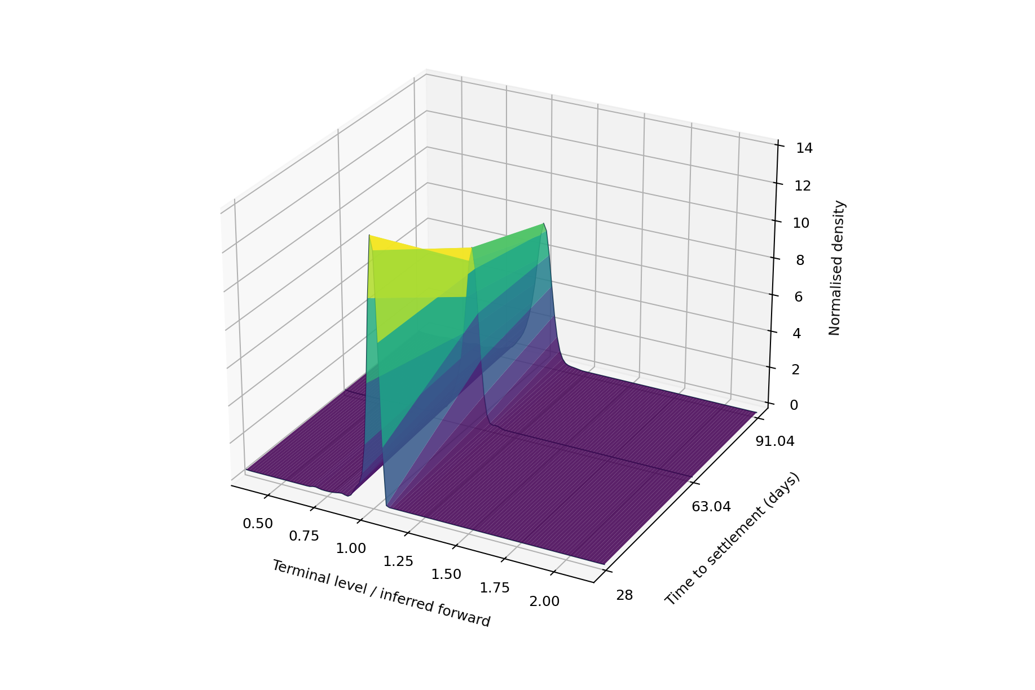
Figure 28. The primary selected empirical density across three settlement horizons. The surface connects bin centres and the three fitted maturity curves for visual guidance. It is not a fitted continuum of maturities. The horizontal terminal-level coordinate is normalised by each expiry’s inferred forward; the vertical coordinate is its corresponding density. Exact steps and alternative smoothing choices are available in the offline empirical explorer.
The empirical explorer provides exact histogram slices as well as the visual surface. It labels post-hoc settings and spread-miss counts with the selected curve. These presentation choices ensure that a convincing 3D view does not hide the fitting limitations.

Original-spread compatibility and dated comparisons

Defining a common empirical comparison
The final analytical stage uses all three snapshots and the same October, November and December SPXW expiries. It retains 840 pairs in August, 969 in the standard September snapshot and 950 in the later snapshot. Carry is inferred separately for each observation and expiry. A common-contract control uses the intersection of retained contracts across snapshots and re-estimates carry on that sample; it changes composition and carry together.

Snapshot (2026) | Expiry | Retained pairs | Common strikes | Elapsed days | Inferred D | Inferred F (points)
31 Aug · 15:00 CT | 2026-10-16 | 296 | 288 | 46.00000 | 0.99742995 | 7716.6750
31 Aug · 15:00 CT | 2026-11-20 | 305 | 296 | 81.04167 | 0.99157534 | 7742.7428
31 Aug · 15:00 CT | 2026-12-18 | 239 | 230 | 109.04167 | 0.98782814 | 7762.9681
18 Sep · 15:00 CT | 2026-10-16 | 364 | 288 | 28.00000 | 0.99692766 | 7666.5433
18 Sep · 15:00 CT | 2026-11-20 | 344 | 296 | 63.04167 | 0.99259513 | 7691.7365
18 Sep · 15:00 CT | 2026-12-18 | 261 | 230 | 91.04167 | 0.98895253 | 7712.2104
18 Sep · 15:15 CT | 2026-10-16 | 361 | 288 | 27.98958 | 0.99698753 | 7680.0067
18 Sep · 15:15 CT | 2026-11-20 | 337 | 296 | 63.03125 | 0.99256973 | 7705.6095
18 Sep · 15:15 CT | 2026-12-18 | 252 | 230 | 91.03125 | 0.98914398 | 7725.9946
Table 31. Retained matched pairs, the intersection of strikes across all three snapshots, and independently inferred carry at each expiry. Times in the snapshot labels are Chicago civil time. The common-contract fit re-estimates carry on its smaller sample; the last two columns describe the all-pair fit.

As Cohen, Reisinger and Wang discuss in Detecting and Repairing Arbitrage in Traded Option Prices, bid–ask information is relevant to assessing price compatibility [23]. Their soft-bound repair formulation is not implemented here. Instead, the project checks compatibility within its finite density family and then requires the fit to satisfy the original intervals without quote repair.

Distinguishing grid feasibility from quote inconsistency
Equation (41) intersects the call spread with the parity-transformed put spread, using the point carry inputs. A call inside that intersection has a parity-implied put inside the original put interval.
$$\begin{matrix}ℓ_{mi}^{C}=max\{B_{mi,C},B_{mi,P}+D_{m}\left(F_{m}−K_{mi}\right)\}, \\ u_{mi}^{C}=min\{A_{mi,C},A_{mi,P}+D_{m}\left(F_{m}−K_{mi}\right)\}.\end{matrix}$$
Equation 41. Intersection of original call and parity-transformed put intervals.
Let $P_{J}$ denote the masses satisfying non-negativity, unit mass, unit normalised mean and the interval calendar restrictions. Equation (42) calculates the minimum uniform price widening needed for the exact bin-price map to meet the interval bounds.
$$\begin{matrix}δ_{J}^{*}=\min_{δ≥0, W∈P_{J}}δ \\ \text{subject to} ℓ_{mi}^{C}−δ≤{\left(A_{m}w_{m}\right)}_{i}≤u_{mi}^{C}+δ \\ \text{for every }m,i.\end{matrix}$$
Equation 42. Minimum diagnostic quote widening under the finite density basis.
The LP uses the linear-programming framework described by Boyd and Vandenberghe [11], with interval refinement for calendar restrictions. The widening is diagnostic only. A positive value blocks that representation; the widened prices are not used for estimation. Its result is conditional on carry, support and bin basis and does not establish model-independent market arbitrage.

Snapshot | Bins | Minimum widening (points) | Final outcome | Equivalent quote-row multiplier: status
31 Aug · 15:00 CT | 120 | 0 | Solved | 1: solved
31 Aug · 15:00 CT | 240 | 0 | Solved | 1: solved
18 Sep · 15:00 CT | 120 | 0 | Solved | 1: postcheck_failure, 10: solved
18 Sep · 15:00 CT | 240 | 0 | Solved | 1: solved
18 Sep · 15:15 CT | 120 | 0.0265641741 | Blocked on this grid | No QP attempted
18 Sep · 15:15 CT | 240 | 0 | Solved | 1: solved
Table 32. The disclosed 120/240-bin feasibility comparison and subsequent hard-bound QP outcome. Positive row multipliers give algebraically equivalent constraints; failed numerical attempts are retained. A printed zero is the LP’s numerical result, subject to the residual checks below.

The late snapshot requires approximately 0.026564 points of widening on 120 bins, both with independent maturities and with calendar constraints. On 240 bins, the original spreads are feasible. The finer common grid is therefore used for all three primary fits. This decision follows pilots on all snapshots; none is an untouched temporal test set. The 120-bin controls remain available.

Selecting a smooth member of the feasible family
Let $F_{J}$ be the subset satisfying the original intervals without widening. Equation (43) chooses the member with minimum density-height curvature, using the finite-difference stencil described by Driscoll and Braun [7] and the smoothing framework discussed by Boyd and Vandenberghe [11].
$$\begin{matrix}\hat{W}=arg\min_{W∈F_{J}}R_{J}\left(W\right), \\ R_{J}\left(W\right)=\frac{1}{J−2}\sum_{m=1}^{M}{\sum_{j=2}^{J−1}{{\left(\frac{w_{m,j+1}−2w_{mj}+w_{m,j−1}}{Δu}\right)}^{2}}}.\end{matrix}$$
Equation 43. Minimum-curvature density inside original quote restrictions.
For a fixed equal-width grid this is a positive multiple of Equation (21), so it gives the same minimisers when used alone. There is no trade-off parameter against midpoint error. Spread compatibility is now imposed; a zero in-sample miss count is therefore a construction property, not independent density validation.
As Goulart and Chen’s solver discussion makes clear [15], numerical stopping criteria are formulation dependent in finite precision. The physical-price QP initially returned AlmostSolved. Objective multipliers of 0.1, 10 and 100 did not resolve it. Dividing quote rows and bounds by the forward achieved strict Solved status for the primary fits without changing their feasible sets. Accepted QPs require solver tolerances of ${10}^{−11}$ and independent checks in original price units.
A September 120-bin control returned Solved but missed a physical bound by $2.97×{10}^{−7}$ points, above the ${10}^{−7}$ acceptance threshold. An equivalent positive quote-row multiplier of ten resolved that case. The runner records all attempts with multipliers one, ten and one hundred; it neither modifies the quotes nor loosens the acceptance rule.

Snapshot | Estimator | Expiry | Call RMSE (points) | Put RMSE (points) | Calls / puts outside | Largest miss (points)
31 Aug · 15:00 CT | 240-bin constrained | 2026-10-16 | 3.2961 | 3.3985 | 0 / 0 | 1.38e-11
31 Aug · 15:00 CT | 240-bin constrained | 2026-11-20 | 3.1513 | 2.8919 | 0 / 0 | 1.06e-11
31 Aug · 15:00 CT | 240-bin constrained | 2026-12-18 | 2.7834 | 2.4480 | 0 / 0 | 1.03e-11
18 Sep · 15:00 CT | 240-bin constrained | 2026-10-16 | 0.7861 | 0.5697 | 0 / 0 | 6.96e-11
18 Sep · 15:00 CT | 240-bin constrained | 2026-11-20 | 0.7695 | 0.6337 | 0 / 0 | 6.3e-11
18 Sep · 15:00 CT | 240-bin constrained | 2026-12-18 | 0.7234 | 0.5273 | 0 / 0 | 6.11e-11
18 Sep · 15:15 CT | 240-bin constrained | 2026-10-16 | 0.4469 | 0.2602 | 0 / 0 | 6.89e-11
18 Sep · 15:15 CT | 240-bin constrained | 2026-11-20 | 0.4221 | 0.2530 | 0 / 0 | 2.06e-12
18 Sep · 15:15 CT | 240-bin constrained | 2026-12-18 | 0.4846 | 0.3167 | 0 / 0 | 2.33e-12
18 Sep · 15:00 CT | Notebook 9 primary | 2026-10-16 | 0.8895 | 1.0036 | 100 / 236 | 1.866071
18 Sep · 15:00 CT | Notebook 9 primary | 2026-11-20 | 0.4477 | 0.8228 | 36 / 145 | 1.368845
18 Sep · 15:00 CT | Notebook 9 primary | 2026-12-18 | 0.3323 | 0.7146 | 6 / 127 | 0.630488
18 Sep · 15:00 CT | 120-bin constrained | 2026-10-16 | 0.7915 | 0.5688 | 0 / 0 | 0.000000
18 Sep · 15:00 CT | 120-bin constrained | 2026-11-20 | 0.7661 | 0.6341 | 0 / 0 | 0.000000
18 Sep · 15:00 CT | 120-bin constrained | 2026-12-18 | 0.7191 | 0.5289 | 0 / 0 | 0.000000
Table 33. Original call/put spread diagnostics and midpoint RMSE. The September 120-bin control changes the criterion while retaining the first empirical study’s bin count. The 240-bin comparison changes both criterion and resolution. All counts use the stated ${10}^{−7}$-point tolerance.

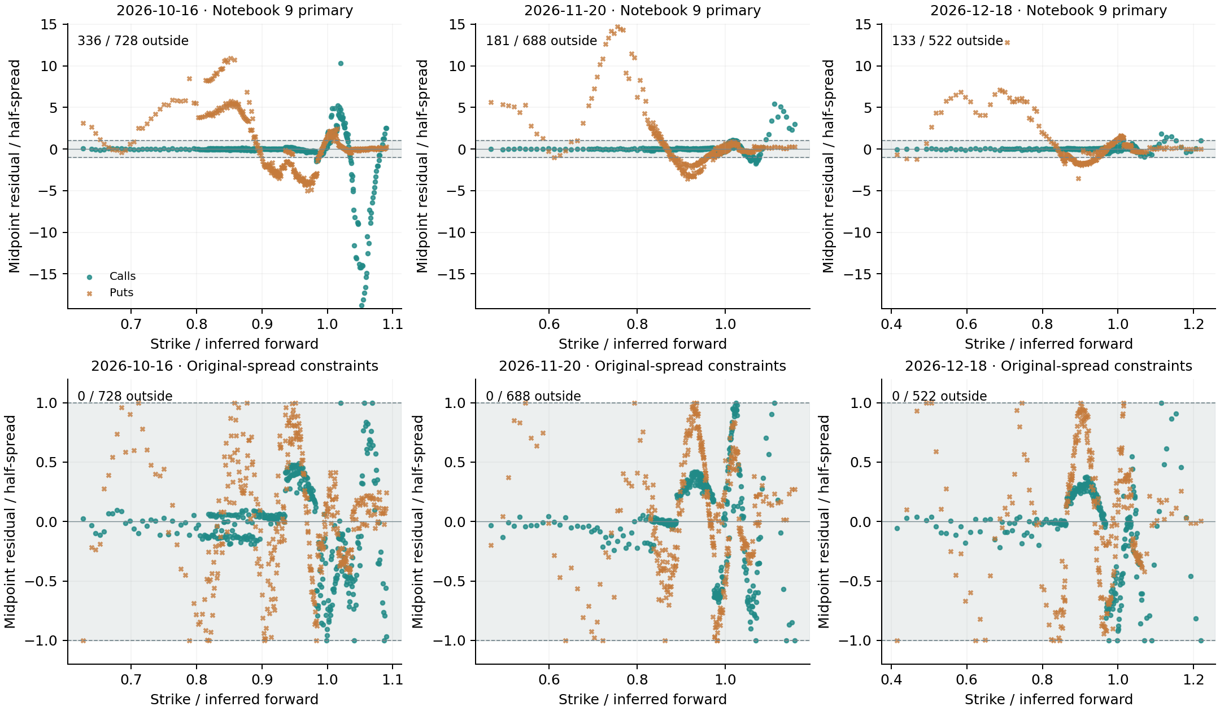
Figure 29. Standard September snapshot: the first empirical study’s selected 120-bin midpoint fit above, and the new 240-bin original-spread fit below. Shading spans the quoted bid–ask interval in half-spread units. The upper and lower rows have different vertical scales, and all residuals are displayed. The 120-bin hard-bound control also has zero counted spread misses; the September improvement therefore does not require the finer grid.

All 5,518 original option intervals across the three primary snapshots have zero counted misses at the stated tolerance. The September 120-bin hard-bound control also achieves zero, showing that its improvement does not require increased resolution. Across the wider run, sixteen of eighteen attempted QP cases are accepted, giving forty-eight marginal fits. The late 120-bin case is blocked by grid feasibility, and one late validation fold remains numerically unresolved.

Held-out pairs and the unresolved fold
Whole call–put pairs are withheld at interlaced interior strikes. Carry is recomputed using training pairs only. As Cawley and Talbot discuss [17], evaluation after inspected design choices must be described carefully: these are descriptive interpolation checks, not blind evidence of future-date performance.

Snapshot | Solved folds | Evaluated quotes | Outside spreads | Outside (%) | Largest miss (points) | Pooled normalised MSE
31 Aug · 15:00 CT | 3 / 3 | 1668 | 40 | 2.398 | 0.872056 | 1.496021e-07
18 Sep · 15:00 CT | 3 / 3 | 1926 | 46 | 2.388 | 0.392571 | 7.838472e-09
18 Sep · 15:15 CT | 2 / 3 | 1256 | 24 | 1.911 | 0.058489 | 2.261022e-09
Table 34. Held-out call and put errors. Each successful fold contributes its actual quote count to the pooled forward-scaled midpoint MSE. The late snapshot has only two accepted folds, so its score must not be treated as directly comparable complete-fold evidence.

The first late-snapshot fold is feasible in its LP, but its QP does not meet the complete numerical rule. Row multiplier one returns Solved with a physical miss of approximately $1.29×{10}^{−7}$ points; multipliers ten and one hundred return AlmostSolved. The case is retained and excluded with explicit coverage of two accepted folds out of three. It is not reclassified as quote incompatibility or silently replaced.
Even successful folds leave some held-out prices outside their ranges: forty of 1,668 evaluated option quotes in August and forty-six of 1,926 in standard September. The late result covers only 1,256 quotes and is not directly comparable as a complete-fold score. Exact in-sample compatibility does not automatically extend to unseen strikes.

Conditional ranges rather than a single tail answer
As Malz explains [14], tail probabilities can depend strongly on extrapolation choices. To quantify the remaining freedom within the declared empirical representation, Equation (44) removes the curvature objective and minimises or maximises each event probability over $F_{J}$. The vector $a$ contains exact event fractions within bins.
$$\begin{matrix}{\underline{p}}_{J}\left(a\right)=\min_{W∈F_{J}}a^{T}vec\left(W\right), \\ {\overline{p}}_{J}\left(a\right)=\max_{W∈F_{J}}a^{T}vec\left(W\right).\end{matrix}$$
Equation 44. Conditional feasible lower and upper event probabilities.
All maturities remain jointly constrained while one event is optimised. The seventy-two completed LPs provide conditional feasible ranges. They fix the 240-bin support, point carry, selected observations and any stated interpolation weights. They are not confidence intervals, do not propagate carry or sampling uncertainty, and are not asserted to be sharp over every possible distribution. Their independent physical-price residual limit is $2×{10}^{−6}$ points, separately reported from the QP counting tolerance.

Fixed expiries and a common elapsed horizon
A fixed expiry is eighteen days closer in September than in August and another fifteen minutes closer in the late snapshot. Each fit also uses its own inferred forward. Figure 30 therefore combines changing observations with changing time to settlement, and a fixed normalised threshold need not represent the same physical index level.

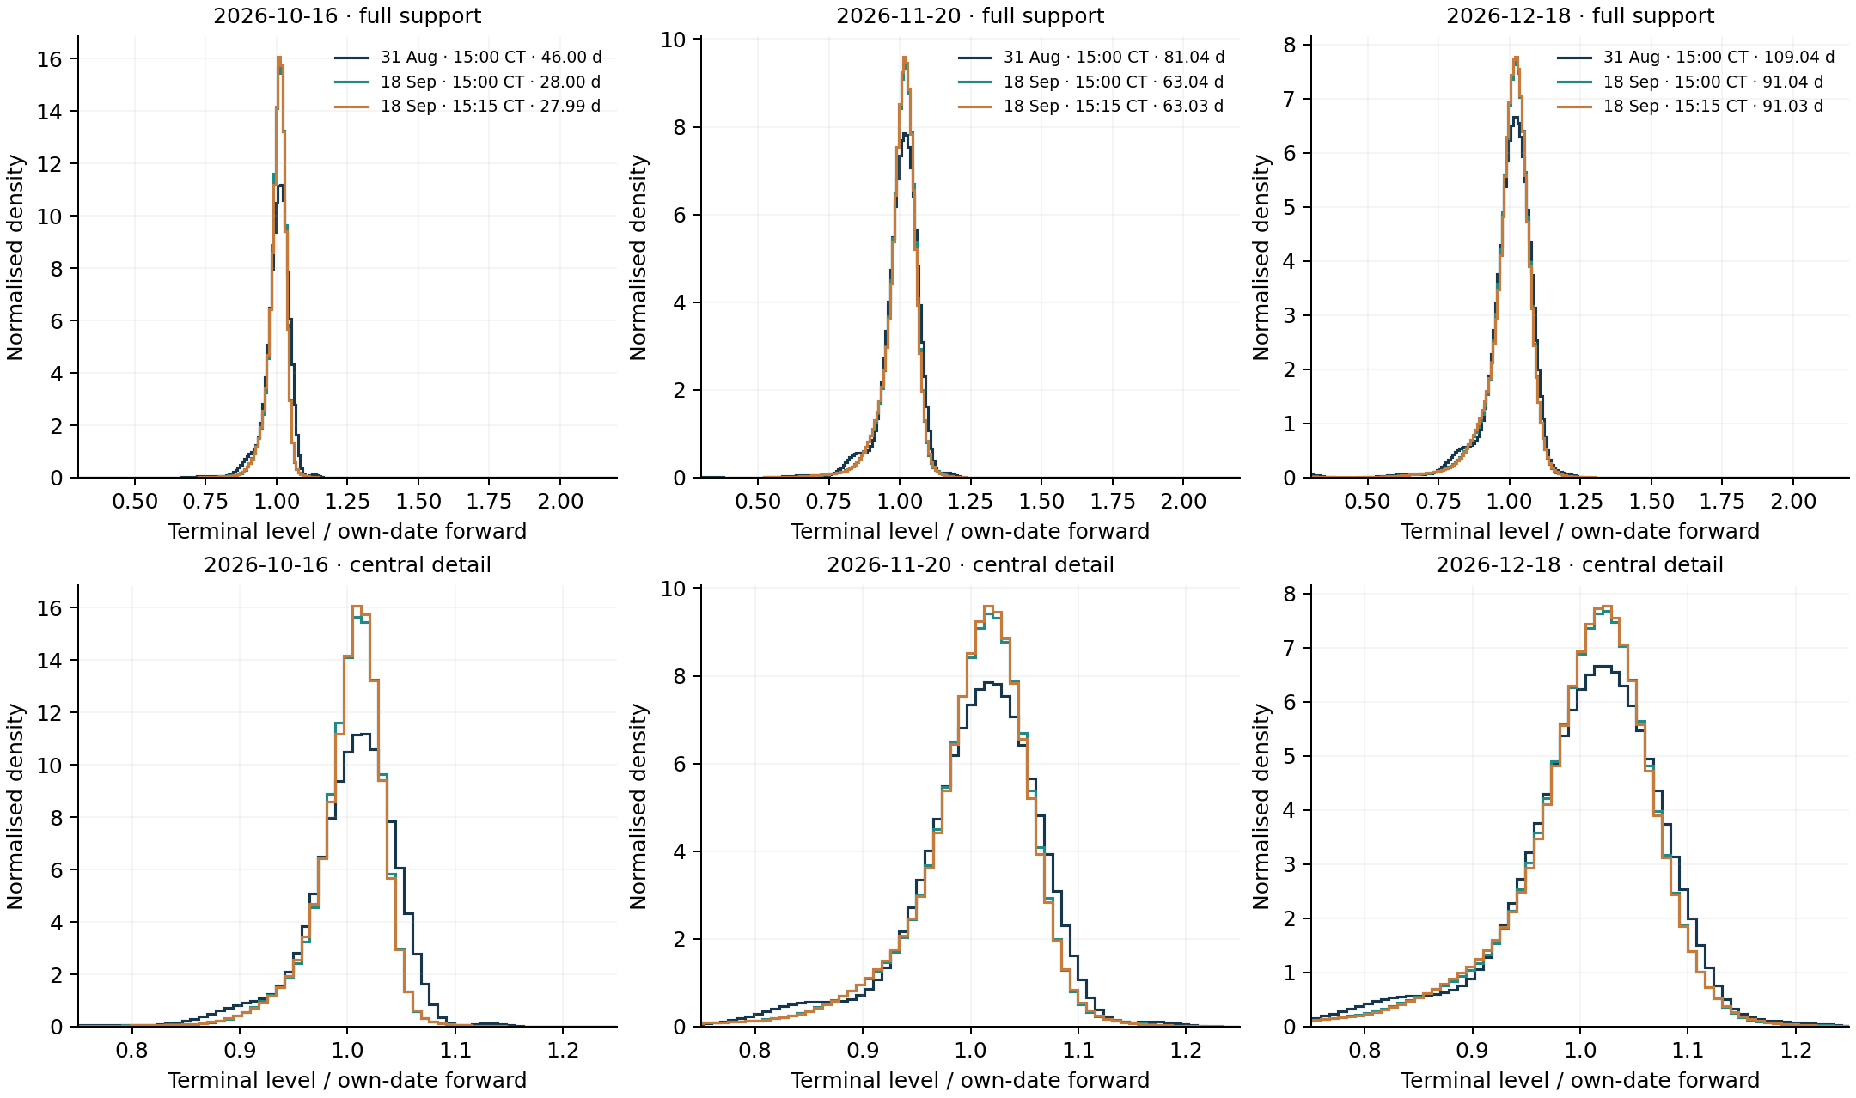
Figure 30. Fixed-expiry density comparisons, with full support above and central detail below. The elapsed horizon falls by 18 days between August and standard September, and by another 15 minutes at the later snapshot. Each curve uses its own inferred forward; the same normalised threshold can therefore correspond to different index levels. These curves cannot isolate a pure change in expectations at a fixed horizon.

For a complementary comparison, Equation (45) explicitly assumes a linear mixture between adjacent normalised maturity distributions bracketing sixty elapsed days. It does not extrapolate or invent a sixty-day discount factor or forward.
$$\begin{matrix}ω_{*}=\frac{T_{*}−T_{a}}{T_{b}−T_{a}}, T_{a}≤T_{*}≤T_{b}, \\ w_{*}=\left(1−ω_{*}\right)w_{a}+ω_{*}w_{b}.\end{matrix}$$
Equation 45. Assumed interpolation of normalised distributions at a common horizon.
The mixture preserves non-negativity, unit mass and unit normalised mean. Normalised call values mix linearly and remain between their ordered endpoints. This mathematical preservation does not turn the interpolated slice into an observed sixty-day distribution. Its events concern the assumed normalised variable.

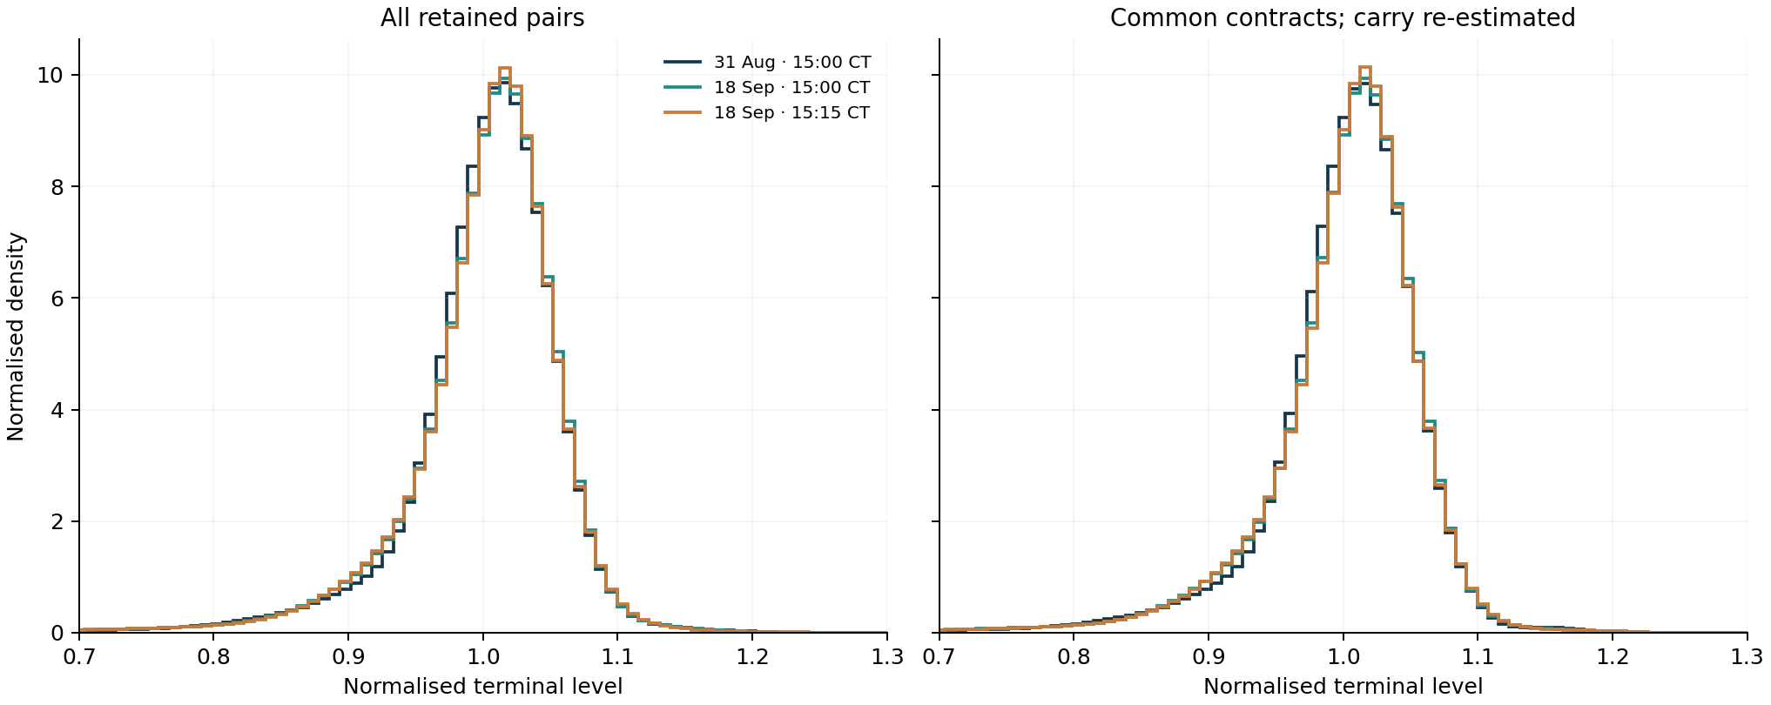
Figure 31. Interpolated 60-day normalised density using all retained pairs, and the separately re-estimated common-contract control. The panel displays 0.7–1.3 for detail; the fitted support remains 0.3–2.2, and tail calculations use the complete support. The right panel changes both quote composition and inferred carry.

Snapshot | Pairs used | Below 0.8 (%) | Above 1.2 (%) | Above 1.8 (%) | Normalised variance
31 Aug · 15:00 CT | All pairs | 1.3072946 | 0.0288369 | 0.0000000 | 0.00391937
31 Aug · 15:00 CT | Common contracts | 1.3088835 | 0.0288158 | 0.0000000 | 0.00394024
18 Sep · 15:00 CT | All pairs | 1.3888690 | 0.0239813 | 0.0002990 | 0.00408341
18 Sep · 15:00 CT | Common contracts | 1.4007878 | 0.0591652 | 0.0001475 | 0.00406689
18 Sep · 15:15 CT | All pairs | 1.3771398 | 0.0724494 | 0.0000000 | 0.00403270
18 Sep · 15:15 CT | Common contracts | 1.3742812 | 0.0617352 | 0.0000464 | 0.00403093
Table 35. Conditional 60-day point summaries from the stated interpolation. Tail columns are percentages of the interpolated normalised distribution, not observed physical probabilities. Values rounded to zero are not proofs of a zero-probability event.

Equation (46) provides a descriptive distance between two histograms on the same normalised bins. Integrating each constant bin-height difference gives the sum of absolute mass differences. Neither fitted density is treated as truth.
$$\begin{matrix}d_{1}\left({\hat{g}}^{\left(a\right)},{\hat{g}}^{\left(b\right)}\right)=\int_{0.3}^{2.2}{\left|{\hat{g}}^{\left(a\right)}\left(x\right)−{\hat{g}}^{\left(b\right)}\left(x\right)\right|} dx \\ =\sum_{j=1}^{J}{\left|w_{j}^{\left(a\right)}−w_{j}^{\left(b\right)}\right|}.\end{matrix}$$
Equation 46. Absolute distance between two fitted normalised densities.
The common-sixty-day August-to-September distance is 0.048225 using all pairs and 0.051226 for the common-contract control. Between the two September snapshots it is 0.018170 and 0.017322, respectively. These are distances between conditional fitted distributions, not recovery errors or measures of statistical significance.

Snapshot | 60-day event | Chosen estimate (%) | Feasible lower (%) | Feasible upper (%)
31 Aug · 15:00 CT | Below 0.8 × forward | 1.3072946 | 0.9821901 | 1.7321271
31 Aug · 15:00 CT | Above 1.2 × forward | 0.0288369 | 0.0000000 | 0.2002381
31 Aug · 15:00 CT | Above 1.8 × forward | 0.0000000 | 0.0000000 | 0.0185933
18 Sep · 15:00 CT | Below 0.8 × forward | 1.3888690 | 1.1862115 | 1.6390830
18 Sep · 15:00 CT | Above 1.2 × forward | 0.0239813 | 0.0000000 | 0.2005809
18 Sep · 15:00 CT | Above 1.8 × forward | 0.0002990 | 0.0000000 | 0.0157987
18 Sep · 15:15 CT | Below 0.8 × forward | 1.3771398 | 1.1515257 | 1.6626283
18 Sep · 15:15 CT | Above 1.2 × forward | 0.0724494 | 0.0000000 | 0.2129429
18 Sep · 15:15 CT | Above 1.8 × forward | 0.0000000 | 0.0000000 | 0.0192084
Table 36. Conditional feasible ranges from Equation (44) for the interpolated 60-day distribution. Bounds are computed from the all-pair fits’ fixed carry; they do not apply to the common-contract refits. The corresponding extrema for every actual expiry, LP residuals and extremising masses are retained in the result files.

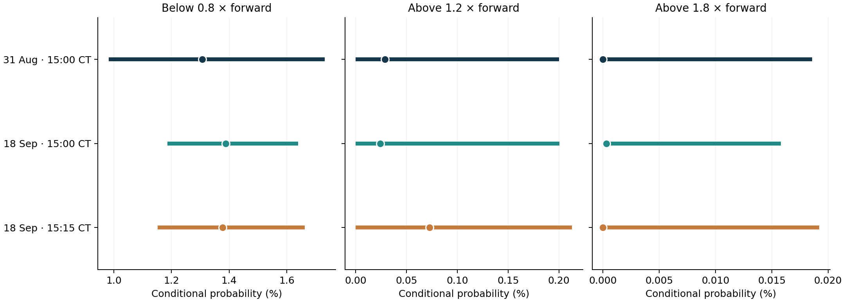
Figure 32. Dots are the minimum-curvature point estimates; horizontal bars are the conditional feasible probability ranges. Panels use different horizontal scales and percentages throughout. The bars are not statistical error bars. In particular, a nearly zero selected upper-tail probability can coexist with a materially positive feasible upper bound.

The selected probability below 0.8 is 1.3073% in August and 1.3889% in standard September. Their conditional feasible ranges, approximately 0.9822–1.7321% and 1.1862–1.6391%, overlap. The standard September probability above 1.8 is approximately 0.0002990%, yet its feasible upper bound is approximately 0.0157987%. A near-zero selected value therefore does not establish a near-zero compatible event range.
The intervals do not support a statistically established date change or a particular market-event explanation. They expose the dependence of individual tail estimates on the selected solution within the stated family.
The dated explorer retains shared scales, exact histogram slices and the separately labelled sixty-day mixture. Playback steps through the three observations rather than manufacturing observations between the two dates. The all-pair risk ranges are hidden when the common-contract control is selected because its quote family and carry differ.

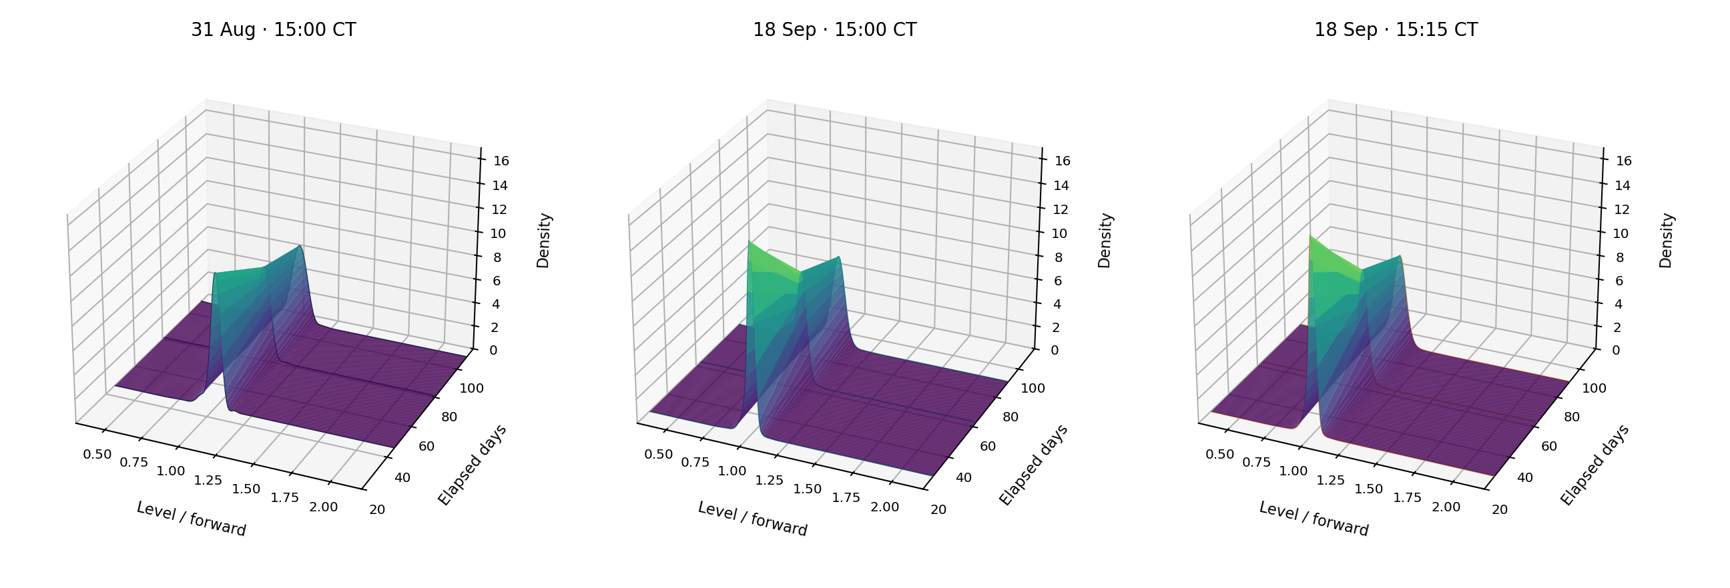
Figure 33. The three fitted surfaces on common normalised-level, elapsed-day and density scales. Only three expiry densities are fitted in each snapshot. Surface joins between bin centres and maturity rows aid viewing; they are not extra observations. The companion adds rotation, zoom, hover, observed-snapshot playback, exact histogram slices and the separately labelled 60-day mixture.

Development challenges and lessons learned

Purpose of the development record
The development process forms part of the evidence for the final method. This chapter records observed setbacks, approaches tested, outcomes and remaining limitations across all ten notebooks. Deliberately invalid fixtures and designed stress tests are distinguished from unexpected implementation failures. The full, continuously maintained record remains in research/development_reflection.md; the following account consolidates its substantive lessons into the research argument.

Notebook 1: a smaller numerical step was not always better
The first setback was tiny negative curvature in the far left tail of the clean benchmark. Nearly linear call values made second differences vulnerable to cancellation. The response was to inspect the location and size of the problem, restrict the lower evaluation boundary and check retained mass, mean, convergence and repricing. Negative values were not clipped away. Driscoll and Braun’s account of truncation and roundoff [7] explained why refinement alone could not guarantee improvement.
The intentional noise experiment then produced much larger negative estimates. Its lesson differed from the cancellation case: raw differentiation amplified inconsistencies already present in the perturbed quotes. This motivated the constrained estimator. In presentation, the explanation of Figure 4 was moved below its own figure and caption, keeping the interpretation adjacent to the evidence; that placement is preserved in this paper and in the notebook.

Notebook 2: retrieving prices did not establish usable observations
The candidate download looked substantial but lacked a verified complete observation instant and meaningful size interpretation. Treating an underlying last trade as an option quote timestamp would have supplied an unsupported shortcut. Instead, the raw payload and row-level exclusions were retained, provider documentation was reviewed and calibration remained blocked for that candidate. Later retrieval of the same array with a fuller timestamp did not itself settle the timestamp’s meaning.
The useful outcome was a source audit rather than a forced empirical fit. Quote counts, roots and provisional spread screens could still be studied without overstating what they established. This separated access, metadata interpretation, contract matching and numerical suitability. A solver cannot recover information that was never established in its inputs.

Notebook 3: smoothing required an interpretable constrained object
Clipping negative derivatives would have hidden the problem while changing mass and moments. The replacement represented probabilities directly and priced them by exact uniform-bin integration. This gave an inspectable connection between the unknowns, probability constraints and price shape. Independent integration and small known-histogram checks verified the payoff map.
Smoothing introduced another choice rather than eliminating modelling judgement. A visually attractive density could be obtained at different penalties with different price and density errors. The lesson was to report imposed properties separately from measured accuracy, and to keep the known analytical density out of the fitting objective.

Notebooks 4–5: good slices did not guarantee a consistent surface
Independent maturities passed their own checks but violated normalised call ordering, predominantly beyond shared quote coverage. Joining the slices in a 3D display made the family visible but did not enforce a valid relationship between them. The remedy was a joint programme, supported by an independent fit using the same solver so that solver changes were not confused with the effect of the new restrictions.
The first joint construction still missed violations between bin boundaries. The key improvement was to use the exact quadratic form of the within-bin gap: inspect endpoints and eligible interior stationary points, then add violating locations and resolve. A constructed counterexample showed that this was a necessary check, not merely a denser plotting grid. Five rounds resolved the baseline gap to the target tolerance.
The remaining tail bump was retained after the calendar checks passed. It taught a separate lesson: internal consistency constrains the admissible family, but does not establish that the selected member matches the true distribution. The subsequent work therefore examined support, resolution and risk integrals directly.

Notebook 6: fair sensitivity comparisons and a solver limitation
Changing the number of bins initially appeared to be a simple resolution experiment. However, the existing penalty changed strength with spacing. Deriving a grid-scaled roughness criterion and converting its coefficient made the comparisons interpretable. Nested support choices also preserved the baseline spacing, reducing avoidable confounding between support and resolution.
The two-component benchmark then exposed a numerical limitation that the simpler example had not. Raising OSQP’s iteration allowance from 100,000 to 300,000 was insufficient. Objective scaling and explicit-residual attempts with that backend also failed the strict acceptance requirements. The eventual implementation used an equivalent residual formulation with Clarabel, verified against the earlier formulation on a smaller controlled case. This preserved the mathematical objective and tolerances while changing its numerical treatment.
Finally, every accepted fit could pass probability and calendar checks while giving biased far-tail estimates. The response was to include omitted benchmark mass, fixed-threshold event errors and variance rather than relying on central plots. The lesson was to distinguish numerical completion, structural validity and recovery accuracy throughout the reporting.

Notebook 7: repeated studies required more than additional runs
A coverage comparison could have mixed the effect of quote count with the effect of missing wings. The Sparse 41 and Central 41 patterns controlled that issue by using equal counts with different spans. Shared random draws paired comparable cases, while clean-input controls exposed errors present without noise.
Extending strikes made some clean calls so small that a fixed additive perturbation could create negative supplied prices. The price-dependent bounded amplitude in Equation (26) resolved that positivity problem without asserting full arbitrage consistency. The change and its variance were documented rather than describing the new amplitude as a standard deviation or a fitted market-noise model.
Scaling to 808 joint fits also required saved random states, complete case accounting and precise uncertainty language. Individual estimate variability, MCSE of an average and paired contrast precision were reported separately, following Morris and colleagues [16]. Completed cases could be reused only when their input and code fingerprints matched.
Numerical completion did not guarantee complete figure files. An export problem detected during artifact checks led to writing temporary PNG and SVG files, validating them and only then replacing their destinations. The lesson was that reproducibility includes the displayed evidence, not merely the numerical arrays.

Notebook 8: the selection target and the evaluation target diverged
The selected penalty improved some interior price predictions while worsening density recovery or extrapolation. Instead of changing the benchmark or selecting a more favourable evaluation region, the primary results were retained and a clearly labelled post-hoc inside/outside diagnostic located the discrepancy. Cawley and Talbot’s distinction between selection and evaluation [17] provided the relevant framework.
Unequal fold sizes required pooling individual residuals rather than averaging fold means. The forward stress created a further interpretive risk: using each perturbed forward to redefine the event would move the threshold while claiming to measure sensitivity of the same probability. Re-expressing saved physical fits against the unchanged reference forward prevented that error. Separate uniform-distribution and integration checks verified the conversion.
The large positive-forward price errors were then investigated through the convex-payoff lower bound. This identified incompatible inputs without labelling them as solver failure. Repeated selection also expanded the audit requirements: each nonzero stress retained the exact selected parent fit, coefficient and input fingerprints.

Notebook 9: empirical access, inferred inputs and misleading visual agreement
Unavailable sample access and unsuitable timestamp metadata were genuine setbacks. The response was to complete and test the input process on a labelled fixture, then assess the subsequently supplied market files on their own documented terms. The eventual exchange-BBO profile did not silently relax or relabel the earlier external-curve and actual-size profile.
The supplied files contained two price families. Identifying the exchange market fields avoided fitting indicative marks as though they were observed bids and asks; recognising that the files represented two dates avoided treating three snapshots as three independent days. Indicative size entries were not converted into market depth.
Missing discount inputs were handled through an explicit quote-implied carry proxy, with feasible projections and rate-equivalent interpretation. This introduced a route for held-out information to affect predictions. Re-estimating both discount and forward inside each training fold addressed that dependency. The proxy remains an assumption-dependent estimate, not a substitute for independent rate evidence.
The weakest smoothing candidate won, and the subsequent lower grid improved the call score but left substantial put-spread misses. The primary result and post-hoc status were retained. Residual plots were also checked to ensure that a large discrepancy did not sit outside a favourable plotting range. A small fixture miss and the larger empirical misses both illustrated the same distinction between parity compatibility and the chosen density’s price reproduction.
An intentionally invalid one-row fixture exposed an error in empty timestamp summaries. The adapter was changed to preserve the explicit rejection reason and unavailable extrema instead of crashing before reporting them. This corrected failure reporting without changing valid market results. The lesson was to verify rejected cases and presentation paths as well as successful calibrations.

Notebook 10: feasibility, finite precision and unresolved evidence
Improving the midpoint objective had not answered whether a density could satisfy both original spreads. The response separated an LP compatibility diagnostic from a hard-bound minimum-curvature estimator. The late snapshot’s 120-bin failure could have been mistaken for incompatible market quotes; the feasible 240-bin representation demonstrated the importance of qualifying the result by its basis and fixed carry.
Equivalent mathematics behaved differently numerically. Physical-price rows and several objective scalings failed to reach strict status. Forward-scaled quote rows resolved the primary cases, while a further row multiplier resolved a control that had returned Solved but failed its physical-price postcheck. All unsuccessful attempts and original acceptance tolerances were retained.
One late holdout fold remains unresolved. Its LP is feasible, but the QP attempts do not meet the complete numerical rule. The reported validation coverage is therefore two of three folds. Preserving that distinction avoids both declaring an infeasible market and reporting a complete validation result that was never obtained.
Zero in-sample spread misses also did not identify the tails. Event-probability LPs quantified the remaining range within the declared family. Dated comparison introduced a further issue because fixed expiries move closer with time. The separately labelled sixty-day mixture and common-contract control made those assumptions visible, while avoiding a causal story unsupported by two dates.
The date-aware explorer required the same discipline. Shared scales support comparison; exact histogram slices expose the fitted representation; all-pair ranges disappear for common-contract refits because they no longer apply. The interactive view thus carries the scope of the calculation rather than presenting every displayed curve as equally observed.
A verification run initially inspected results while the batch was still being written and consequently saw an incomplete snapshot set and no final hash record. Waiting for completion resolved that reporting issue without changing the numerical routines. Subsequent checks covered the full batch and the browser behaviour, including offline operation and narrow-screen layouts. This reinforced the need to distinguish incomplete output from a failed scientific calculation.

Final assembly: retaining the evidence in a readable paper
The final assembly uses the author’s engineering reports as references for typography, front matter, numbered sections, captions and author-led scholarly discussion. The research sequence follows the SPX investigation itself. Historical stage reports are integrated into one argument, with a dedicated conclusion and explicit distinction between preparation fixtures, empirical observations and subsequent diagnostics.
All forty-six equations, thirty-three figures and thirty-six research tables retain their established numbers. The symbols include units, and the front-matter lists provide page references to the finished layout. The long mathematical expressions are arranged across lines without changing their meaning. Wide scientific assets use landscape pages where necessary to preserve legibility. The original notebooks and interactive companions remain alongside the assembled document, so the paper’s synthesis can be checked against the detailed record.
The first document conversion introduced duplicate image captions and empty portrait sections between adjacent landscape assets. These were removed by controlling caption generation and section boundaries. More significantly, visual inspection found that the PDF exporter mishandled empty cells in aligned native equations and omitted some lines. Single-column equation arrays preserved the complete expressions while keeping editable Word mathematics. The corrected equations were rendered and inspected again. This setback demonstrated why successful file creation and text extraction cannot replace visual verification of mathematical content.

Discussion and limitations

What the evidence establishes
The experiments show that a useful recovery workflow requires several distinct checks. Exact payoff integration and constrained masses address structural validity. Joint fitting and analytical interval minima address the implemented calendar restrictions. Independent residual checks address the finite-precision solution. Quote audits and original-spread tests address input interpretation and observed-price compatibility. Recovery errors, sensitivity studies and feasible event ranges address what remains uncertain about the distribution.
The synthetic results make these distinctions measurable. Clean finite differences converge, while perturbations destabilise them. Joint restrictions remove calendar violations with little change in price accuracy, but do not remove the tail mismatch. Changing resolution or coverage can materially change density error while barely changing price RMSE. Selecting smoothing by interior call prediction can improve that objective while worsening a separate density target. These findings follow from the reported experiments, rather than being general claims that one estimator always dominates another.
The empirical extension shows that hard original call/put restrictions are attainable for the three primary snapshots within the stated 240-bin family. It also shows why this success should not be overstated: the compatibility is in sample and imposed by construction, some held-out prices miss their spreads, and one validation fold remains unresolved. The reported event ranges reveal meaningful flexibility even after all primary quoted intervals are satisfied.

Limits of identification and probability interpretation
As Bahra emphasises [1], option-implied probabilities are risk-neutral. This paper does not estimate the change of measure required to interpret them as real-world forecasts. Market risk preferences, funding assumptions and dividend treatment are not independently identified by the density fit.
The histogram has finite support and a chosen resolution. Curvature selects one member of its feasible family but supplies no claim that the selected shape is the true terminal density. As Malz’s discussion motivates [14], upper-tail integrals include extrapolated regions even when the threshold itself lies inside observed strike coverage. Conditional LP ranges improve transparency, but retain the same support, basis and point carry; they do not measure every source of uncertainty.
Synthetic truth is available only for the chosen benchmark families. The noise mechanism is deliberately simple, independent and bounded in the repeated studies. Its price-dependent amplitude is not a market microstructure calibration. Consequently, favourable recovery under those experiments is evidence within their design, not proof of general empirical reliability.

Limits of empirical and numerical validation
Two dates and three snapshots do not support a long historical conclusion, an event attribution or a tested forecasting strategy. The common sixty-day density is an assumed mixture of normalised maturity distributions. The common-contract control changes the inferred carry as well as sample composition. Neither comparison isolates a single causal effect.
The observed prices are documented exchange BBOs with an activity screen; actual depth and consolidated NBBO are not established. Quote-implied discounts and forwards are conditional point inputs. The selected finite grid and row-scaling retry rule followed inspected pilots, and the lower smoothing diagnostic followed the primary fit. These design decisions are disclosed so they cannot be mistaken for blind validation.
Strict numerical criteria strengthen the evidence but remain tolerance-based. Tiny signed masses and calendar residuals are retained. Feasibility LPs and QPs have different independent price-residual thresholds. The unresolved late fold demonstrates that LP compatibility and successful optimisation of the selected curvature criterion are separate outcomes. The accompanying case records make those differences reviewable.

Conclusions and future work

Conclusion
This project achieved its aim of developing and evaluating a reproducible route from European option prices to constrained risk-neutral terminal densities. The work progressed from a known analytical benchmark to a joint multi-maturity estimator, repeated recovery studies and an empirical SPXW application. The final method uses exact histogram payoff integration, explicit probability constraints and analytical checks of calendar gaps between the constraint locations.
The central research question can be answered conditionally. A numerically consistent density can be trusted to satisfy the restrictions that have been imposed and independently checked, within their stated tolerances. That evidence does not by itself establish accurate density recovery, identify extrapolated tails or justify a real-world probability forecast. The synthetic experiments demonstrate this directly: similar price errors can accompany different density errors, and valid calendar ordering can coexist with biased tail probabilities.
The empirical analysis resolved the original-spread problem for the three primary snapshots: all 5,518 retained option intervals were satisfied at the declared counting tolerance using the common 240-bin representation. It preserved the failed 120-bin late control, the incomplete late validation fold and the limitations of inferred carry. The feasible event ranges then showed why a single smooth density should not be presented as the only answer supported by the observed prices. In particular, a nearly zero selected upper-tail probability can coexist with a materially positive feasible upper bound.
The strongest outcome is therefore a method with an explicit account of what its evidence supports. It distinguishes valid inputs, a valid probability representation, numerical acceptance, price reproduction and distributional identification. The development record contributes to that outcome: setbacks led to interval-level checking, comparable smoothing across grids, training-only input inference, original-spread constraints and more qualified tail reporting. Unresolved issues remain visible rather than being removed from the final account.

Priorities for further work
The first priority is to resolve the failed late holdout fold using an independently verified numerical formulation or solver, retaining the same quotes and acceptance criteria. The comparison should establish whether a satisfactory optimum can be obtained without confusing numerical status with feasibility.
The second priority is broader empirical evidence. A predeclared sequence of dated observations, documented snapshot conventions and an independently observed discount/dividend input set would permit a stronger assessment of temporal stability. Selection and design choices should be fixed before an untouched evaluation period is examined, following the separation principle discussed by Cawley and Talbot [17].
The third priority is to broaden the uncertainty analysis. Carry, support and resolution should be varied alongside quote information, and event ranges compared across those declared families. Alternative density bases and tail treatments could determine which findings depend on the histogram representation. Such extensions should retain the distinction between conditional feasible ranges and statistical confidence intervals.
Finally, the common-horizon analysis could be extended through an explicitly estimated maturity model, checked against its economic restrictions and evaluated where observations permit. Until then, the interpolated sixty-day slice remains a useful, clearly labelled comparison convention. These extensions would build on the present work’s main lesson: an interpretable result requires a transparent connection between the observations, assumptions, numerical method and claim being made.

References
[1] B. Bahra (1997), “Implied risk-neutral probability density functions from option prices: theory and application,” Bank of England, Working Paper No. 66. Sections 2.1–2.2 and Mathematical appendix; §§3.5–3.6 additionally consulted for the mixture benchmark for the mixture study. Full paper.
[2] Cboe, “SPX delayed quotes.” Retrieved 19 September 2026. Source page. Primary data source; not a research paper.
[3] Cboe DataShop, “Option Quotes.” Accessed 19 September 2026. Product documentation.
[4] Cboe DataShop, “Option Quotes Specification,” v1.1, pp. 1–2. File specification.
[5] Cboe, “S&P 500 Index Options Product Specifications.” Accessed 19 September 2026 and rechecked 21 September 2026 for the empirical contracts. Contract specifications.
[6] D. T. Breeden and R. H. Litzenberger (1978), “Prices of State-Contingent Claims Implicit in Option Prices,” The Journal of Business, vol. 51, no. 4, pp. 621–651. doi:10.1086/260618. Original attribution; the derivation was consulted through Bahra [1] and Aït-Sahalia and Lo [10].
[7] T. A. Driscoll and R. J. Braun, Fundamentals of Numerical Computation, author-maintained online textbook, §§5.4–5.5. Finite differences, especially Equation (5.4.9); Convergence and roundoff. Accessed 19 September 2026.
[8] F. Black and M. Scholes (1973), “The Pricing of Options and Corporate Liabilities,” Journal of Political Economy, vol. 81, no. 3, pp. 637–654. doi:10.1086/260062. Publisher abstract and metadata consulted; the lognormal implementation is supported by [1] and [10].
[9] Y. Aït-Sahalia and J. Duarte (2003), “Nonparametric option pricing under shape restrictions,” Journal of Econometrics, vol. 116, nos. 1–2, pp. 9–47. Section 2. doi:10.1016/S0304-4076(03)00102-7; author-hosted paper.
[10] Y. Aït-Sahalia and A. W. Lo (1998), “Nonparametric Estimation of State-Price Densities Implicit in Financial Asset Prices,” The Journal of Finance, vol. 53, no. 2, pp. 499–547. Sections I and III.A, especially Equations (16)–(17). Author-hosted paper.
[11] S. Boyd and L. Vandenberghe (2004), Convex Optimization. Cambridge University Press, §§4.4 and 6.3, especially pp. 152–153 and 305–308. Author-hosted book. The quadratic-programme formulation and smoothing-regularisation discussion were consulted directly.
[12] J. Gatheral and A. Jacquier, “Arbitrage-free SVI volatility surfaces,” Quantitative Finance, vol. 14, no. 1, pp. 59–71; first published online 2013. doi:10.1080/14697688.2013.819986. Journal metadata checked through Crossref. The consulted text is the author preprint, arXiv:1204.0646v4, §2, particularly §2.1 and Lemma 2.1. Accessed 20 September 2026. Their SVI estimator is not implemented here.
[13] B. Stellato, G. Banjac, P. Goulart, A. Bemporad and S. Boyd (2020), “OSQP: An Operator Splitting Solver for Quadratic Programs,” Mathematical Programming Computation, vol. 12, no. 4, pp. 637–672. doi:10.1007/s12532-020-00179-2. Metadata checked on the author publication page. Consulted author preprint, arXiv:1711.08013v4, §§1.1, 3.4 and 4, for the formulation, stopping criteria and optional polishing. Accessed 20 September 2026. The code uses OSQP 1.1.3; current interface details are documented separately below.
[14] A. M. Malz (2014), “A Simple and Reliable Way to Compute Option-Based Risk-Neutral Distributions,” Federal Reserve Bank of New York, Staff Report No. 677, June. Publication page; full paper. Sections 2.3 and 3.2 consulted directly on 20 September 2026 for extrapolation and threshold-based tail summaries. This is a central-bank research paper, not a peer-reviewed journal article. Its spline estimator is not implemented in this project.
[15] P. J. Goulart and Y. Chen (2024), “Clarabel: An interior-point solver for conic programs with quadratic objectives,” research preprint, arXiv:2405.12762v1, 21 May. Paper record; full paper. Sections 1 and 2.6 consulted directly on 20 September 2026 for the quadratic/conic formulation and stopping criteria. This is a research preprint; no journal-publication claim is made.
[16] T. P. Morris, I. R. White and M. J. Crowther (2019), “Using simulation studies to evaluate statistical methods,” Statistics in Medicine, vol. 38, no. 11, pp. 2074–2102. doi:10.1002/sim.8086; open full journal article. Sections 3, 4.1 and 5.1–5.4 consulted directly on 21 September 2026 for experiment design, reproducible random streams, missing simulation results and Monte Carlo standard errors. This source supports the simulation methodology; its biomedical application examples are not used as financial models.
[17] G. C. Cawley and N. L. C. Talbot (2010), “On Over-fitting in Model Selection and Subsequent Selection Bias in Performance Evaluation,” Journal of Machine Learning Research, vol. 11, pp. 2079–2107. Journal publication page; open full article. Sections 2.1 and 5.1 consulted directly on 21 September 2026. This peer-reviewed paper supports treating model selection as part of the procedure under evaluation; its kernel-classification estimators are not implemented here.
[18] Cboe DataShop, “Option EOD Summary” and “Option EOD Summary Specification,” v1.1, pp. 1–2. Product page; file layout. Accessed 21 September 2026. Primary operational documentation, including snapshot fields and the early-close exception. The advertised sample download returned HTTP 403; no sample contents were consulted.
[19] HistoricalData.net, “Historical Options Data,” provider’s dataset and field documentation. Primary documentation. Accessed 21 September 2026. Used only to assess the advertised 2022 sample’s unsynchronised quote convention and lack of quote timestamps for that period. The sample was not downloaded. This vendor page is not scholarly evidence for density estimation.
[20] Wharton Research Data Services, “OptionMetrics,” institutional data-vendor description. WRDS product documentation. Accessed 21 September 2026. Establishes a possible institutional data route and described coverage, not access rights, the schema of an unseen export or verified observations in this project.
[21] Cboe, “Proprietary Index Marking Prices.” Accessed 21 September 2026. Primary documentation and downloads. Operational evidence for the two price families and snapshot labels. Three supplied CSVs were independently matched to the advertised downloads; the archived verification records retain hashes and HTTP results. This provider page supplies no density-estimation theory.
[22] Cboe, “Hours & Holidays: U.S. Options,” 2026 schedule. Accessed 21 September 2026. Exchange session schedule. Read with the SPX/SPXW specifications [5] to check the three selected expiry dates. New York civil-time conversion uses the named timezone, including the November daylight-saving transition.
[23] S. N. Cohen, C. Reisinger and S. Wang (2020), “Detecting and Repairing Arbitrage in Traded Option Prices,” Applied Mathematical Finance, vol. 27, no. 5, pp. 345–373; first published online 8 February 2021. doi:10.1080/1350486X.2020.1846573. Journal metadata checked through Crossref; the consulted text is the author preprint, arXiv:2008.09454v1, §§2.1 and 3.2, accessed 21 September 2026. The publisher full-text page was unavailable. Their soft-bound price-repair LP is not the hard-bound finite-density estimator used here.

Appendix A Reproducibility and interactive companions

A.1 Structure of the project package
The cumulative project contains all ten executed analytical notebooks, the underlying Python modules, archived inputs, numerical case records, tests, figure exports, methodological notes and the maintained development reflection. The final paper sources and build script are in paper/. The saved results support inspection of the reported evidence without requiring every simulation to be rerun.
The notebooks retain their original stage-specific context. Statements about what remained to be done at an earlier milestone describe that historical stage; the present paper supplies the completed synthesis. In particular, the original candidate quote audit is not reclassified as an accepted market calibration, and the preparation fixture is not relabelled as empirical data.
Input, code and result fingerprints link completed cases to their declared protocols. Random generator states and nested-strike memberships allow synthetic observations to be reconstructed. Each empirical case retains the selected rows, training and held-out membership where applicable, inferred carry, masses, solver attempts and independent diagnostics. Failed and blocked cases are part of this record.

A.2 Interactive figures
Four offline HTML companions are supplied in interactive/: the independent synthetic maturity surface, the independent-versus-joint comparison, the first empirical surface and the dated empirical comparison. They can be opened in a browser after extracting the project package and do not require a live data connection. Their exact filenames are listed in the project’s README.
The companions provide rotation, zoom, hover and exact maturity slices. The dated version additionally steps through the three observed snapshots, offers the common-contract control and labels the assumed sixty-day mixture separately. Visual joins between maturity rows and bin centres assist viewing; they do not introduce additional fitted observations. Static Figures 10, 14, 28 and 33 remain the paper’s printable counterparts.

A.3 Reproduction and software scope
The project README specifies its environment and entry points. The milestone builders regenerate the related analyses, figures and executed notebooks from the saved inputs. The final stage uses build_milestone10_notebook.py; rebuilding the paper is a separate operation and does not rerun the numerical experiments. This separation preserves the published numerical evidence while allowing document layout to be reproduced.
The recorded software includes OSQP 1.1.3, Clarabel 0.11.1, NumPy SeedSequence and PCG64, Python zoneinfo and the bundled Plotly.js 3.1.0. Software documentation supports the interfaces; the scholarly references support the mathematical relationships.

Appendix B Attribution and reporting conventions

B.1 Established relationships and project definitions
The valuation and density-extraction foundations are attributed to Bahra [1], Breeden and Litzenberger [6], Black and Scholes [8], and Aït-Sahalia and Lo [10]. Shape restrictions follow the discussion by Aït-Sahalia and Duarte [9]. Numerical differentiation follows Driscoll and Braun [7]; the convex-programme and regularisation framework follows Boyd and Vandenberghe [11]. Calendar ordering is used under the assumptions discussed by Gatheral and Jacquier [12]. Solver methodology is supported by Stellato and colleagues [13] and Goulart and Chen [15]. Malz [14] supports the discussion of tail extrapolation, Morris and colleagues [16] the simulation summaries, and Cawley and Talbot [17] the separation of selection from evaluation.
The bin representation, exact uniform-bin payoff coefficients, interval refinement, penalty conversions, experiment settings, empirical carry convention, finite-grid feasibility diagnostics, probability LPs and common-horizon mixture are explicitly project constructions or derivations. Cohen and colleagues [23] motivate attention to bid–ask compatibility, but their price-repair estimator is not implemented. Provider sources [2–5,18–22] support only the operational facts within their documented scope.
The full relationship-to-source map is retained in research/references.md. Where an original publication was not consulted in full, the bibliography identifies the consulted account. Author-led paraphrases are used throughout; no invented quotation is attributed to an author.

B.2 Units and interpretation
Option prices, strikes and physical forwards are in index points, not dollars per contract. Normalised density coordinates are dimensionless. A probability displayed as a percentage is one hundred times its unit-interval value; an error of one percentage point is an absolute probability difference of 0.01. Density height in physical coordinates is per index point, and its integral gives probability.
RMSE against noisy fitting inputs, clean synthetic validation prices and empirical held-out midpoints describe different targets. Truth-based integrated density error is reserved for synthetic benchmarks. Distances between empirical fitted densities are descriptive comparisons. MCSE describes simulation-summary precision; sensitivity ranges and conditional feasible event ranges have their separately stated meanings. Values rounded to zero, especially far-tail probabilities, are not proofs of a zero-probability event.

